Definitions of health, wellness, illness, disease and other relevant terms
  - Summary notes from September 13 Power Point Notes

In the News:
“Proper diet best defence against bad cholesterol: study”
- 50 per cent of Canadians are considered to have a high level of LDL (bad) blood cholesterol
- Eating less saturated fat – found in meat, poultry and high fat dairy products – helps to lower LDL cholesterol.
- But according to a new Canadian study, you need to do more than slash saturated fat to control blood cholesterol.
- People whose diets included a combination of certain cholesterol-lowering foods saw their LDL cholesterol drop considerably more than those who followed a conventional low saturated fat diet. In fact, the low fat diet had little impact on blood cholesterol.
- Health professionals have always stressed the importance of diet as the primary way to improve cholesterol levels. However the introduction of statin drugs(cholesterol lowering medication such as Lipitor) in the late 1980s highlighted the relative ineffectiveness of standard diet advice.
- Foods such as oat bran, nuts and soy have been shown to lower cholesterol and have also been associated with lower risk of coronary heart disease. So too have foods fortified with plant sterols, compounds found naturally in nuts, vegetable oil, whole grains, fruits and vegetables cuts LDL cholesterol by 28 percent which is very significant for ANY scientific study and is a reduction similar to first generation statin
- Adding these foods to your normal diet will help in cholesterol reduction. The more vegetarian you are, the better the results.
- Viscous fibre: 7 servings a day This type of fibre – plentiful in oats, oat bran, barley and psyllium – traps dietary cholesterol and fat in the digestive tract and speeds their removal from the body.
- Soy Protein: 45 grams a day
- Nuts: 1.5 servings a day Studies have consistently found that nuts, packed with heart-healthy unsaturated fat, help reduce blood cholesterol.
- Plant sterols: 2 grams a day Compete with food cholesterol in the gut to be absorbed into the bloodstream. As a result, they have been shown to reduce the absorption of dietary cholesterol by 50 per cent.

  - Definition: Health

HEALTH:
- “A state of complete physical, mental and social wellbeing and not merely the absence of disease or infirmity.” (WHO, 1946)
- The extent to which an individual or a group is able to realize aspirations and satisfy needs, and to change or cope with the environment; health is a resource for everyday life, not the objective of living; it is a positive concept, emphasizing social and personal resources as well as physical capabilities.” (WHO, 1984)
- A sustainable state of equilibrium or harmony between humans and their physical, biological, and social environments that enables them to coexist indefinitely.” (Last, 2007)
- 3rd def is the most accurate.
- Health has been defined by different people in many different ways.
- Most people reference the World Health Organization’s definition.
Definition # | Explanations
1 | This definition takes into account that being healthy is not about being physically sound, without disease, but that health involves also an element of mental and emotional well being.
2 | This definition goes beyond the first definition by describing health as an asset for living, a resource, that we need as individuals and as a population to do and obtain the things we want and need in life and to be able to cope with stresses. The definition also incorporates a focus on social and personal resources which can be considered a little vague. Similar to the first definition, there is an emphasis on not only the physical being but the emotional and social health which can be described as having the sense of having support available from family and friends.
3 | Health in general is more of a concept. There’s no one specific measure that can be used to judge a person’s overall health. Researchers use many health measures to determine a person’s or population’s level of health but often takes a focus.

- One of the measures that we use to get at maybe a more general measure of health is to just ask people how they rate their health. This is called “self-reported health status”.
  - Some people would argue too subjective and that cultural differences between countries will influence how people evaluate their health.
  - Can also be argued that people’s perceptions of their own health have been found to be a good predictor of future health-care use and of mortality rates.
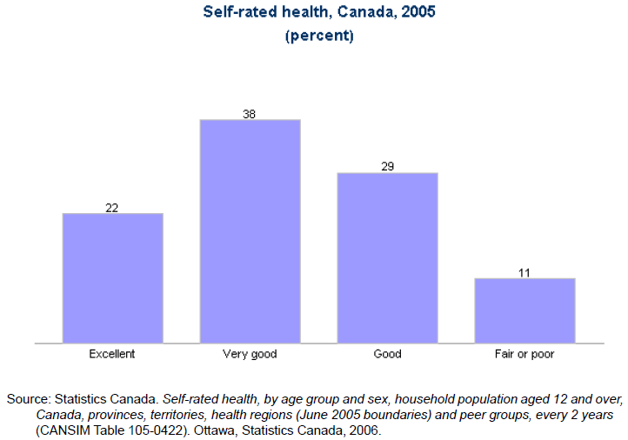
- Things to note:
  - Shows normal distribution
  - 60% of people considered themselves to have either very good or excellent health

  - Definition: Wellness
  - Definition: Well-being
  - Definition: Quality of Life

- WELLNESS: Life satisfaction or gratification in living (Cowen, 1991)

- WELL-BEING: Happiness and meaning and self-realization (Ryan and Deci, 2001)

- QUALITY OF LIFE: An essentially subjective judgment of the way people perceive themselves as contented and happy or otherwise, and able to function physically, emotionally, and socially. Others, including health workers, can make a relatively objective judgement of some of these aspects of a person’s way of living, but the affected individual is the ultimate judge. (Last, 2
- Wellness and well-being are basically the same terms. They are used often used interchangeably. They basically describe a state of happiness and contentment.

- Quality of life is self-explanatory. We often talk about quality of life as an important component to living, in addition to extended life.
- Quality of life is a subjective judgment and it’s how people rate the quality of their life, usually taking into consideration how happy they are and how healthy they feel physically, emotionally, and socially.
- Quality of life is actually a complicated measurement because it’s so subjective.
- Often times people are given a rating scale and they are asked to rate between a scale of 0 to 1. 0 is death and 1 is perfect health. So people are asked then to put a line on how they feel. For example, say you’re in the hospital with chronic pain, on dialysis, you’re just feeling really bad. You might rate the quality of your life closer to the 0.

  - Definition: Disease
  - Definition: Illness

- DISEASE: Literally, dis-ease, the opposite of ease or comfort, a general word descriptive of any departure from good health. Best applied to a physiological and/or psychological departure from normal function, as contrasted with illness. A disease is a conceptual entity defined by clinical, pathological, and epidemiological criteria that enable it to be studied systematically. (Last, 2007)

- ILLNESS: The subjective sensation of experiencing a diseased state (Last, 2007)

- Diseases are generally diagnosable on the basis a persons departure from the norm in terms of physical and/or psychological health status.
- The classification of diseases itself is complicated and has taken years and years of study and constant updating.
- The medical system uses for example the International Classification of Disease system that was developed in 1990 and has been used since around the world as a common system for coding and labeling diseases.
- Illness is a subjective feeling that is related to having a disease.
- It’s the experience of a symptom related to the disease. You may have a disease but you may not feel ill from it.

  - Ex) Breast cancer at a particular stage does not exert symptoms. Stage 1 cancer for example, is often pre-clinical, that is at a stage where there are no obvious symptoms that cause a feeling of illness. Since there are no symptoms in early stage cancer it is often difficult to diagnose unless there is a screening strategy in place. Diagnosis of pre-clinical diseases can then lead to early treatment and better prognosis. Cancers are less responsive to treatment once caught during the clinical and later stages, resulting in a higher probability of death.

  - Definition: Death

- DEFINITIONS:
  - Cessation of cardiovascular, respiratory, and neurological activity for a sufficient period to cause irreversible pathological deterioration of vital organs. (Last, 2007)

  - Traditional definition, “irreversible cessation of circulatory, respiratory, and neurological functions”, has become less valid since the development of life support and technology to ventilate lungs and artificially stimulate the heart.

  - Organs and body systems can “die”, however life terminates only when a person experiences brain death, after which organs can be harvested

- Death is basically the state in which the human vital organs no longer function as a result of the lack of cardiovascular, respiratory, and neurological activity.
- To be strict with the definition, death occurs once the person experiences brain death.
- Death is an irreversible state.
- Usually death is considered the absolute worst state to be in. It’s not even a state a health… it's the lack of health all together. However, there may be instances when a person may rate a certain state of health worse than death. This incorporates the concept of quality of life.

  - Definition: Impairment
  - Definition: Disability
  - Definition: Handicap

- Impairment: A physical or mental defect of function or structure in a body system or organ that usually, but not necessarily always, leads to a disability and sometimes to a handicap. Impairments may affect sensory, motor, intellectual, mental, and emotional functions in many possible combinations and may be acute short-term and temporary or chronic, including permanent. (Last, 2007)

- Disability: Reduced capacity of a person to perform usual functions, usually the consequence of an impairment, such as impaired mobility or intellectual impairment. May cause handicap.

- Handicap: Reduced capacity to perform designated tasks or fulfill expected occupational or social roles and functions because of impairment, disability, inadequate training for the task or role, or other circumstances. A handicap usually imposes disadvantages, such as limited access to desired occupational and social opportunities. Many people with impairment or disability consider that their handicap is at least partly due to society’s expectations and the roles that follow from these expectations. (Last, 2007)

- Impairment is an actual defect of physical or mental function or structure. The defect often, but not always, leads to a disability and/or handicap.

- Disability is when a person has a lesser ability to perform a usual function or life activity, and usually as a result of an impairment.
  - Ex) You experience a ski accident that renders you wheelchair bound indefinitely. You have a motor impairment in that you cannot walk. Walking is a usual function that you can no longer accomplish which in term renders you disabled.

- An example where you may be impaired but not have a disability is for example you have a seeing impairment that is corrected with prescription glasses. You are not disabled because you can still see normally relative to others.

  - Definition: Population Health
  - Definition: Public Health

- POPULATION HEALTH:
  - A conceptual framework for thinking about why some populations are healthier than others…(Young, 1998)
  - The health of a population as measured by health status indicators and is influenced by social, economic, and physical environments, personal health practices, individual capacity and coping skills, human biology, early childhood development, and health services (i.e. determinants) (Dunn and Hayes, 1999)

- PUBLIC HEALTH:
  - An organized activity of society to promote protect, improve, and, when necessary, restore the health of individuals, specified groups, or the entire population. (Last, 2007)

  - Definition: Health Behaviour
  - Definition: Lifestyle
  - Determinant of Health

- HEALTH BEHAVIOUR:
  - The actions people undertake that influence their health status.
  - Actions are influenced by the combination of understanding, insight, beliefs, and practices
  - May influence health in a positive or negative way.

- LIFESTYLE: The behaviour pattern, customs, and habits of persons or groups, generally considered in the context of consequences for health, and including nature and amount of exercise, dietary habits, and use of tobacco, alcohol, coffee, tea, stimulant and sedative substances (licit or illicit), and recreational time.

- DETERMINANT OF HEALTH: A definable entity that causes, is associated with, or induces a health outcome. It may be a factor or combination of factors that can be classified as inherited or acquired. They include biological, behavioural, social, economic, cultural, and other factors. Any combination of these may be determinants of health. (Last, 2007)

- Examples:
  - Biological – predisposition to a disease due to family history or genetics
  - Behavioural – healthy or unhealthy habits, lifestyle
  - Social and cultural– education, race/ethnicity, religion, gender/sex
  - Economic – income
  - Physical environment – safe places, climate change, access to clean water and air
  - Political environment – political stability, war/peace
  - Health care system – access to health care services, healthcare coverage

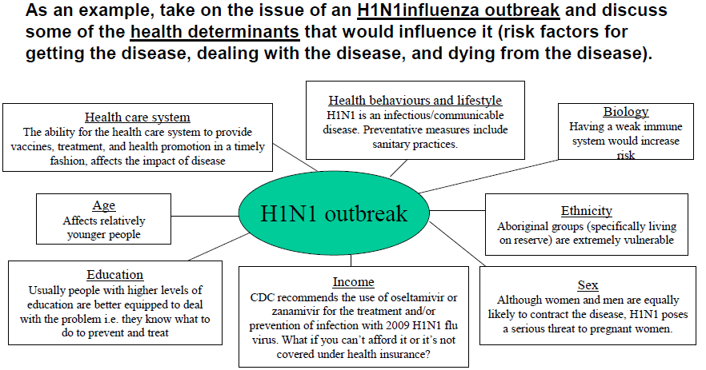
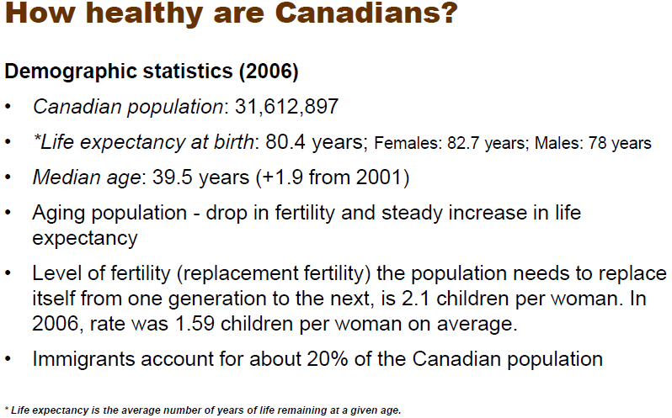
GRAPHS:
Graph | My Interpretation
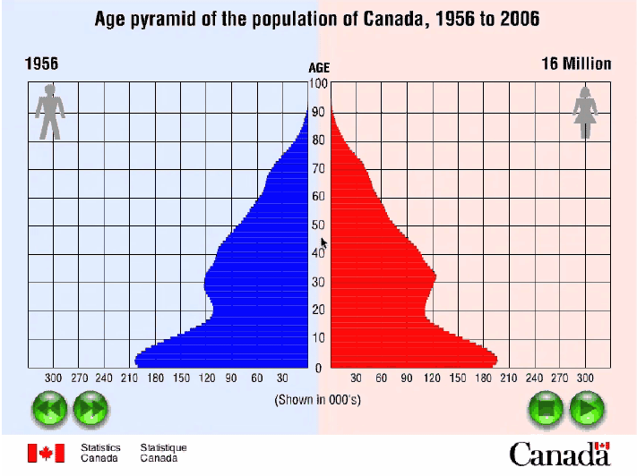
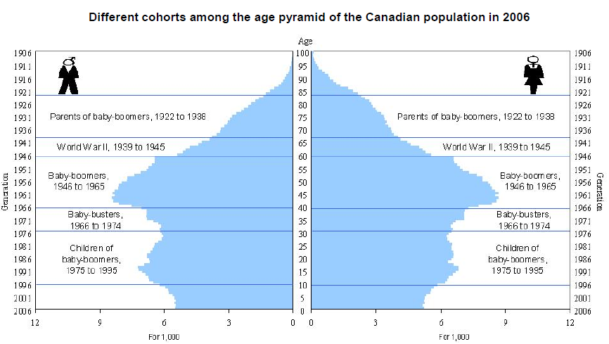 | This figure shows the age pyramid of the Canadian population in 2006. On it is represented six large cohorts: the parents of the baby-boomers, born between 1922 and 1938, the Second world war cohort, born between 1939 and 1945, the baby-boom cohort, born between 1946 and 1964, the baby-bust cohort, born between 1966 and 1974 and the children of the baby-boom cohort, born between 1975 and 1995.
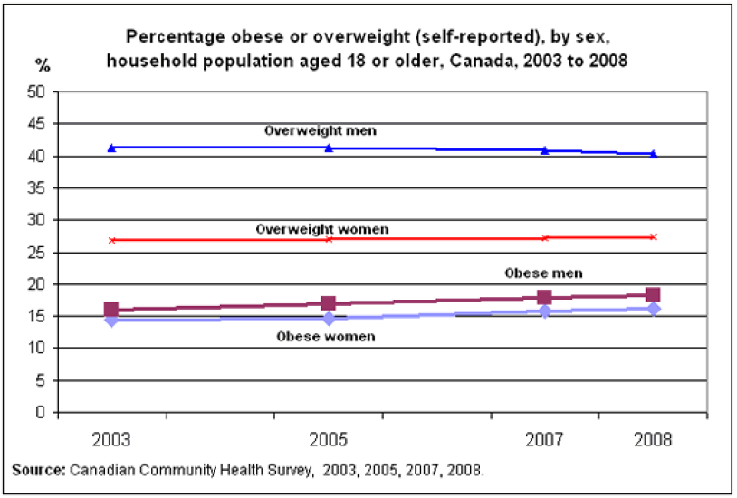
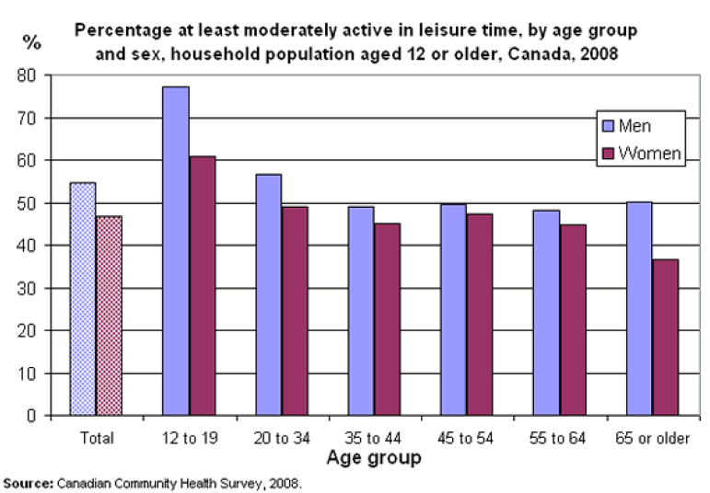
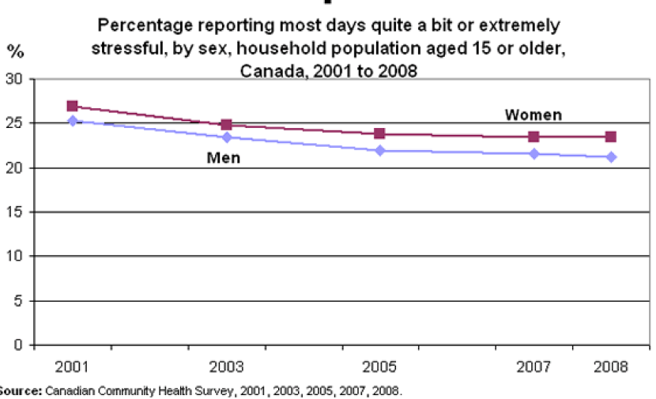
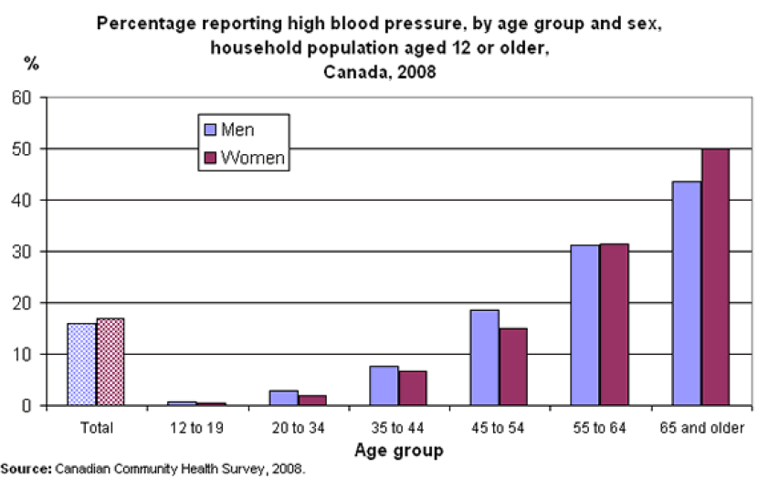
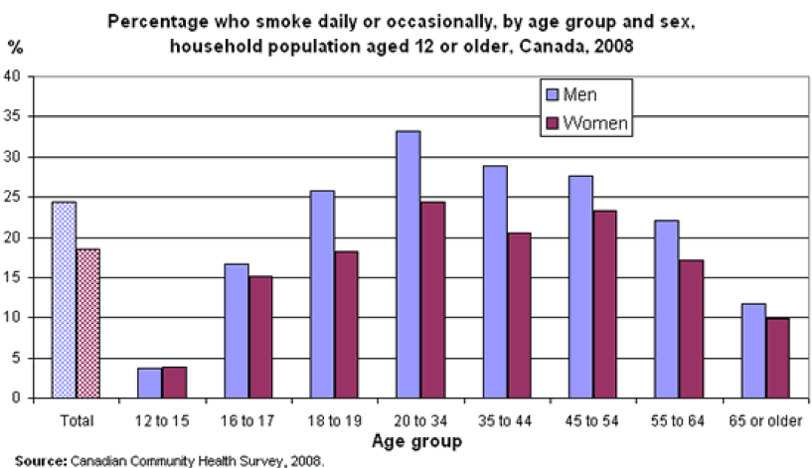
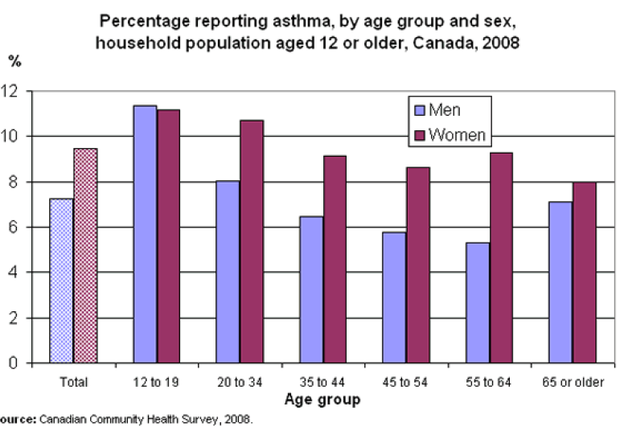
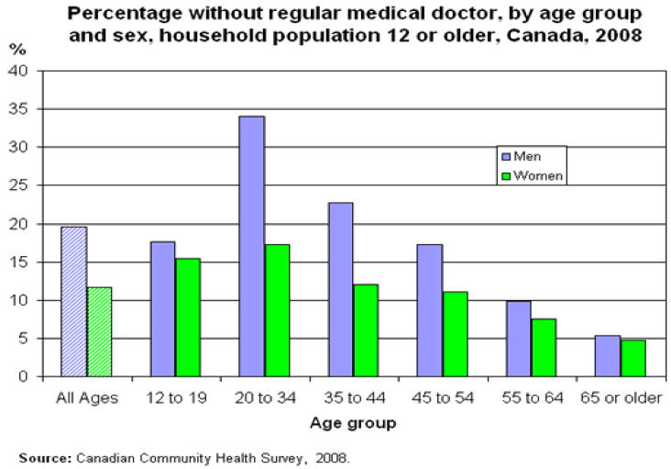
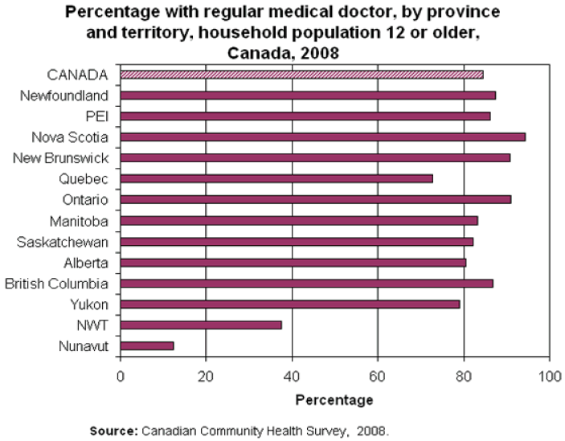
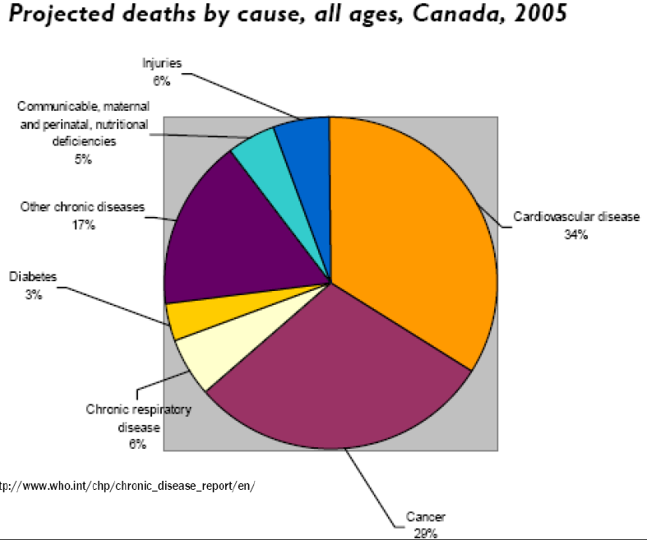

In the News:
Canadians smoking less than ever, survey finds (Globe and Mail)
- A new study reports a smaller percentage of Canadians than ever is smoking tobacco.
- Statistics Canada says the smoking rate dropped to 17 per cent in 2010, down from 25 per cent when the Canadian Tobacco Use Monitoring Survey was first conducted in 1999.
- The survey suggests smoking rates have significantly declined among teens aged 15 to 17, where usage fell to nine per cent, the group's lowest recorded rate.
- The government implemented measures to curb tobacco marketing aimed at youth in 2010, specifically in response to an increase in small-cigar smoking.
- The survey suggests the number of youth aged 15 to 19 who reported smoking little cigars in the 30 days prior to being surveyed was six per cent, down from eight per cent in 2009.
150 half-siblings? Sperm donation creates superfamilies (Globe and Mail)
- A piece in The New York Times examines the growing trend of half-siblings across the United States as sperm banks dole out copious amounts of samples from the same, popular donors.
- Not only does this cause concerns for scientists – who worry about a shrinking gene pool and the possibility of unnatural propagation of rare genetic disorders – but also for parents who suddenly realize that their family has grown exponentially.
- One unforeseen consequence is that accidental incest is a real possibility. One mother has informed her daughter of her donor’s number in case the girl ever decides to become intimate with another sperm-donor child.
- Critics see this as one of many reasons why sperm banks need to be regulated legally. (In Canada there is some regulation, including a national registry of personal health information, but no legislation saying how many children one donor can sire.)
- These elaborate extended family networks are being discovered courtesy of the Internet, as more and more mothers head to sites such as the Donor Sibling Registry. After the shock wears off, these sites can have a positive impact. One group of five families met with their half-related children for an event that was “like a family gathering with people you've never met.”
- As The New York Times article revealed, some of these men are equally shocked when they find out their biological offspring tally is in the dozens.
- Do you think governments limit how many samples from one donor a sperm bank can sell?
READING: Understanding Population Health Terminology

