Time value of money
- The dollar one year from today is worth less than the dollar today, because of
- Risk: a dollar today is certain, whereas a dollar later may not materialize due to reduction
- Real interest: interest before we consider inflation
- Inflation: it is worth more today because inflation reduces buying power
- Concept important to leases, mortgages, bonds, retirement contributions, stock valuation, etc.
- Compounding interest means you calculate the interest not just on the dollar amount (base) but also on any other interest accumulated

Single Amount – Future Value (FV)
${FV}_{singleamount }=PMT {(1+r)}^{n}$
- r = interest or discount rate
- PMT = amount of payment
- N = number of periods in years
Example: what will you have in 3 years if you deposit $100 into an account that earns 4% interest compounded annually?
- r = 0.04
- PMT = $100
- N = 1
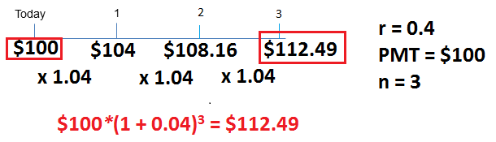

Example: how much money will you have in 5 years if you deposit $200 into an account that earns 3% compounded annually? ${FV}_{singleamount }=200 {(1+0.03)}^{5}=\$231.85$

Single Amount – Present Value (PV)
${PV}_{singleamount}=\frac{PMT}{{(1+r)}^{n}}$

Example: how much do you have to deposit today to have $100 in a year (assume 4% interest compounded annually?) What’s the PV of $100 to be received in 1 year (assume 4% discount 1rate)
${PV}_{singleamount}=\frac{100}{1+0.04}$ = $96.15

Example: how much money do you have to deposit today to have $100 after 3 years (assuming 4% interest compounded annually)?
${PV}_{singleamount}=\frac{100}{{(1+0.04)}^{3}}=\$88.90$

Example: how much do you have to deposit today to have $3000 four years from now (assuming a 5% discount rate)?
${PV}_{singleamount}=\frac{3000}{{(1+0.05)}^{4}}$ = $2468.11

Multiple Amounts – Future Value (FV)
- Annuity: multiple payments of the same value, equally apart from each other in time
${FV}_{ordinaryannuity}=PMT \left[ \frac{{\left(1+r\right)}^{n}-1}{r}\right]$ used when you deposit starting at the end of this year

${FV}_{annuitydue}=PMT \left[ \frac{{\left(1+r\right)}^{n}-1}{r}\right](1+r)$ used when you deposit starting today, time zero

Example: What will you have after 3 years if you deposit $100 each year for 3 years (beginning at the end of this year) into an account that earns 4% interest compounded annually?
${FV}_{ordinaryannuity}=100 \left[ \frac{{\left(1+0.04\right)}^{3}-1}{0.04}\right]$
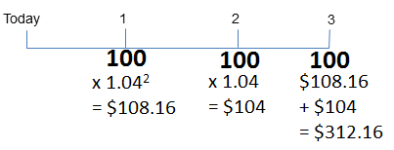
= $312.16

Example: what will you have after 3 years if you deposit $100 each year for 3 years (starting today) into an account today that earns 4% interest compounded annually?
${FV}_{annuitydue}=100 \left[ \frac{{\left(1+0.04\right)}^{3}-1}{0.04}\right]\left(1+0.04\right)$
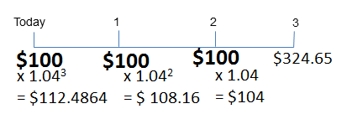
= $324.65

Example: how much must we put into an account each year earning 4% if we want to have $20 000 at the end of 10 years?
${FV}_{ordinaryannuity}=PMT \left[ \frac{{\left(1+r\right)}^{n}-1}{r}\right]$ $PMT= \frac{{FV}_{ordinaryannuity}}{\left[ \frac{{\left(1+r\right)}^{n}-1}{r}\right]}$
$PMT= \frac{20000}{\left[ \frac{{\left(1+0.04\right)}^{10}-1}{0.04}\right]}=1665.82$
- If question doesn’t mention if the deposit is today, assume it is in the future and use FV_{ordinaryannuity}

Multiple Amounts – Present Value (PV)
${PV}_{ordinaryannuity}=PMT \left[\frac{1}{r}- \frac{1}{{r\left(1+r\right)}^{n}}\right]$ use if starting at end of year
${PV}_{annuitydue}=PMT \left[\frac{1}{r}- \frac{1}{{r\left(1+r\right)}^{n}}\right](1+r)$ use if starting today
- One less period if you use annuity due than if you use ordinary annuity, during which your money accumulates interest before starting your withdrawals
Example: how big must your trust fund be today if you want to receive a payment of $500 each year for the next 3 years? Assume an interest/discount rate of 4%.
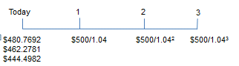

= $1387.55

Example: you borrowed $20 000 to fund your education. How big will you educational loan payment be if you want to have the loan paid off in 4 years, you make the first payment at the end of this year, and the discount rate is 3%?
${PV}_{ordinaryannuity}=PMT \left[\frac{1}{r}- \frac{1}{{r\left(1+r\right)}^{n}}\right]$

$20 000=PMT \left[\frac{1}{0.03}- \frac{1}{{0.03\left(1+0.03\right)}^{4}}\right]$
PMT = 5380.54

Example: how big must your trust fund be today if you want to receive a payment of $500 each year for the next 3 years starting today? Assume an interest/discount rate of 4%.
${PV}_{annuitydue}=500 \left[\frac{1}{0.04}- \frac{1}{{0.04\left(1+0.04\right)}^{3}}\right](1+0.04)$
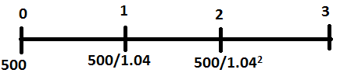
= $1443.05

Combinations example
Example: how much would you pay for an investment that will give you $1000 after 4 years and a payment of $50 a year as well? Assume 3% interest compounded annually.
${PV}_{ordinaryannuity}=PMT \left[\frac{1}{r}- \frac{1}{{r\left(1+r\right)}^{n}}\right]$ + ${PV}_{singleamount}=\frac{PMT}{{(1+r)}^{n}}$
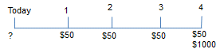
= $50 \left[\frac{1}{0.03}- \frac{1}{{0.03\left(1+0.03\right)}^{4}}\right]+ \frac{1000}{{(1+0.03)}^{4}}$
${PV}_{ordinaryannuity}$= 1074.34

Perpetuity
- Annuity that goes on forever (ex: dividend on a preferred share)
${PV}_{perpetuity}= \frac{PMT}{r}$

Example: what is the value of an investment in a 5% preferred with a par value of $12 if interest rates are 3%?
${PV}_{perpetuity}= \frac{0.05*12}{0.03}=\$20$

Payment and compounding periods
- Payment and interest periods are not always the same
- Always multiply “n” (number of years) by number of payments per year
- n must always represent the number of payments you give/receive over the time of the investment period
- Adjust compounding rate to match payment frequency (r must match n) this is your new “r”
- If payment and interest periods are the same, but more than once per year (or single payment but compounding more than once a year), divide r by the number of payments per year

Example: what is the present value of 4 years of $50 payments received every 6 months and compounded semi-annually at 3%?
- Payment = $50
- Years = 4
- Payments per year = 2
- n = 4*2 = 8
- r = 0.03/2 = 0.015
${PV}_{ordinaryannuity}=50 \left[\frac{1}{0.015}- \frac{1}{{0.015\left(1+0.015\right)}^{3}}\right]=145.61$

When interest and payment periods don’t match, you have to re-calculate a new r
- called effective monthly rate or effective annual rate depending on #payments a year
- if rate is stated as Annual Percentage rate (APR), just devide APR by the number of payments a year
$Effective Rate for Payment Period={(1+\frac{r_{nom}}{m})}^{mp}-1$
- r_{nom} = rate given
- m = # of compounding periods per year
- p = payment period measured in fractions of a year
Example: what is the FV of $100 received monthly for 3 years and compounding at 5% semi-annually?
- n = 3*12 = 36
$r={(1+\frac{0.05}{2})}^{2*\frac{1}{12}}-1$ = 0.0041
${FV}_{ordinaryannuity}=100 \left[ \frac{{\left(1+0.0041\right)}^{36}-1}{0.0041}\right]$

Example: what is the effective rate if you are calculating the PV of a 3 year annuity of $1000 compounded at 5% semi-annually?
$r={(1+\frac{0.05}{2})}^{2*1}-1$

Bond example
- remember: bonds pay coupons semi-annually and interest is compounded semi-annually

Example: what would you pay for a GM 9.5 of 2021, if the yield (prevailing rate) on similar risk bonds issued today is 10.5%?
- GM is the issuer of the bond
- significance of 2021 is the maturity date: return of face value, coupon payments stop
- 9.5% coupon rate = $95 a year over 10 years + $1000 in 10 years
- 10.5% is the discount rate to value this bond

- Draw a timeline
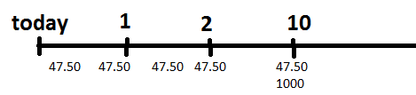
- What are we calculating?
Calculate PV of 10 years of semi-annual annuity payments of $47.50 + single payment of $1000 to be received in 10 years. The discount rate is 10.5% compounded semi-annually.
Price = PV_{singleamount} + PV_{ordinaryannuity}
Price = ${PV}_{singleamount}=\frac{PMT}{{(1+r)}^{n}}$ + ${PV}_{ordinaryannuity}=PMT \left[\frac{1}{r}- \frac{1}{{r\left(1+r\right)}^{n}}\right]$
- PMT of annuity = 95/2 bonds pay interest semi-annually
- PMT of single payment = $1000

- What is my r and n?
- Interest and payments happen at the same frequency (twice a year)
- r = 0.105/2 = 0.0525
- n = 10 * 2 = 20

- Plug numbers into formula
Price = $\frac{1000}{{(1+0.0525)}^{20}}$ + 47.5$\left[\frac{1}{0.0525}- \frac{1}{{0.0525\left(1+0.0525\right)}^{20}}\right]$
= 359.3833 + 579.61

Mortgage example
Calculate your mortgage payments if you buy a house for $300 000, make a down payment of $50 000, pay 6% interest compounded semi-annually, and make monthly payments
- Mortgages are calculated over 25 years, but we actually only sign for 5 years or less
- At the end of 5 years, we redo calculation on remaining balance for remainder of years
- When talking about loans, we’re usually trying to figure out what are those payments going to be that will give us the PV of the loan?
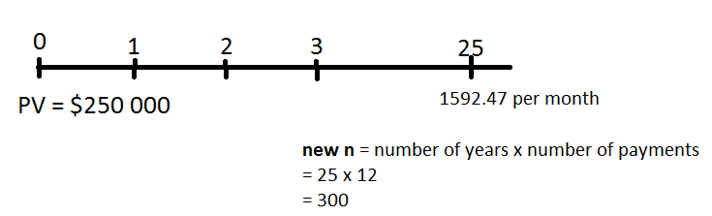
- Amount owing today = 300 000 – 50 000 = 250 000
- $Effective monthly Rate ={(1+\frac{0.06}{2})}^{2(\frac{1}{12})}-1$
r = 0.0049
- ${PV}_{ordinaryannuity}=250 000= PMT \left[\frac{1}{0.0049}- \frac{1}{{0.0049\left(1+0.0049\right)}^{300}}\right]$
= 1592.47

How much do you still owe when the mortgage is renewed at the end of 5 years?
N = 300 – (12 x 5) = 240
$${PV}_{ordinaryannuity}=1592.47\left[\frac{1}{0.0049}- \frac{1}{{0.0049\left(1+0.0049\right)}^{240}}\right]$$
= 224 441.56

Principal repaid =250 000 – 224 441.56 = 25558.44 (owing – what is still owing)
Interest paid = 1592.47 x 5 x 12 – 25558.44 = 69 989.76 (total payments – principal)

Draw a time line with points 0, 5, 10, 25 (put dotted lines on line between numbers)
Point out that our mortgage payment calculation assumed repayment over 25 years
Put payments on top of each point ($1592.47)

Lease example
Leased a $25 000 car at 4% APR with $2000 down payment and residual of $7000. What are the monthly lease payments?
- a lease is a loan, and starts immediately (thus use annuity due) and usually lasts 4 years
- residual = 1 lump sum payment at the end of the year (single payment) not the same value today as it is in n years, and since the loan is in today’s dollars, take account of lump sum in today’s dollars as well
- PV = 23 000, interest 4% APR
- There are a series of monthly equal payments over 4 years (PV annuity due)
- R = APR/12 = 0.04/12 = 0.0033
- N = 4 years x 12 payments per year = 48
PV_{lease} = PV_{singleamount} + PV_{annuitydue}

Summary
- Draw timeline and note other variables
- Figure out which formula(s) to use
- Are you calculating PV or FV?
- Hint: Look for the question mark or where your final total falls on your time line!
- Is it an annuity, a single payment, or both?
- Hint: Count the number of payments on your time line!
- Calculate the “r” and “n” you will use
- Calculate “r” to match payment frequency (# of payments per year)
- Multiply “n” by number of payments per year
- Plug new “r” and “n” into formulas

Remember
- Show formula and calculation steps
- Take number to 4 decimals while calculating
- Round final answer to nearest penny

