Chapter 4 – Social Environment
Ethics
- Individual ethics: ethics are based on individual beliefs and social concepts regarding what is right and wrong or good and bad vary; we are influenced by peers and as experiences shape our lives
- Managerial ethics: standards of behaviour that guide individual managers in their work
- Behaviour toward employees: hiring and firing, wages, working conditions, privacy and respect
- Behaviour toward organization: conflict of interest (when an activity benefits an individual at the expense of the employer), confidentiality and honesty
- Behaviour toward other economic agents: relationship with customers, competitors, stockholders, suppliers, dealers and unions. In dealing with such agents, there is ethical ambiguity in every activity advertising, financial disclosure, bargaining and negotiation, etc.

Assessing ethical behaviour
- Gather relevant factual information
- Analyze situation: determine the most appropriate moral values
- 1- Utilitarian approach: generates the most good for most people
- 2- Rights approach: don’t violate basic/legal rights
- 3- Fairness/justice approach: equitable distribution of burdens and awards
- 4- Caring approach: consistent with people’s responsibilities to each other
- If no on all 4 criteria, the act/policy is unethical
- If yes on 2-3 criteria:
- Is there any reason for overriding 1-2 of the ethical norms?
- Is one ethical norm more important than the others?
- Is there any reason why one may have been forced into committing an act/following a policy?
- make judgment: based on the rightness or wrongness of the proposed activity or policy

Managing ethics in organizations
- organizations try to promote ethical behaviour, but the unethical and illegal activities of both managers and employees have motivated many firms to take additional steps to encourage ethical behaviour establish codes of conduct and develop clear ethical positions on how the firm and its employees will conduct their business
- hiring criteria, managerial role modeling, mission statement, code of conduct ethics booklets and training, goals and evaluation criteria, rewards systems, employee protection mechanisms

Stakeholders
- people who have an interest in the actions of an organization and who have the ability to influence it, or are significantly affected by the organization’s activities
- Stakeholders’ importance depends on situation and the issue
- affect willingness and opportunity to act may have conflating expectations

Business-Stakeholder connection
- stakeholders provide business with the capacity to operate
- owners and creditors: capital
- customers: purchases
- employees: human resources
- BOD: leadership
- Natural environment: natural resources
- Stakeholders have the expectations of the business
- Owners and creditors: rules of investment
- Customers: quality, choice, communication, safety, respect
- Employees: fair pay, meaningful work, safety, fair treatment, training
- Board of directors: responsible management
- Natural environment: responsible stewardship

Strategic importance of stakeholder
- When importance is high, use strategic partnering in Savage et al+ Table 2 of Harrison & St. John
- Have customers/suppliers work with you to come up with new products more likely to be successful if customers find it exciting and agree if it works
- Suppliers can offer other materials/components that can benefit your products
- Partner with the government
- Cannot partner with activist groups as it reduces their legitimacy work with them to understand
- Competitors: benefit from working with them
- Community and unions: some companies even have unions join on the board of directors. Some even use profit sharing to bring in employees and unions. Unions get an incentive to be paid when the company benefits and thus they behave.
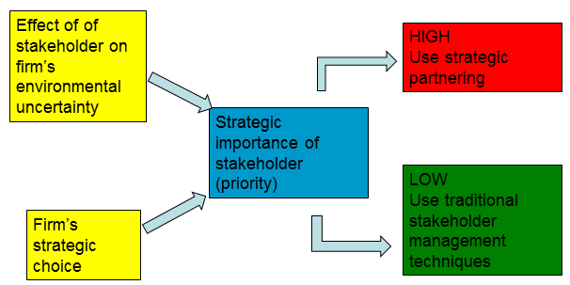

Why manage stakeholders?
- Cope with environmental turbulence and uncertainty
- To keep pace with societal change in which stakeholders want a voice
- To avoid adverse actions by stakeholders
- To improve ability to predict/control the external environment
- To improve the percentage of successful new product/service introductions
- To promote higher levels of operating efficiency and organizational flexibility
- To promote more favorable legislation/regulation
- To promote higher entry barriers leading to more favourable competitive environment
- To promote higher levels of trust more likely to negotiate efficiently with trust
- To potentially improve profitability
- To align company values with societal values (moral and philosophical basis)
- To increase media power everybody likes a story

Savage et al’s approach to managing stakeholders
- Identify key organizational stakeholders. Importance of stakeholder varies by issue. manage the most important stakeholders because there is only so much time available
- Stakeholders that depend on your organization are more likely to cooperate
- Diagnose them along 2 critical dimensions of potential for threat and potential for cooperation
- Threatening = increase uncertainty. Determined by relative power, capacity and willingness to act.
- Cooperative = decrease uncertainty. Determined by dependence on organization and capacity to expand interdependence.
- Formulate appropriate strategies both to enhance or change current relationships with those key stakeholders and to improve the organization’s overall situation effectively implement strategy
 | High potential for threat | Low potential for threat
High potential cooperation | Mixed blessing (Government)  Strategy: collaborate to prevent them from becoming non-supportive | Supportive (customer, investor)  Strategy: involve, let them give you their ideas
Low potential cooperation | Non-supportive ( Activist Groups)  Strategy: defend against high threat, always challenging | Marginal (Society)  Strategy: monitor what they think of you

Social Responsibility Areas of social responsibility
- Corporate social responsibility (CSR) refers to the way in which a business tries to balance its commitments to organizational stakeholders how business addresses ethical conduct at the organizational level “collective code”
- Managerial capitalism: a company’s only social responsibility is to make money for its shareholders, as long as it doesn’t break any laws in doing so focus only on profits
- Opposing view is that companies must be responsible to many stakeholders

Towards the natural environment
- air pollution, land pollution
- results when a combination of factors lowers air quality large amounts of chemicals
- government regulations and social pressures increased leading to “corporate greening” measures

The sustainability challenge (Dr. David Bell)
- States that we have to learn to live differently
- 2 billion to 9 billion is the predicted population increase in 2050
- Dominant paradigm: take from the environment, make stuff, waste it
- Model of the 1st industrial revolution is not sustainable want sustainability not waste
- 99% of goods produced in U.S. are in waste stream in 6 months
- Need “closed loop, cradle to cradle” approach
- Business may be the primary cause of the problem, but it’s likely to be the solution

History of business & sustainability
- 1994, J. Elkington extended concept of “sustainable development” to “Triple Bottom Line”
- Equity, environment, economy equity = how fair we are in terms of how we impact people.
- people, planet, and profit
- 2000: K. Annan initiated United Nations Global Compact it is a policy initiative for businesses. It has 10 universally accepted principals covering 4 areas: human rights, labor, environment, and anti-corruption. This compact has 130 countries, and 52 companies.
- 2006: executives agreed that there are numerous financial justifications for businesses to solve social environmental challenges. 10% believed you should only focus on profit.
- 2009: Accenture and the World Business Council for Sustainable Development reported that 3 major waves of concern that impact business with respect to environmental and social issues
- Regulatory pressures become more responsible
- Market demands as a market we care where/how our organizations produce but only 26% of people think about what we buy
- Global integration

Sustainable Value Creation – Stuart Hart
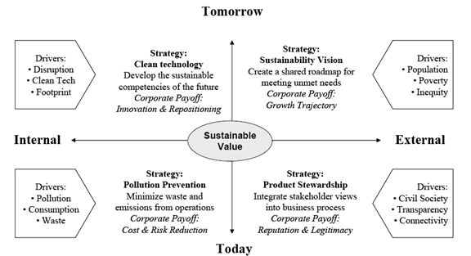

- When we develop strategies, social responsibilities, we must think of today and tomorrow, external and internal environment
- Transparency: we can see how they are doing business companies cannot hide anything
- Connectivity: we are more connected
- Pollution Prevention: less waste means lower costs, and nobody likes pollution
- Clean technology: ways to reduce pollution, ways to manufacture that are clean
- Repositioning is good if you are at the front

Towards society
- human development, poverty eradication
- innovative business models and disruptive technologies can alleviate poverty, in order to diffuse the issues of social decay, political chaos, terrorism, and further environmental degradation
- social business must be self-sustaining generate revenues and recycle them to grow profits are used to grow social business and social value, not the business itself
- opportunity of social entrepreneurship:
- business model that leverages entrepreneurial skills to general innovative responses to societal issues (students offering support SOS, microfinance)
- must create social value, and be unique and self-sustaining

Towards customers
- responsibility to customers affects profits, avoids regulation and establishes/protects reputation
- consumerism: movement dedicated to protecting consumer rights in dealings with business
- right to safe products: Tylenol scare although it was out of control, better seals are safer
- the right to be informed: if your product is faulty, consumers should know
- the right to be heard: listen to customers, or they will go to the media
- the right to choose what they buy
- the right to be educated about purchases: benefits and dangers, make informed decision
- the right to courteous service
- unfair pricing: interfering with competition can mean illegal pricing practices
- collusion among companies (including getting together to “fix” prices) is against the law
- price gouging: responding to increased demand with steep price increases shortage
- ethics in advertising
- truth in-advertising: misleading advertisements
- advertising of counterfeit brands
- stealth (undercover) advertising: variation of viral marketing that involves companies paying individuals to extol the virtues of their products to other individuals who are not aware that they are listening to a paid spokesperson for the company
- morally objectionable advertising: examples include models in skimpy underwear, or junk food commercials on children’s programs (they lack judgment to make good decisions)

Towards employees
- Responsibility to employees will make them want to work for you, gives you a good reputation, reduces costs (happy employees like to stay and work harder) and increases productivity.
- responsible hiring and promotion no discrimination, and if you don’t promote, they’ll leave
- safety physically and emotionally employees trust you more
- respect of privacy controversy in areas like drug testing and computer monitoring
- Opportunities for advancement equal for different genders, races, etc.
- Whistleblowers: employee who discovers and tries to end a company’s unethical action by publication should be able to report the problem, and expect managers to stop the act

Towards investors
- Corporate responsibility has 2 extremes
- Responsibility for all + investors
- Responsibility for investors only
- It’s been 10 years since the collapse of Enron Corp
- Agency problem: business often begins with 1 owner/manager. As the business grows, the owner must hire other managers to manage the firm on his/her behalf.
- As the owner, your primary objective is to watch the business grow and increase profits. As a manager, you may make safer decisions than the owners because you want to keep your job. Management and ownership incentives and decisions are very different.
- Owners become shareholders, and have a large company with many managers. Investors don’t have the time or knowledge to be involved in the decisions
- In corporations, we elect a board of directors to represent our interests, who supervise management to ensure that they are making decisions that invest interest of shareholders.
- But most shareholders do not exercise their right to vote. They sign a proxy over to management the management is choosing the board of directors (unwise)
- Managers are going to choose a board that they like board will not really reflect the interests of the shareholders, but more of the managers.
- New regulations for boards, and new expectations from investors.

- Trends:
- More independence: only 5% of the board members can be connected to the firm
- New practices: training to make the right decisions
- New disclosure rules: against insider trading. They must disclose when they are going to buy/sell that company’s stock it is a heads up
- Different attitude: directors and investors do jail-time due to decisions that investors would not have approved of
- Canadian Coalition for Good Governance is the development of a body to ensure that investors are not taken advantage of
- If you lose reputation with investors, they won’t buy your equity
- management changeover is not difficult, but can drive down the price of the company’s stock

Approaches to Social Responsibility
- Obstructionist stance: do as little as possible to solve problems when they cross the ethical/legal line that separates acceptable from unacceptable practices, their response is to deny
- Defensive stance: do everything required legally; bad choices are dealt with legally
- Accommodative stance: meets legal and ethical requirements but also go further in certain cases but must be asked to do these things; they do not do it voluntarily
- Proactive stance: take to heart the arguments in favor of CSR proactively seek opportunities to contribute. The most common and direct way to implement this stance is by setting up a foundation to provide direct financial support for various social programs.

Implementation requirements
- Commitment of top executives: lead by example, they set the tone and make the choices
- Planning by committee of managers: what are we going to do and how?
- Implementation: have employees representing different areas of organization to get involved
- follow up social audit at regular intervals to check if money spent actually achieved intentions
- triple bottom line reporting: measuring the social, environmental, and economic performance

Impact of Demographics
- Based on David Foot’s book “Boom, Bust, and Echo”
- Demography is the study of human populations or people’s vital characteristics. It is important because the basis for any market is people, it’s a powerful predictor of human behaviour, and it provides certainty & simplicity of age data (we do many things in certain points in our lives)
- You can be more successful if you understand the market better
- What are the key factors to know to predict consumer behaviour?
- Number of people in each age group
- Activity participation rate: the rate, or the % of the people, who engage in a particular activity
- Factors affecting the size of cohorts
- Fertility rate average number of children/women
- Birth rate total number of births over size of population
- Describe cohorts in Canada, categorize as big/small& discuss general advantage + disadvantages. Give examples of strategic business opportunities/threats that arise from demographics
- What are the opportunities and threats for Canadian businesses? Companies should strategically pursue business opportunities that meet present+ future demand from large demographic cohorts.

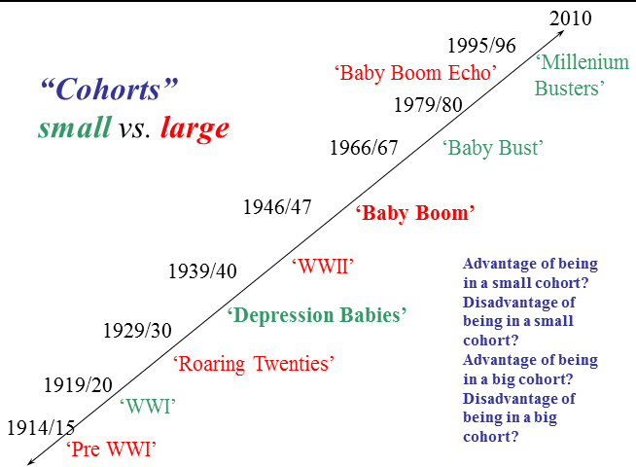

Small cohort vs. Big cohort
- Small: competition is smaller, but there are not many of you from the government perspective as voters and business perspective as consumers, you do not have a large voice
- Large: government/businesses pay attention to large cohorts more votes, customers, opinions
- But larger competition, more intense
- Graduate university harder to find jobs, get promotions
- Pre 1914/15: large cohort
- Traditionally people had many children (high birth rates)
- High levels of immigration
- But presently most of them are not around anymore
- 1916-20 WW1: smaller cohort
- Men go off to WWI
- Birth rates lower
- 1920-30 Roaring 20s: large cohort
- Men came home higher birth rates
- Economic boom from the wars
- dealt with the depression
- 1930-40 Depression babies: small cohort
- Economic depression poor conditions
- Families suffering, less children and lower birth rate
- Live through WWII, grow up and became adults small cohort don’t need to compete much so they moved up the economic scale and post WWII economic boom
- Also, post WWII, the economy was very strong, so the depression babies who were born in a bad time were in the right place at the right time for the rest of their lives.
- 1940-47 WWII Babies: large cohort
- Larger than roaring 20s and WWI
- Less men lost than WWI
- As WWII ended, higher economic boom
- 1950-67 Baby boom: large cohort
- Depression babies having lots of children
- Large competition
- Baby boomers born in late 40s/early 50s are at the front of the cohort and better off
- Economic boom + small cohort of depression babies = more children
- 1970-80 Baby bust: small cohort
- More women entered workforce
- Birth control became widely accepted and used
- 1980s-1995 baby boom echo: large cohort
- Children of the baby boomers babies of a larger cohort
- Tall end of the baby boom echo (us) are worse off than others
- Late 1990s, 2010+ Millennium busters

The Boomer Effect
- 2011: year the first baby boomer cohort reaches age 65
- 2015: estimated year when seniors (65+) will outnumber children (<16)
- 13% of population that were 65+ in 2005
- 25-30% of population that will be seniors in 2056
- 50% of population that will be 47+ in 2056

Video statistician
- In 1810, life expectancy was 40, everyone was sick and poor. UK Netherlands were better off, but not by much.
- Industrial revolution caused a difference by the WWI, and Spanish flu epidemic. USA was moving up by 1900
- Japan and others tried to follow, but most stayed poor and sick.
- USA was at the front, Japan was in the middle with Brazil and Iran. All the Asian countries were in the sick and poor (1950s)
- Then by 1970s, Asians caught up with the others, and by 2011, most lived in the middle. The worst were Congo. Shanghai was way up at the front while the rest of China was in the middle.

