Psychomotor Behavior Lab Midterm Notes

Lecture 1- Hick’s Law

Information Processing
- Composed of stimulus identification, response selection and response execution
- Hick’s law focuses on response selection (especially in choice RT)

History
- Nevil Maskelyne was one of the first to consider temporal measure, by looking through telescope and recording the time it took for star to pass through the center
- Time was off by almost a second
- Bessel studied differences between himself and others, and observed a consistency in the difference in the RT of two astronomers
- He introduced the concept of the ‘personal equation’ in an attempt to correct for the constant errors of observers, which lead to the general realization that perceptual and cognitive processes took a quantifiable time
- We do not all process information at the same time or speed: Individuals are different and have different cognitive processes that take time
- Hermann Helmholtz was interested in how long it takes to transmit information through the body
- He stimulated the nervous system of a frog and looked at muscle reaction
- He knew that neurons attached to muscle and devised a system to record muscle activity (EMG), he stimulated the neuron and recorded time to muscle movement
- By stimulating different areas of the neuron, he could find velocity of nerve impulse (v=d/t)

Donder’s Subtractive Method
- Thought about the difference in a simple (1S, 1R) test and a choice (2S, 2R) test, and how it concerned a decision in a choice and an action of the will in response to that action
- The big assumption for Donder’s method is that the processes occur one after the other and do not overlap, but recent research has shown there to be more of a continuum
- For choice RT and go/no-go RT you must identify the appropriate response
- It was assumed that inserting an additional requirement into an RT paradigm would not affect the other components, and the no-go response does not have to be preprogrammed
- The problem with this is that recent research has shown that in the go/no-go RT test, not having a response is also a choice, therefore it is actually 2S, 2R as well
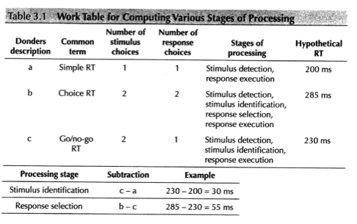
Information Processing Model
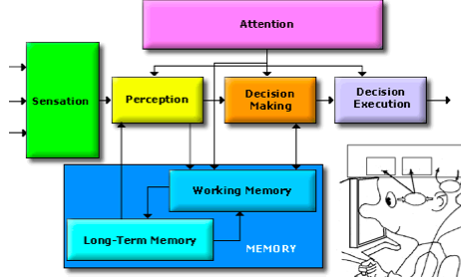
- In order to initiate a response, need to go through different stages (perception, decision making, decision execution)
- Factors can affect how quickly these processes occur (i.e. RT faster if you are paying attention)
- Working & LT memory can become better with practice & can influence RT
- The basic tenets of information processing are that:
  - Mental operations occur between reception of stimulus and production of response, cognitive operations process information, processing is time consuming, stimulus characteristics, complexity of decision-making, complexity of response will all affect processing
  - By measuring time, we have an idea of how long these mental operations take & should be able to make assumptions/conclusions about how long processes take

3-stage Model
- For simplicity we break it down into three easy stages: stimulus identification, response selection, response programming
- Stimulus identification: receives information from senses, identifies and classifies information, extracts relevant information (brain cannot focus on every piece of information coming in, therefore need to focus on what is relevant)
- Response selection: decide on a plan of action, translate between stimulus and response
- Response programming: organize and prepare a response, send appropriate motor commands

Mental Chronometry
- States RT is the interval between the presentation of a stimulus to the initiation of a response, and the index of time for information processing
- The louder/brighter the stimulus, the faster the response (tactile>auditory>visual)
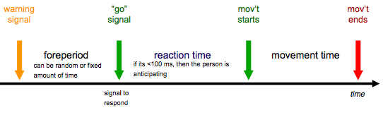
RT and Electromyography
- Looking at activation of surface electrodes and the time it takes, which gets characteristics of muscle contraction
- Measures surface electrical potentials from muscles
- EMG: spatial and temporal summation of many motor unit action potentials
- Premotor time: represents central processing time- information processing involved in preparation
- Motor time: represents muscular processes- initial contractile activity required to overcome inertia
  - See activity in muscle before response b/c we need to overcome inertia
- EX: When debating RT of a finger vs. leg muscle, there should be no difference seen in premotor time, the difference will be seen in motor time (i.e. bigger muscle needs more neurons to activate)
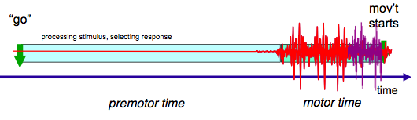
Factors Influencing RT
- Age: RT decreases through childhood before beginning to increase (slowly up to 50-60 years, rapidly around 70+ years), it also becomes more variable with age (less attention- use it for balance, decreased nerve conduction velocity)
- Sex: males are typically faster, but females tend to be more accurate
- Hand used: the left hemisphere is the verbal and logical brain, and the right hemisphere controls creativity, spatial relations, the recognition of faces and emotions, right hemisphere controls the left side of the body
  - Some research has shown dominant hand faster, but some has shown differently
- Fatigue: greater fatigue increases RT, can also have distraction, stimulant (such as caffeine) and arousal
  - There is a midpoint of optimal arousal, which is where you want to be for optimal RT
- Intelligence: RT is correlated with intelligence in the sense that people that have a higher IQ, tend to have a fast RT
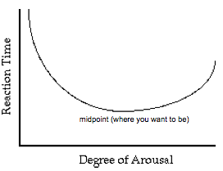
Factors Influencing Stimulus Identification
- Stimulus detection
  - Stimulus clarity: target in central is more clear than peripheral vision, which takes longer to detect
  - Stimulus intensity: more intense the stimulus, faster the RT
  - Stimulus modality: visual (190 ms), tactile (150 ms), auditory (160 ms), longer pathway for visual
- Pattern Detection: when the stimulus is meaningful and a pattern can be recognized, then RT decreases (i.e. expert chess players were better at reconstructing a chess board when the pieces were arranged meaningfully)
  - Anticipatory information pickup by expert athletes: expertise/familiarity can help you get information faster & you are more accurate at predicting what will happen
  - Quicker stimulus identification= faster RT

Choice RT
- An increase in RT is seen with an increase in alternatives
- RT doesn’t change by the same amount when you increase S-R alternatives by 1, but by 2
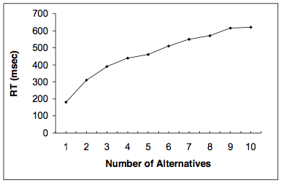
Hick’s Law
- RT increases proportionally every time the number of alternatives is doubled: represents how much info is being processed
- RT is related to the quantity of info processed (log₂(N), where N= # of S-R alternatives)
- Time required to make a response is linearly related to the amount of information that must be processed

Hick’s Law: Amount of Information
- Related to the amount of uncertainty that is reduced by a signal
  - Amount of information contained in a signal is measure in bits (binary digits)
  - One bit is the amount of information that you need to reduce the original uncertainty by ½
  - EX: on a 4x4 grid, how many questions would need to be asked to determine where X is (L or R, T or B, H or L), has 4 bits of info but 16 S-R alternatives (2⁴= 16)
- Doubling S-R alternatives is the same as increasing bits by 1

Hick’s Law Equation
- Because relationship between RT and S-R alternatives is linear, can get an equation to determine RT
- RT= a + b • log₂(N)
  - A= intercept, when log₂(N)= 0 (bits), which is during simple RT
  - B= slope, how much RT will increase each time alternatives is doubled or bits increase by 1
  - Log₂(N)= bits of information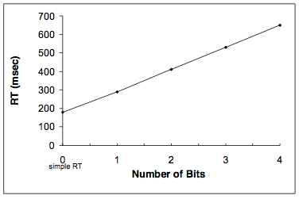
Exceptions to Hick’s Law
- Practice: with practice, Hick’s law is eliminated
- Modality of stimulus: do not see Hick’s law with tactile stimuli b/c tactile input has a direct S-R relationship
- Response required: do not see Hick’s law in eye movement tasks b/c eye movements tend to be fairly automatic

Lab 1
- Pushed button according to stimulus
- Proved Hick’s law that as S-R alternatives increase, so did RT

Lecture 2- S-R Compatibility

Information processing
- S-R compatibility takes place in the response selection phase of information processing
- Addresses types of compatibility, spatial compatibility, the Simon Effect and LRP

S-R Compatibility
- Degree of natural or learned correspondence between a stimulus and a response
- Idea that we have this experience of how to respond to different stimuli, some of it is learned, some of it innate (natural inclination to respond to a stimulus in a certain way)
- If the stimulus meets our expectations, we will react faster
- If S-R are compatible, we react faster, with fewer errors, and are less frustrated

Types of Compatibility
- Conceptual: deals with degree to which codes and symbols correspond to people’s conceptual associations (i.e. red with stopping, green with go)
- Movement: relationship between the movement of a control and corresponding display and response of system being controlled (i.e. turning a knob to turn up volume)
- Modality: deals with the degree of compatibility between certain S-R modalities (i.e. fastest response to audio stimulus, also faster when stimulus and response are of the same modality)
- Spatial: deals with the spatial arrangement of controls and displays, or stimuli and responses (most common experiments with spatial)

Design Lessons from the Stove
- Performance data shows benefits of spatial compatibility
- Preference data is not always the same as performance data- take preference data with a grain of salt
- Just because there is strong data, doesn’t mean it is used
  - Most manufacturers are not taking into account S-R compatibility when designing stove tops

Spatial Compatibility Effect
- States that RT is faster when spatial S-R are compatible (i.e. LS, LR)
- Sometimes the graph could be slanted, particularly some people are better with their right hand
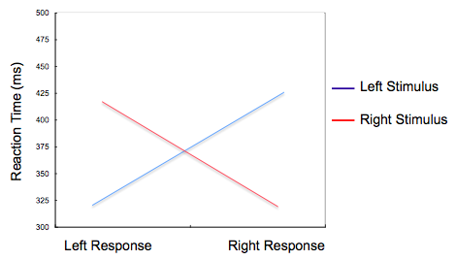
Inter-hemispheric Connections
- Left half of brain controls right body, and vice versa for right brain
- If LS, LR then right side of brain processes stimulus in left visual field, and executes response with left hand, so therefore faster
- If LS, RR then right side of brain will have to pass the response to left side, in order for the movement to be carried out with right hand

Crossed-hands Placement: Spatial Compatibility Effect
- Have LS, LR (with right hand) or RS, RR (with left hand)
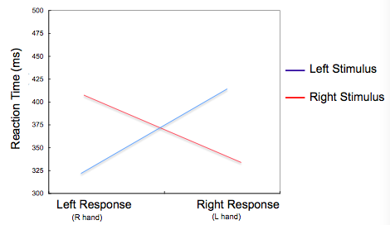

Relative Location Coding of the Response
- Tend to be more accurate with the same spatial code for stimulus ad response
- Faster with LS, LR even if RH is doing LR
- Anatomical wiring is not as effective as spatial orientation

S-R Compatibility
- Spatial layout of S-R array has an important influence on response selection
  - The relative spatial relationship (conceptual correspondence) between the location of the stimulus and the location of the response greatly impacts responses
- Compatibility effects are regarded as a:
  - Cognitive phenomena that reflect the mental codes used to translate between stimuli and response

Spatial Coding Hypothesis
- Present whenever implicit or explicit spatial relations exist
- Will be relatively independent of the manner of stimulus presentation and response execution
  - Compatible S-R mapping: if cognitive codes based on spatial features of stimulus and response sets are similar
  - Incompatible S-R mapping: if cognitive codes are incongruent

Simon Effect
- Have a choice RT test (2S, 2R)
- The irrelevant (spatial) feature of the stimulus influences response selection processes
- Tested response based on stimulus feature (i.e. shape), not location
- Have triangle (press R) and circle (press L), have to give same response regardless of where the stimulus is (i.e. left triangle, still press right)
- Spatial location is irrelevant, yet it still influences performance
- Unconsciously, subjects take into account where the stimulus is located
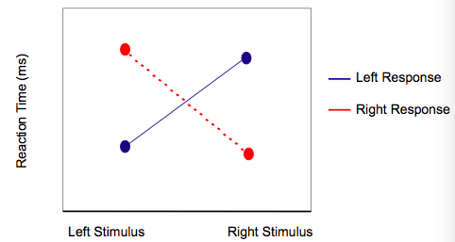

Spatial Coding & the Simon Effect: Dual process model of response selection
- Conditional Process: stimulus is translated and response is selected and activated intentionally
- Unconditional Process: stimulus onset primes the spatially corresponding response automatically
- Correspondence of responses activated via conditional and unconditional processes determines whether response competition occurs
- When we translate stimulus into response, there is conditional and unconditional processes
- Unconditional processes corresponds to spatial location of stimulus giving weight to location of response (done automatically)
- Conditional and unconditional responses may compete with one another, therefore when they agree RT is faster

Spatial Coding & the Simon Effect: Premotor Theory of Attention Orientation
- Stimulus identification requires visual attention (i.e. must orient visual attention towards stimulus)
- To orient visual attention: must prepare saccade to stimulus location, saccade preparation specifies spatial parameter (gives ride to spatial code for stimulus)
  - Saccade: eye movement has a spatial parameter, which may or may not compete with response that we want to give

General Points of Compatibility: S-R compatibility effects
- Can occur in a wide variety of perceptual-motor situations
- Is based on a conceptual correspondence (relative spatial relations) of S-R mappings, rather than physical correspondence
- Can occur regardless of whether stimulus location is relevant or irrelevant for determining the response
- Reflects processes associated with response selection and perceptual-motor translation

EEG
- Record activity of the brain
- Can record from different electrodes over time
- Look at C3 (left) and C4 (right) which are over central area of skull
- Underneath C3 and C4 are motor areas that program responses
- Subjects do many trials and the EEG looks noisy, which is why we use average of the trials to eliminate noise

Event-related Potential (ERP)
- Electrical potentials (voltage changes) recorded from the scalp
  - Are specifically time-locked to a sensory, motor, or cognitive process
  - Used to determine time-course (and location) of processes in the brain
  - Provide and electrophysiological window into brain function
- Masked in EEG by potentials due to other unrelated activity
- Average multiple instances of the EEG waveform before and after a specific event
- Averaging preserves the components time-locked to the event
- Interested in lateralized readiness potentials (LRP)

Movement-related Cortical Potential
- Slow shift in cortical potential preceding a voluntary movement
- Bilateral, slowly increasing negative wave
- Starts up to 1000 ms prior to movement
- Associated with preparation of movement
- Buildup of activity in C3 and C4 can be seen before reaction starts (up to a second before movement starts)
- See more activity in L brain, which makes sense b/c we are responding with R hand
- Readiness potential over contralateral hemisphere has greater amplitude

Lateralized Readiness Potential (LRP)
- Increase in activation in brain opposite the hand that is responding (contralateral motor pathways)
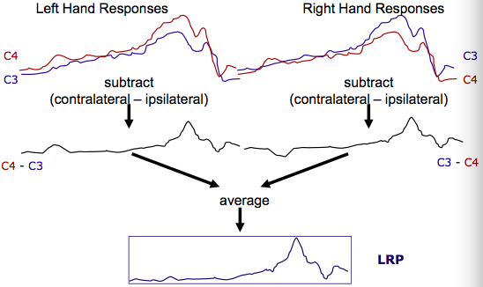
- Derived from asymmetric lateralization of readiness potential immediately preceding response
  - LRP onset an index of end of response selection
  - Can get an indication if we’re performing the correct or incorrect response
- LRP polarity indicates activation of correct/incorrect hand
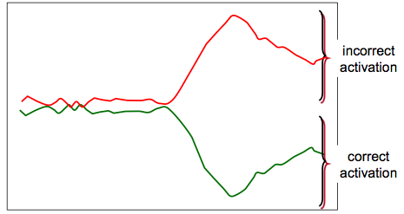

Fractionating Premotor RT with LRP
- Premotoric processes: occur between stimulus onset and LRP onset
  - Reflects early cognitive processing during RT (stimulus identification- response selection)
- Motoric processes: occur between LRP onset and EMG onset
  - Reflects final selective motor preparation (index of end of response selection)
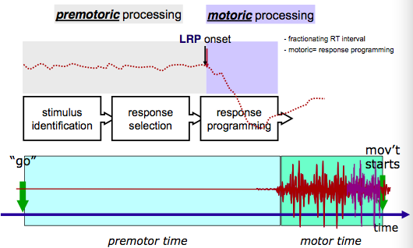

LRP & the Simon Effect
- Compatible stimulus: < & > arrows indicate left (<) and right (>) response
- Incompatible stimulus: > & < arrows indicate right (>) or left (<) response
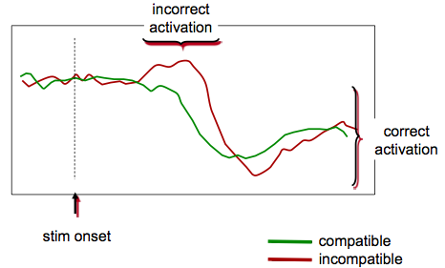

Lab 2
- Sat on computer and pressed buttons in four conditions
  - Normal hand & keyboard (compatible)
  - Crossed hand & normal keyboard (compatible)
  - Normal hand & flipped keyboard (incompatible)
  - Crossed hand & flipped keyboard (incompatible)
- Found that the more compatible the S-R, the faster the RT
- Anatomical positioning of the hands did not affect RT as strongly as spatial locations (i.e. normal keyboard was more successful)

Lecture 3- Fitt’s Law

Information Processing
- What is the relationship between the speed of a movement and the accuracy?
- Takes place during action execution

Goal-directed Limb Movements
- Woodworth showed that for continuous movements, variable error increased with both distance (amplitude) and the speed of the movement
  - Initial adjustment phase: initial part of trajectory, preprogrammed (open loop)
  - Current control phase: where corrections occur, utilize feedback given sufficient time (closed loop)
- Looked at how we control our movements
- People draw a line on a piece of paper, supposed to keep drawing as paper moved back & forth
- Variable error was studied, depending on how variable their movements were (i.e. always landing on the same spot VE= 0)
- At peak velocity, movement shifts from open to closed loop control (which is when corrections can happen)
- Some movements only have one phase of preprogrammed open-loop control, but will never have closed-loop component by itself

Speed-accuracy Relations
- Preprogrammed movements were studied with constrained MT paradigm
  - Required matching goal MT
  - Keeps target size constant
  - Measure effective target width (We)
  - Analyze variable error (SD)
- EX: need to hit a target in the assigned amount of time, take SD of the errors around that target, moving the target farther away, the effective target width will increase (more variability)

Preprogrammed Movements
- The faster you move, the more variability you’re going to have
- Increasing the velocity, you have a greater effective target width
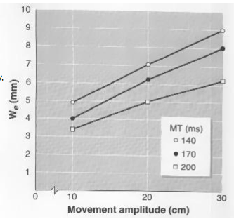
- Movements in general consist in only one phase, we pre-program the whole movement ahead of time without accounting for correcting errors
- We= a + b (A/MT)
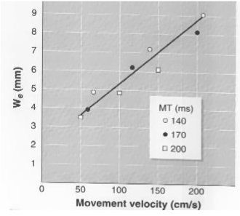

Speed-accuracy Trade-offs
- Linear trade-off: error is linearly related to the speed at which one is moving
- Feedback-based movements: studied with Fitt’s paradigm (constrained accuracy)
  - Requires optimization of movement time and accuracy
  - Manipulate the target distance and size
- Fitt’s task: examines the relation between MT, movement amplitude & target width
- Constrained error: can fall outside of the target on a maximum of 5% of the trials
- Amplitude and width of targets can be manipulated

Fitt’s Law
- Movement is considered more difficult if the targets are far apart, or if they have a small width
- Longer MT as the index of difficulty (ID) increases
- MT= a + b • log₂(2A/W)
- ID of 0= no amplitude (log₂(2A/W)= 0, 2⁰= 2A/W, 1= 2A/W, W= 2A)
- ID is measured in bits
- In general, there is a linear trend
- See similar linear relationship no matter what we are moving (arm, leg, finger, etc.)
- Describes logarithmic relation between MT and accuracy demands of movement
- Movements requiring greater accuracy: take longer to allow for processing of information and correcting movement if necessary
- Speed at which movement completed depends on target you’re moving to/degree of accuracy necessary
- The necessary time to reach a target is proportional to the distance between the starting point and the target, and inversely proportional to the size od the destination area
- The more demanding the movement, the more time required to make it correctly
- Even when the movement is being imagined, this relationship is still seen
- Can be applied to man-machine interface (i.e. apple has used this in the sense that they have some targets grow bigger as you approach them with the mouse)
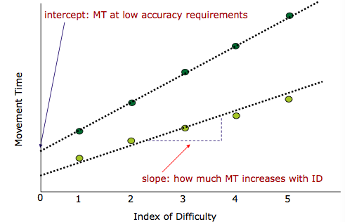

Index of Performance (IP)
- IP (bits/s)= ID/MT
- Measure of how well we can use a mouse, etc. in order to react with a target
- Can change based on expertise and practice
- Movements are usually composed of 2 phases, so we make corrections b/c we need to hit that target

Goal-directed Limb Movements
- Can see corrections in different trials of the movements
- Could be obvious (i.e. see them in displacement profile) or may not be evident until velocity or acceleration profile
- Whether the velocity or acceleration crosses 0 can show if the movement has been corrected
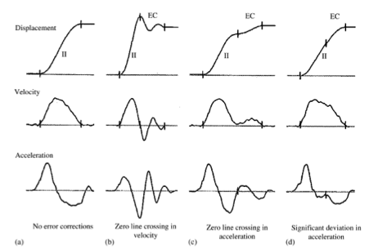

Speed-accuracy Trade-offs
- Fitt’s law: logarithmic relation, movements under open and closed-loop control
  - Changing target demands, see changes in MT
- Linear Trade-off: linear relation, preprogrammed movements under open-loop control
  - Changes in effective target width

Visual Motor Control
- Performance measures: terminal accuracy and variability measures, timing MT
  - End result of visual-motor processes
- Motion analysis: kinematic measures
  - Determine level at which visual feedback impacts upon performance
  - Look for when velocity & acceleration curves begin to differ
  - When the individual is correcting their movement
  - If the individuals are not provided with vision, there is no correction
  - Longer MT when vision is available

Visual Feedback Processing
- How quickly can one process and use visual feedback to guide movement?
- What is the duration of the visual processing delay?
  - If control of movement depends on visual feedback, then the time needed for visual feedback is a limiting factor on performance
- EX: reaching for an object and it moves, so how long it takes to adapt to that change in movement
- When do we begin to see a difference between movements with and w/o vision

Time to Process Visual Feedback
- How fast can visual feedback be processed during a reaching movement
  - Compare performance with and without visual feedback and under different movement durations
  - Compare conditions in which there is no benefit to have vision available
- If there is no difference in how well we perform, vision is not being used

Woodworth (1899)
- Studied targeting movements with eyes open and eyes closed
- Eyes closed has more error, but there is a point at which there is no difference between eyes open and eyes closed
- Only with eyes open and reduced speed were improvements seen
- Accuracy decreased with increasing movement speed (due to inability to visually control movements)
- Movement duration must be long enough to allow time for visual feedback to operate

Selective Exclusion of Feedback
- Carlton (1981) examined performance accuracy and kinematics of limb movements
- Movements began without visual feedback, and it become available during the movement
- Took 135-150 ms
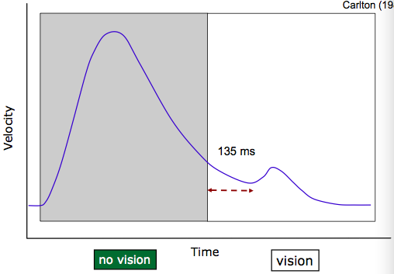

Visual Feedback Processing
- Whiting et al. (1970) examined visual feedback during catching
- Manipulated at what point in flight ball became available (in flight for 0.4 s)
- The more time you have with vision, the more your performance improves
- Between 0.3 and 0.4 s no changes are seen, therefore vision at the end of catching is not useful
- Can use visual information during a movement quicker than initiating a movement with vision

Distortion of Feedback
- Smith & Bowen (1980) provided visual feedback of hand via video
- Had subjects reach to target by moving mouse
- Delay condition was delay in mouse after the hand had already made the movement (i.e. had to overshoot the target to get the mouse there
- In all times with the delay, they overshoot the target
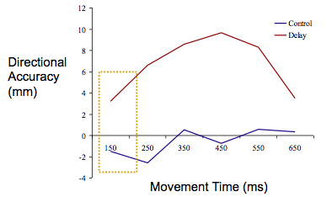

Reacting to Perturbations
- Paulington et al. (1991) examined reaching and grasping movements
- Targets were displaced at movement onset, timing of peak acceleration changed within 100 ms of target displacement
- In order to use visual feedback, have to let the subject move for over 100 ms

Lab 3
- Did tapping lab with stylus
- Displayed the positive linear relationship between MT and ID
- Demonstrated Fitt’s law
- As ID increase, MT increased as well

Lecture 4- Proprioception

Information Processing
- Proprioception & kinesthesia take place in the action execution stage of information processing

Considerations in Measurement
- Variable needs to be objective, reliable and valid
- Objective: two observers evaluating the same performance arrive (measure) the same or similar result, sensitive to changes in skill of the performer
  - Measuring the upper limit in performance
  - Providing information on performance or just outcome
  - Told what is independent & dependent variable
- Reliability: measurement is repeatable under similar conditions, try to reduce variability
  - Intra and inter-subject: attention, fatigue
  - Environment: try to make sure there is no additional distraction or attention shifts in lab
- Validity: test measures what we intend it to measure
  - Try to make it as similar to a game setting as possible
  - Performance needs to translate into game situation

Measuring Motor Behavior
- Describing the outcome of the movement
- Describing movement characteristics
- Movement kinematics
- Describing underlying neural correlates
- EEG (LRP)
- EEG gives some index of what is going on in the brain

Describing the outcome of Movement
- Quantify performance with respect to the target (i.e. hit target?)
  - Speed (RT & MT)
  - Accuracy: must be measured on aiming task

Accuracy
- Constant Error (CE): average error (BIAS), direction and amount of deviation (need to retain +/- sign), gives how close it was to target, but not consistency
  - CE= ∑(x_{i}-T)/n
  - Take each score, minus the target (T), sum them and divide my # of trials (n)
  - Has magnitude & direction
- Variable Error (VE): variability of performance around the mean (inconsistency)
  - VE= √(∑(x_{i}-M)²/n)
  - Each score minus the mean (M), squared, summed and divided by # of trials (n), then square rooted
- VE more sensitive to effects of practice compared to CE
- CE changes quickly over first few motor learning trials
- Overall Error (E): total variability around a target for a set of movements (consistency around a target)
  - E²= CE² + VE²
  - E= √(∑(x_{i}-T)²/n)
- Absolute Error (AE): measure of overall accuracy in performance
  - Average absolute deviation between movements and target (usually similar to E)
  - AE= ∑|(x_{i}-T)|/n

What is Proprioception/Kinesthesia
- Kinesthesia: Bastian (1880) said that kinesthesia was the conscious perception of limb movement; movement or motion sense
- Proprioception: Sherrington (1906) sais proprioception was a sense of body position and orientation in space (6th sense); joint position sense
- Dynamic position sense: motor position during motion

Information that Contributes to Position/motion sense
- Sensory receptors in: joints, skin, tendons, muscles (muscle spindles)
- Central contribution: sense of effort (motor command)
- Receptors that provide proprioceptive information

Role of Proprioception/Kinesthesia in Movement
- Use proprioceptive information to know where our body is in space
- Calibrating hand position in space, sustaining constant muscle force levels/movement amplitudes, discriminating object weights, performing targeted movements, producing coordinated gait patterns, controlling timing of muscle contractions

Testing Position Sense
- Joint matching task: contralateral concurrent matching task
- Is position accuracy dependent on how the limb was positioned or how it is maintained (active vs. passive)
  - Would mean there is central contribution
  - More active you are, less errors you’ll make
  - Most errors when limb is moved passively into place

How to Test Position Sense
- Ipsilateral remembered match: need to remember proprioceptive position
- Ipsilateral concurrent match: with a second marker (i.e. visual)
- Contralateral concurrent match: relies on interhemispheric communication
- Contralateral remembered match: need to remember proprioceptive position, relies on interhemispheric communication
- Not only looking at proprioception, but processing & memory as well

Considerations when Testing Position Sense
- Choice of task: ipsilateral vs. contralateral matching
- Cognitive factors will influence results:
  - Are you examining proprioceptive memory?
  - From contralateral: where would the deficit come from? Are you examining the ability to transfer information between the two hemispheres?
- Errors increase as we go from ipsilateral to contralateral tasks (b/c we have to take it across hemispheres)
- Limb preference: better with non-preferred hand (typically left)
- Reference position establishment: magnitude of target (farther target= more error), active vs. passive achievement of target position (time it takes to be achieved)
- Age
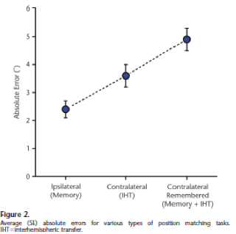

Task Workspace
- Better at far left workspace
- Better with non-dominant hand in general
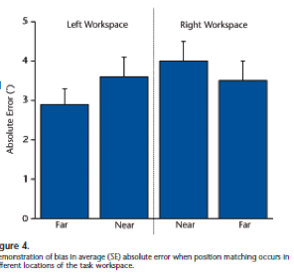

How to Test Motion Sense
- Motion (kinesthesia) sense: ability to detect motion
  - Threshold at which passive joint movement can be perceived: displacement rate, ROM
  - If displacement rate & speed is small, we may not notice limb is moving
- Dynamic position sense: ability to monitor limb position during motion
  - Indicate when the limb has achieved a certain position
  - Monitoring position/joint angle as the limb is moving

Proprioception/Kinesthesia & Aging
- Declines in system= fundamental aspect of aging process
- Neurophysiological mechanisms: peripheral changes
  - Receptors decrease in size, number, sensitivity
  - Nerve damage
- Neurophysiological mechanisms: central changes
  - Memory
  - Ability to transfer information across hemisphere
  - Attention
- Older adults have proprioceptive scores 1.5-2 times greater than younger adults
- Older adults are less accurate
  - Children tend to be visually dominant, therefore, poor proprioception
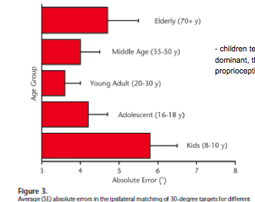
- Older subjects are worse when absolute error is measured
  - No difference when CE is measured
  - Suggests that there are similar biases and that older objects are more variable in their movements
- Older adults movements of matching arm are more variable
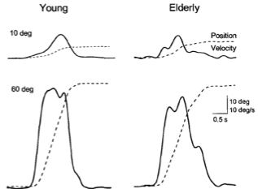
- Older adults also have decreased memory abilities & decreased integrity of the corpus callosum
- Older adults are worse at sensing motion: less capable of sense joint motion, especially at low displacement rates
- Seems to depend on direction of motion: better able to detect knee flexion vs. knee extension
- Dynamic position sense: older subjects are worse
- Postural control: task to keep the center of gravity over the base of support
  - Requires proprioceptive feedback
  - Correlation between postural stability and position sense
  - Proprioceptive acuity significantly predicted the number of falls experienced over the last 12 months
- Activities of daily living: correlation between time to complete activities and proprioceptive acuity
- Position and motion sense seem to be more accurate in active vs. sedentary older adults
  - More specific to the type of PA
  - Tai chi: slow movements and continuous monitoring of body position sense increases proprioception
  - Golf: requires precise movement and balance control, which increases proprioception
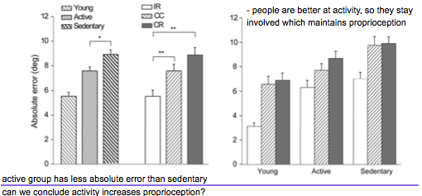

Training Proprioception/Kinesthesia
- Balance related exercises shown to have some benefits on sense of movement
- Unclear if we can actually train/improve the sense
- Most research has shown no change in performance

Lecture 5- Vision & Proprioception

Information Processing
- Visual dominance & proprioception come into play in the action execution stage of information processing

Visual System
- Information coming in through the eye and going to the brain
- Left visual field processed by right brain & right visual field processed by left brain
- Nerves bring in information, which goes to the brain & on to the effectors

Goal-directed Actions
- Task>sensory input>CNS>motor action
- EX: grabbing a coffee mug is the task, sensory input is where you body is in space/where it has to be to grab the cup, CNS programs the movement, muscles carry out the action
- Two sources provide information about the same action
  - Visual input (tends to dominate)
  - Proprioceptive input

How does the brain combine (integrate) sensory information?
- Visual information dominates: tend to rely more on vision than any other sense
  - Visual information tends to attract one’s attention more easily than any other sensory signal
- Not usually a problem because all stimulus tend to provide the same information (redundant)

Motor Learning
- Set of processes associated with practice or experience leading to relatively permanent changes in the capability of responding
  - Involves acquiring information about movements, including what output to produces as well as how and when to produce it
  - Results in the formation and retention of motor memories
- The goal is to improve performance

Motor Tracing Task
- Create a conflict between incoming visual and proprioceptive information to evaluate how visual and proprioceptive information are integrated and modified through learning process
  - Proprioceptive sense telling where the hand is
  - Vision will be reversed
- Conflict created between proprioception & vision
- The brain is plastic, it recognizes proprioceptive information
  - People get better at the mirror matching task with practice
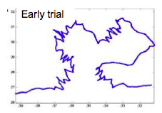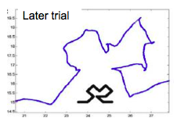
- An individual without proprioception will be more successful at completing the task b/c they will have no conflict in information
  - Visual cues are free to drive the movement from the beginning, without the brain having to resolve conflicting proprioceptive information
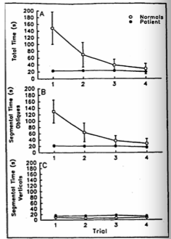

Reaching with Prisms
- Prism creates optical displacement
  - Object will be perceived at a location that it is not

Visual-motor Adaptation (with prisms)
- STAGES OF TESTING:
- Pre-test (baseline)
- Adaptation phase: assesses learning/adaption by examining performance on trials (learning curve)
- Post-test: assesses learning/adaption by comparing performance to pre-test (after effects)
- Subjects initially misreach to the right with prisms on, then they adapt and reach correctly with prisms on, then upon taking off the prisms (after effect), they misreach to the left
  - Subjects are fairly accurate in the pre-test
  - If visual feedback was not provided during post-test, the same errors would be seen in all trials
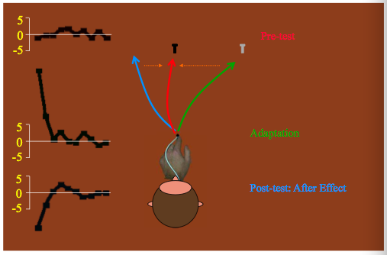
- Even though prisms change the relationship between vision and motor commands for the arm, subjects learn to adjust movements to meet new demands
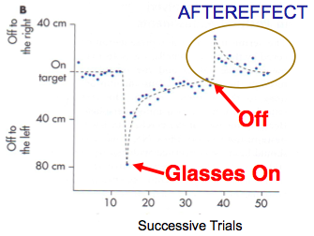

2 Processes of Visual-motor Adaptation
- Strategy (rapid): conscious correction of trajectory
  - Brain is suggesting what it is doing with these sensory signals
- Perceptual recalibration (slow): unconscious recalibration or realignment of sensory sources (proprioception)
  - After effects: subjects have learned to adapt movement
- There is adaptation after viewing active movement through prisms, but not after viewing static hand through prisms (no evidence of learning), and no adaptation after viewing passive movement through prisms

Sensory-motor Learning/Adaptation
- Adapting to visual shift caused by prisms requires integration of both efference and reafference
  - Need to correlate visual and kinesthetic feedback with own active movements
  - Need to experience the sensory consequences of your own self-produced movement
- Only learn motor learning/adaptation with actively corrected movements

