Background and Theories
  - September 5th& 10th 2012

Developmental Psychology and It’s Roots

What Is Developmental Psychology?
- Developmental Psychology
  - The study of changes in behaviour and abilities over the course of development
- Goals of developmental psychology:
  - Description:
    - Identify children’s behaviour at various developmental points
    - Example Questions
      - When do babies start to detect colour
      - What do 5-year olds understand about the mind
      - How do adolescents usually resolve conflicts with their peers
  - Explanation:
    - Determine the causes and processes that govern developmental change
    - Examines the effects of such factors as the genes children inherit from their parents
      - Biological characteristics of the human brain
      - Physical and social environment in which children live and types of experiences they encounter

Why Study Children?
- Period of rapid change
  - Physical growth, social interactions, cognitive and emotional effects
    - acquisition of language, memory abilities
- Long-Term Influences
  - Events and experiences influence an individual’s later adult development
  - Who we are today depends on out development and experiences as children
- Insight into complex adult processes
  - Useful for understanding complex adult behaviours
    - The growing child showcases development of skills and abilities such as language
- Real-world applications
  - Benefits:
    - Poverty, illiteracy, drugs and crime
  - Effects of daycare, classroom teachings methods and parental disciplinary techniques
- Interesting subject matter
  - Human children are intriguing and wondrous

Historical Views
- Ancient Greece and Rome
  - Importance of education but defended
    - Infanticide, slavery, domestic work & service in brothels, severe punishment & exploitation
- Medieval and Renaissance Periods
  - Catholic Church:
    - Promoted idea/image of children being Pure and innocent beings
    - Strong stand against infanticide
  - Renaissance
    - Foundling homes
      - Wealthy individuals took in sick, lost and unwanted children

Materialism and Empiricism
- Materialism
  - Thomas Hobbes (1588 – 1679)
  - Soul is meaningless
  - Nothing exists but matter and energy
  - Human behaviour understood in terms of physical processes in the body, especially the brain
  - Conscious thought is product of brain
- Empiricism
  - John Locke influenced by Hobbes’ work
  - All human knowledge and thought derives from sensory experience
  - Ideas not innately present
  - Though is not product of free will, but a reflection of one’s experience

Early Theorists
- John Locke (1632 – 1704)
  - Believed children gain knowledge though experience and learning
  - Environmentalist Point of View
    - Children are products of their environment and upbringing
    - Stressed use of rewards and punishments
      - No material rewards (toys, candy) or physical punishment
  - “Tabula Rasa” (Latin – “Blank Slate”)
    - The mind is a blank slate at birth; this suggests that all behaviours are learned
- Jean Jacques Rousseau (1712 – 1778)
  - Believed children are born with innate knowledge and ideas that drives development
  - Nativism
    - Inborn processes that guide the emergence of behaviours in predictable manner
    - Whatever knowledge the child doesn’t possess innately is acquired gradually from interactions with the environment, guided by the child’s own interests and level of development
    - Child Rearing
      - Not to instruct children formally, but to have them learn through exploration and discovery
- Johann Gottfried Von Herder (1744 – 1803)
  - Cultural Relativism
    - Each culture should be examined and evaluated on its own terms
    - Everyone is born into a specific cultural community with a shared language and historical traditions
      - shape the minds of the members of community
    - Emphasizes
      - Language
        - Cultural practices and values are transmitted from generation to generation
      - Culture
        - Language and culture not passively absorbed by children
          - We are changed and reinterpreted by members of community
            - “we live in a world we create”
- Charles Darwin (1809 – 1882)
  - “Natural Selection”
    - Evolutionary process in which characteristics that allow the organism to survive are passed along to future generations
  - Recapitulation
    - Development of the individual repeats the development of the species
    - Human development follows a progression; similarly to children’s development
  - Baby Biography
    - research method in which a parent studies the development of his/her own child

Pioneers of Child Psychology
- G. Stanley Hall
  - Father of Psychology
  - Founded the field of developmental psychology
- James Mark Baldwin
  - First academic psychologist in Canada to study development (U of T)
    - Later became interested in child development
  - Research program studying infant development
    - Examining origins of handedness, colour vision, and suggestibility & imitation
- John B. Watson
  - Behaviourism
    - Human development results primarily from conditioning and learning processes
    - Believed psychology should follow the example of the other natural sciences and deal only with objective and observable subject matter
    - Conditioning
      - Animal Psychology
        - Dog to salivate food at the sound of a bell
      - Simple Conditioning
        - Explained changes in human behaviour over time
          - Language
            - Verbal behaviour
              - grow in complexity (baby-adult)
              - gradually develops in a silent form
                - thinking, reasoning, and problem solving
        - important to observe more than just physical changes, instead study first steps in the conditioning process that produces complex human behaviour
- Arnold Gesell
  - Maturation
    - Biological process primarily responsible for human development
  - Norms
    - Timetable of age ranges indicating when normal growth and development milestones are typically reached
    - Produced age-related norms for development
- Sigmund Freud
  - Two major contributions
    - Clinical Psychology
      - Model of personality and techniques of Psychoanalysis
    - Developmental Psychology
      - Stage theory of Psychosexual Development
        - Libido
          - children are born with innate sexual energy
        - Erogenous Zones
          - When the Libido focuses within certain bodily regions
*Stimulation of these regions result in pleasure and gratification*
        - Fixation
          - Failure to move from stage to stage
Age | Psychosexual Stages | Characteristics
Birth – 1.5 | Oral | Libido located at mouth  Physical Pleasure Sucking
1.5 – 3 | Anal | Physical Pleasure Bowel Movements
3 – 6 | Phallic | Libido moves to genital area  Sexual Attraction opposite sex - parent  Conflict rival with same sex parent  Resolution force libido into unconscious & adopt same characteristics as same sex parent
6 – 12 | Latency | Libido remains repressed and inactive
12 – 18 | Genital | Libido re-emerges in the genital area  Sexual Attraction opposite sex - peers

  - Personality Formation
    - Many aspects of adult personality result from events during childhood psychosexual stages
    - Inappropriate childhood experiences
      - Libido remains partially fixated in that erogenous zone rather than moving on
        - Example
          - If a child does not receive appropriate amount of oral gratification during the first stage, the libido will remain partially fixated at the mouth.
          - Later in life, this fixation will manifest in the adult’s behaviour
            - Smoking, chewing on pencils, unusual interest in kissing
  - Phallic Stage
    - Most complex of the psychosexual stages
    - Oedipus Complex
      - When children become sexually attracted to the parent of the opposite sex
      - Feelings of conflict arise with same sex parent – powerful rival
      - Resolve conflict
        - Repression
          - Desires/motivations are driven into unconscious (wipe feelings)
        - Identification
          - The child adopts the characteristics of the same sex parent
  - Two Fundamental Concepts
    - Rejection of both a purely nativistic and strictly environmental explanation of human behaviour
      - Interactionist Perspective
        - Combination of inborn processes and environmental factors
        - Development represents an interaction between biological systems and environmental influences
    - Early experiences can have important effects on behaviour in later life
      - Freud spurred others to test his theories and to develop their own theories
- Erik Erikson
  - Expanded Freud’s stages; proposed an 8-stage model
  - Psychosocial Model
    - Focuses on social and cultural influences on development
    - Expanded on Freud’s stages of psychosexual development
      - proposed an 8-stage model for psychosocial stages
Age | Psychosocial Stages | Characteristics
Birth – 1.5 | Basic Trust vs. Mistrust | Trust must form with caregivers  Inadequate care results in mistrust
1.5 – 3 | Autonomy vs. Shame | Autonomy feelings develop as skills are mastered (walking)  Shame failure to meet expectations
3 – 6 | Initiative vs. Guilt | Initiative take on more in dealing with their environment  Guilt conflicts with caregivers
6 – 12 | Industry vs. Inferiority | Industry successfully dealing with demands to learn new skills  Inferiority failure leads to feelings
12 – 18 | Identity vs. Role Confusion | Must establish occupation, gender, etc... or risk role confusion
Young Adult | Intimacy vs. Isolation | Must form intimate relationships or suffer from loneliness
Adult | Generativity vs. Stagnation | Find means to support future generations through child rearing or other productive activities, or come to a standstill in their lives
Older Adult | Ego Integrity vs. Despair | Must feel a sense of fulfilment in life or experience despair in death

Issues in Developmental Psychology
- Nature vs. Nurture
  - Does developmental change occur primarily due to biological factors or environmental factors
    - Example: When unusual talents are presented
      - Biological Factors
        - A fortuitous combination of genes from parents probably also gifted in similar ways
      - Environmental Factors
        - opportunities provided with to acquire and practise the necessary skills and the rewards received for high levels of achievements
- Continuity vs. Discontinuity
  - Two Components
    - Pattern of development
      - Is developmental change smooth and constant (continuous) or occur at different rates; stage-like (discontinuous)?
      - Example: Height (child growth, puberty); Erikson’s Stage-like theory
    - Continuity
      - Behaviours and abilities can be traced directly back to development early in life
      - Individual skills are added at one time, usually through learning experiences
      - Combine and recombine as children learn these skills to produce increasingly complex abilities
        - Quantitative change
          - The simpler elements are essentially added together to produce the more advanced capabilities
          - Tend to characterize environmentalist models of development
    - Discontinuity
      - Some aspects of development emerge relatively independently of what has come before and cannot be predicted from the child’s previous behaviour
      - Development is guided primarily by internal biological factors
      - Stage Theorists
        - Unevenness of children’s development
          - Relatively stable periods followed by abrupt changes
            - Reflects discontinuous nature of the change taking place in the underlying structures of the body and brain
      - Development is thought to involve qualitative changes in previous abilities or behaviours
- Normative vs. Idiographic
  - Should research focus on identifying commonalities in human development (normative) or on the causes of the individual differences (idiographic)
  - Normative development
    - What children have in common or how development is similar for all children
    - Focus on “average” child, goal of identifying how normal development proceeds each step
    - Universals of Development
      - Behaviours or patterns of development that characterize all children everywhere
    - Research on language development
      - Common patterns different languages
  - Idiographic development
    - Differences in development from one child to the next
    - Research on language development
      - Identify and explain the individual differences that are evident
        - Different experiences
          - Types of speech adults use when talking with children
        - Biological factors
          - Brain trauma
          - Inheritance of genetic disorder

Theories of Development
- Developmental psychologists align themselves with specific theoretical approaches
  - Cognitive-developmental approach
    - Jean Piaget
    - Information-Processing Models
  - Sociocultural approach
    - Von Herder
  - Environmental/learning approach
    - Jon Locke
    - John Watson
  - Evolutionary and biological approach
    - Charles Darwin

Cognitive-Developmental Approaches:
  - Piaget’s Theory
- Piaget was a biologist with strong interests in how children acquire knowledge
- Genetic Epistemology
  - The nature of children’s knowledge, its origins and how it changes as they develop/grow
    - How children think
- Clinical Method
  - Challenged children with simple tasks and verbal problems that required solutions and explanations
  - Asked questions or posed problems, then depending on the child’s response, followed up with other questions intended to reveal the child’s reasoning or problem-solving approach
- Cognitive Structures
  - Schemes (schemas)
    - 2 elements
      - An object in the environment and the child’s reaction to that object
        - Example: A ball
    - As development proceeds, they increase in both number and complexity or organization
      - Number and Complexity define children’s intelligence at any age
    - Perform certain flexibilities
      - Different types of balls different reactions to each
      - Change over time
        - Become more individualized or differentiated
          - Ball to be thrown, rattle to shake, nipple to suck
- Functions
  - Development is the reorganization of knowledge into more complex schemes
    - General Functions
      - Organization
        - New knowledge must be merged with old knowledge
      - Adaptation
        - The survival of an organism depends on its ability to fit with the environment
    - Processes
      - Assimilation
        - Making sense of new information using existing schemes
          - Example
            - Schema for dog & cat. Dogs are hairy, cats are similar so they are both the same
      - Accommodation
        - Changing the existing schemes to fit with new information
          - Example
            - Recognize they are different and title the animals properly
      - Constructivism
        - Children actively create knowledge rather than passively receive it from the environment
- Stages of Development
  - Stage theorist
  - Children move through 4 stages
    - Sensorimotor period: Birth through age 2
      - Infant schemes are simple reflexes, and knowledge of the world is limited to physical interactions with people and objects
    - Preoperational period: Age 2 to 6
      - Child begins to use symbols (words, numbers) to represent the world cognitively
    - Concrete operations: Age 6 to 11
      - Child performs mental operations on the pieces of knowledge they possess, permitting a kind of logical problem solving that was not possible during the preoperational period
    - Formal operations: Age 12 through adulthood
      - Child can use formal problem solving and higher level abstract thinking to deal with events or relations that are only possible, as opposed to those that actually exist
  - Information-Processing Models
- 3 Parts
  - Sensory Input
    - Sights, sounds, tastes, and so on
  - Information Processing
    - Processes in the brain act on and transform the information in a variety of ways
      - encoding it into symbolic forms
      - comparing it with previously acquired information
      - storing it in memory
      - retrieving it when necessary
    - Most psychologists concentrate on this middle part of the system, designing their studies to reveal the nature of these internal processes and how they interact with one another
  - Behavioural Output
    - Speech, social interactions, writing and so on
- Human cognitive processes are similar to the operations of computers
- Specific cognitive processes and corresponding developmental stages

The Sociocultural Approach:
  - Vygotsky’s Theory
- Vygotsky was a product of a Marxist environment, which emphasized socialism and collectivism
- Individual cognitive development is a product of cultural influences
- Cultural Contributions
  - Content of thinking that is, their knowledge from the culture around them
  - Thinking and reasoning processes tools of intellectual adaptation
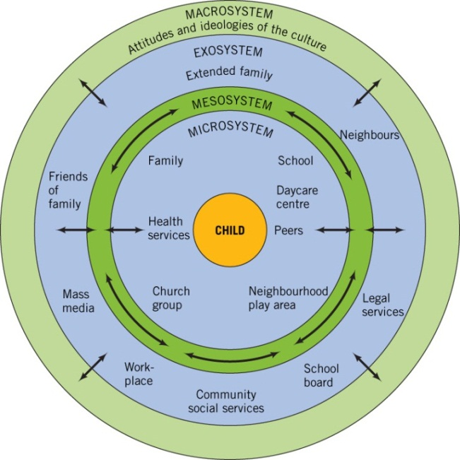
- Through guided interactions with more experienced members of society, children learn problem-solving (dialectical process) which leads to internalization
  - Bronfenbrenner’s Ecological Approach
- Bronfenbrenner’s perspective:
  - Development occurs within broader social and cultural environment
- An understanding of development involves an understanding of the interaction of child’s characteristics and child’s environment (transactional influence)
- Proposed five systems:
  - Microsystem
Figure 1.1
Bronfenbrenner’s ecological
model of the environment.

  - Mesosystem
  - Exosystem
  - Macrosystem
  - Chronosystem
    - Interactions change over time as the child grows adding more complexity and richness

Environmental/Learning Approaches
  - Defining Learning
- Explain how a child’s experiences interact with biological processes to produce development
  - Behaviour Psychology
    - Relies heavily on learning theory to explain development
    - Does not invoke unseen cognitive processes to explain development
- Human behaviour is acquired rather than inborn
- Learning refers to a relatively permanent change in behaviour that results from practice or experience
  - 3 Distinct Elements
    - Relatively Permanent
      - Learned changes in behaviour that are only temporary and that often reflect physiological processes
        - Result of sleep, illness or fatigue
    - Change Behaviour
      - Learning is reflected in observable behaviour
        - Examples
          - Demonstrating whether a child has learned a list of words
            - Writing, reciting or recognizing the words
    - Results from Practice or Experience
      - Separate learned changes in behaviour from changes cause by general biological processes
        - Growth, pregnancy or even death
  - B.F. Skinner
  - Focused on two distinct forms of learning:
    - Respondent
      - Environmental stimuli elicit reflexive responses (salivation response to a steak)
      - Reflex
        - Composed of a stimulus that reliably elicits a specific response
    - Operant
      - The impact of voluntary behaviours on the environment
      - Operant behaviours are controlled by their effects
        - Example
          - Child places a quarter in a candy machine and the machine delivers 30 candy bars rather than one; the child is more likely to place a quarter in that machine on the next occasion
  - Types of Learning
- Habituation
  - The decline of a reflex response after repeated elicitation
    - Example: Ring a bell by a baby and they will startle keep ringing the bell and they will adjust
  - Dis-habituation: recovery of a habituated response that results from a change in the eliciting learning
- Classical conditioning
  - A form of learning in which a neutral stimulus is paired with a reflexive stimulus; after several pairings, the neutral stimulus now elicits a response
  - Unconditioned Stimulus (UCS)
    - The stimulus portion of a reflex, which reliably elicits a respondent behaviour
  - Unconditioned Response (UCR)
    - The response portion of a reflex, which is reliably elicited by a stimulus
  - Conditioned Stimulus (CS)
    - A neutral stimulus that comes to elicit a response through a conditioning process in which it is consistently paired with another stimulus that naturally evokes the response
  - Stimulus Generalization
    - A process related to classical conditioning in which stimuli that are similar to the conditioned stimulus also acquire the power to elicit the response
  - Extinction
    - A process related to classical conditioning in which the conditioned stimulus gradually loses its power to elicit the response as a result of no longer being paired with the unconditioned stimulus
- Operant learning
  - A form of learning in which behaviour changes as a result of reinforcers or punishers
  - Positive Reinforcers
    - A consequence that makes the behaviour it follows more likely through the presentation of something pleasant
  - Negative Reinforcers
    - A consequence that makes the behaviour it follows more likely though the removal of something unpleasant
  - Punisher
    - A consequence that makes the behaviour it follows less likely, either through the presentation of something unpleasant or the removal of something desirable
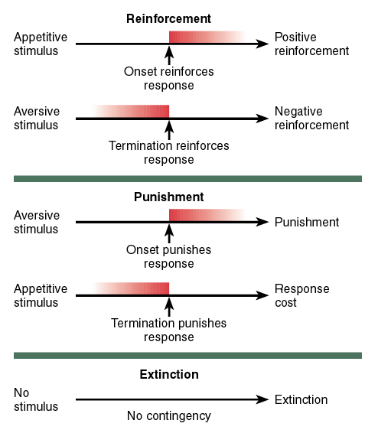
  - Reinforcement, Punishment and Extinction

  - Basic Components of the Classical Conditioning Procedure
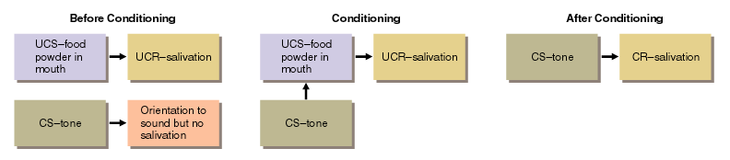
  - Operant Condition vs. Classical Conditioning
- Classical Conditioning
  - Learn relations between one stimulus and another
- Operant Conditioning
  - Learn relations between environment stimuli and one’s own behaviour
  - Little Albert
- http://www.youtube.com/watch?v=Xt0ucxOrPQE

Social – Learning Theory
- Albert Bandura added the concept of observational learning to environmental/learning theory
- Observational Learning: Children learn by observing models and, as a result, experience vicarious punishment or vicarious reinforcement
- Children imitate their models
  - http://www.youtube.com/watch?v=Pr0OTCVtHbU
- Human development involves an interaction between a person’s characteristics and behaviour with the environment (reciprocal determinism)
  - Bandura’s Theory of Observational Learning
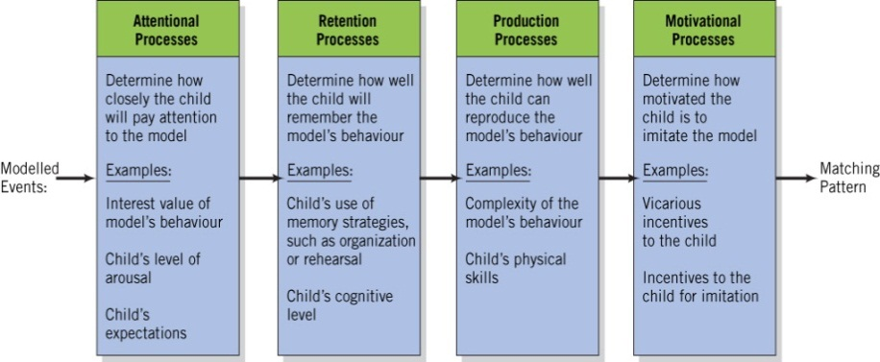
Figure 1.2 Bandura’s model of observational learning.
  - Reciprocal Determinism
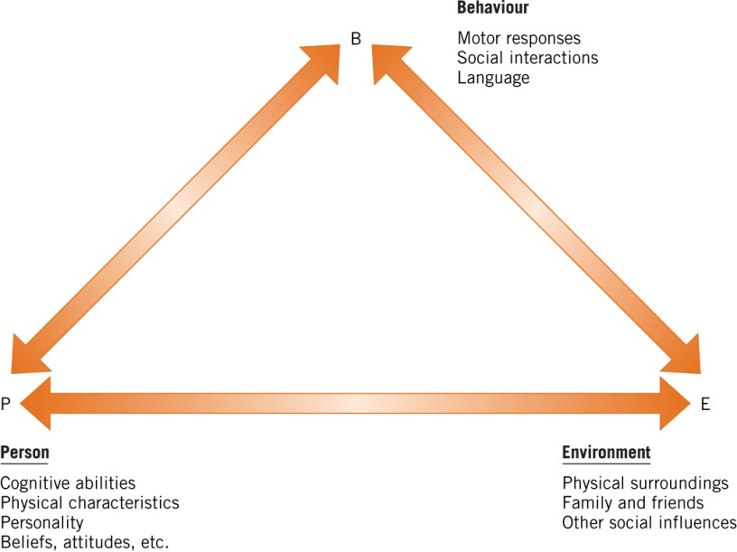

Figure 1.3 Bandura’s model of reciprocal determinism.

Evolutionary and Biological Approaches
- The focus of ethology is on the role of evolutionary processes in development
- Ethology suggests two determinants of behaviour
  - Immediate environmental and internal states
  - Evolutionary determinants refer to the idea that behaviours are functional and that certain behaviours may have conferred evolutionary advantages to an animal, allowing it to survive and reproduce

Classical Ethology
- Ethologists argue that innate behaviours
  - Are universal to all members of the species
  - Require no learning or experience
  - Are stereotyped (similar form)
  - Are minimally affected by the environment
- “Sensitive periods” are periods during which learning is biologically programmed to occur easily
  - Imprinting refers to the emotional bonds formed by young members of a species with their mothers (e.g. Lorenz’s ducklings)

Applications of Ethological Theory
- Bowlby’s observations on institutionalized infants supported the idea that close mother-infant bond (attachment) is crucial to survival of young
- Sociobiology
  - Examines genetic effects on social behaviour
  - Social behaviour shaped by evolution
  - Way we interact with one another is influenced by our social evolution
  - Example:
    - Protective mom creates a gene to pass on
- Evolutionary Development Psychology
  - Proposes that our current characteristics are a result of adaptational challenges
  - Hardwired to pick up languages
  - Reading was not selected
- Development = attributes that promote survival; natural selection

Chapter 1 Recap:
- Early theorists
  - Locke
  - Rousseau
  - Von Herder
  - Darwin
- Pioneers
  - G. Stanley Hall
  - James Baldwin
  - John Watson
  - Arnold Gesell
  - Sigmund Freud
  - Erik Erikson
- Issues In Development
- Theoretical Approaches
  - Cognitive-Dev
  - Sociocultural
  - Env/Learning
  - Evolutionary/Biological

