Chapter 5: Theories of Work Motivation

- Motivation: Extent to which persistent effort is directed towards a goal.
(Characteristics: Effort, Persistence, Direction, Goals)

- Factors Contributing to Individual Job Performance

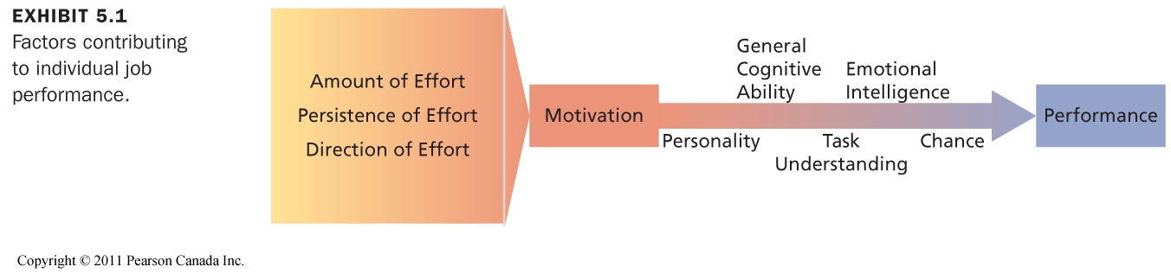

- Emotional Intelligence: The ability to perceive emotion, integrate emotion to facilitate thought, understand emotions and to regulate emotions to promote personal growth
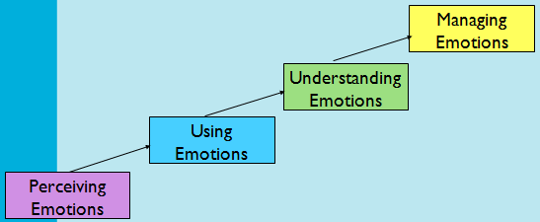
Emotional intelligence is good with social interaction tasks

Extrinsic rewards may decrease intrinsic motivation (intrinsic rewards may have better performance than extrinsic)

- Autonomy, mastery & purpose are the best motivators according to Daniel Pink

- Self-Determination Theory

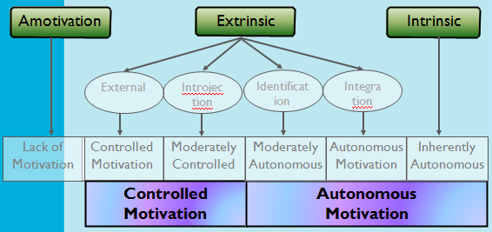

- Lack of motivation
- $ rewards (you have to do it) [Extrinsic Controlled]
- Prove smthing/show others (feel guilty if not done) [Extrinsic Controlled]
- Personal Goal (Values/want to understand why) [Extrinsic Autonomous]
- Fun, challenges, enjoyableness [Intrinsic Autonomous]

High autonomy and low control is the best. High in both is the second best.
If basic physchological needs are met autonomous behaviour can be achieved.
Consequences of Autonomous Motivation

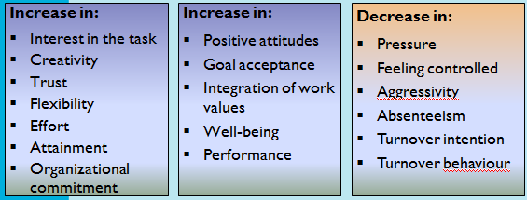

Basic Psychological Needs for Autonomous Motivation:
Autonomy, Competence & Relatedness

- Need Theories of Work Motivation

Specify the kinds of needs people have and the conditions under which they will be motivated to satisfy these needs in a way that contributes to performance. Needs are physiological and psychological wants or desires.

Can be satisfied by acquiring certain incentives or achieving particular goals:
NEEDS BEHAVIOUR INCENTIVES AND GOALS

- McClelland’s Theory of Needs
Outlines the conditions under which certain needs result in particular patterns of motivation.

3 needs reflect relatively stable personality characteristics:

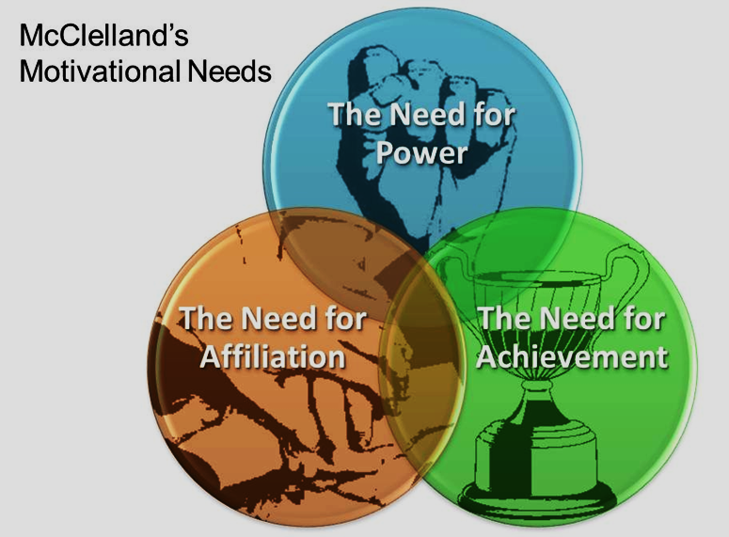

Need for Achievement: Sales jobs or entrepreneurial positions
Need for Affiliation: Social work or customer relations
Need for Power: Journalism & Management

Managers must evaluate employees’ needs and offer goals & incentives accordingly

- Process Theories of Work Motivation
Motivation theories that specify the details of how motivation occurs.

- Expectency Theory
Motivation is determined by the outcomes that people expect to occur as a result of their actions on the job.

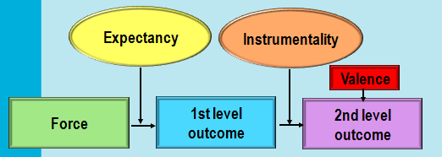

2nd level outcome is valued by employees (e.g. peer recognition)

Valence: value it has to employees e.g. bonus is pizza coupons but you hate pizza

Instrumentality: probability that a first level outcome will be followed by a certain second level outcome. e.g. guaranteeed bonuses is high instrumentality. 1 spot open promotion is low instrumentality

Expectency: Force/effort (how likely it is to achieve a certain level of performance)

Managers want all of these high

- Will my effort produce the desired performance?
- Will my performance lead to desired outcome?
  - People will be motivated to perform in those work activities that they find attractive and that they feel they can accomplish.
  - The attractiveness of various work activities depends on the extent to which they lead to favourable personal consequences.

Managerial Implications
- Boost Expectancies: Ensure that employees expect to be able to achieve first-level outcomes.
- Clarify Reward Contingencies: Employees should be convinced that first-level outcomes are clearly instrumental in
  - obtaining positive second-level outcomes and
  - avoiding negative outcomes.
- Appreciate Diverse Needs: Analyze the diverse preferences of employees and attempt to design individualized “motivational packages”.

- Equity Theory
Scales calibrated and measured against comparable references.
Inputs/Outputs

Inputs: What I put into my job: time, effort, ability, loyalty, tolerance, flexibility, integrity, commitment, reliability, heart & soul, personal sacrifice, etc.

Outputs: What I get from my job: pay, bonus, perks, benefits, security, recognition, interest, development, reputation, praise, responsibility, enjoyment, etc.

People become demotivated, reduce input and/or seek change/improvement whenever they feel their inputs are not being fairly rewarded. Fairness is based on perceived market norms.

To Reduce Inequity
- Perceptually distort one’s own inputs or outcomes
- Perceptually distort the inputs or outcomes of the comparison person or group
- Choose another comparison person or group
- Alter one’s inputs or alter one’s outcomes
- Leave the exchange relationship

- Goal-Setting Theory

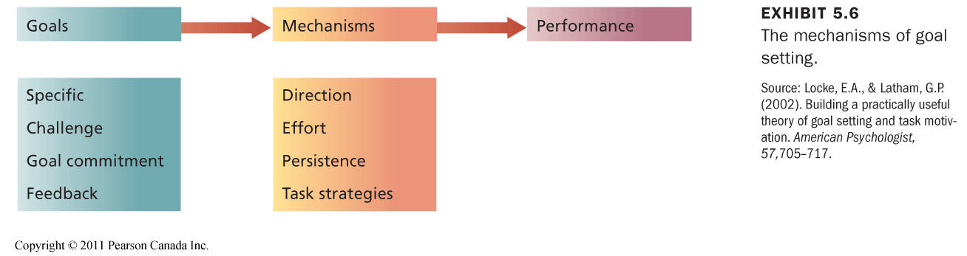

- Set specific and challenging goals and provide ongoing feedback.
- Enhancing Goal Commitment
  - Participation
  - Rewards
  - Management support
- Specific, difficult goals lead to improved performance and productivity on a wide variety of tasks and occupations.
- The effects of goal setting on performance depend on a number of factors.
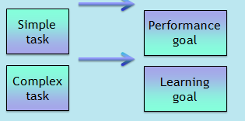
Motivation across Cultures
- Self-determination theory is effective in different cultures
- Need theories face some cultural limitations.
- Equity theory will be constrained by what is considered “fair” in a particular culture (e.g., equity versus equality).
- Because of its flexibility, expectancy theory is very effective when applied cross-culturally.
- The goal setting process must be adjusted to the culture (e.g., individual versus group goals).

DATATRONIC CASE STUDY, P.176
- What factors do you think contribute to the performance of the employees at DATATRONIC? Refer to Exhibit 5.1 to explain your answer.
- Self-determination theory: Consider the needs of the employees. Is their motivation autonomous or controlled?
- Explain what DATATRONIC is doing and what they should be doing according to
  - equity theory
  - expectancy theory
  - goal setting theory
- Integrate the findings from each theory to propose a motivation plan. What would you do to motivate DATATRONIC employees?

- Money as a Motivator
Money: pay + various fringe benefits

How effective is pay as a motivator?
  - Pay can satisfy a variety of needs.
  - Pay should be highly valent.
  - Pay should be clearly tied to performance (instrumentality).

Production Jobs
- Piece-rate: $/unit of production completed
  - pure piece-rate
  - base salary + piece-rate
- Wage incentive plans
- Potential problems
  - Lowered quality
  - Differential opportunity
  - Reduced cooperation
  - Incompatible job design
  - Restriction of productivity

White-Collar Jobs
- Merit pay plans
- Potential problems
  - Low discrimination
  - Small increases
  - Pay secrecy

Teamwork
- Profit Sharing (Cash bonuses, retirement supplements, etc.)
- Employee Stock Ownership Plans (ESOPs)
- Gainsharing (Group pay incentive plan based on productivity or performance improvements over which the workforce has some control)
- Skill-based Pay ($/# Job skills)

- Job Design as a Motivator

The goal of job design is to
  - identify the characteristics that make some tasks more motivating than others
  - capture these characteristics in the design of jobs.

Types of Job design:
  - Scientific Management
Until 1960s, Taylor’s principles of Scientific Management were the prevailing philosophy of job design
    - Job simplification
    - Extreme division of labour and specialization.
    - Careful standardization and regulation of work activities and rest pauses.
    - Motivational strategies: close supervision and piece-rate pay.

  - Job Scope (breadth - # of activities - and depth – degree of control over how work is performed - of a job)
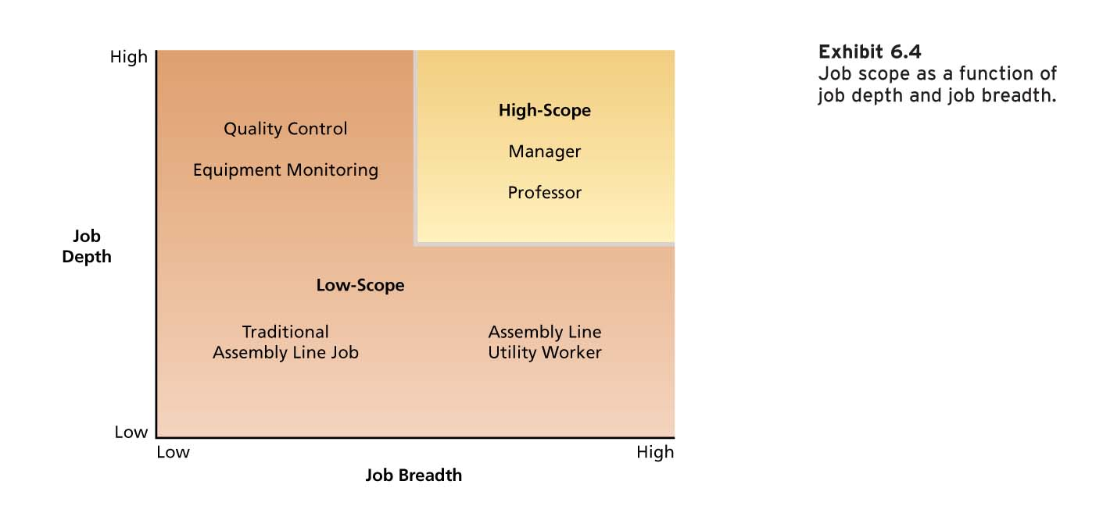

To increase the scope of a job: Stretch assignments & include job rotation (rotating employees to different tasks and jobs in the organization)

  - Job Characteristic Model
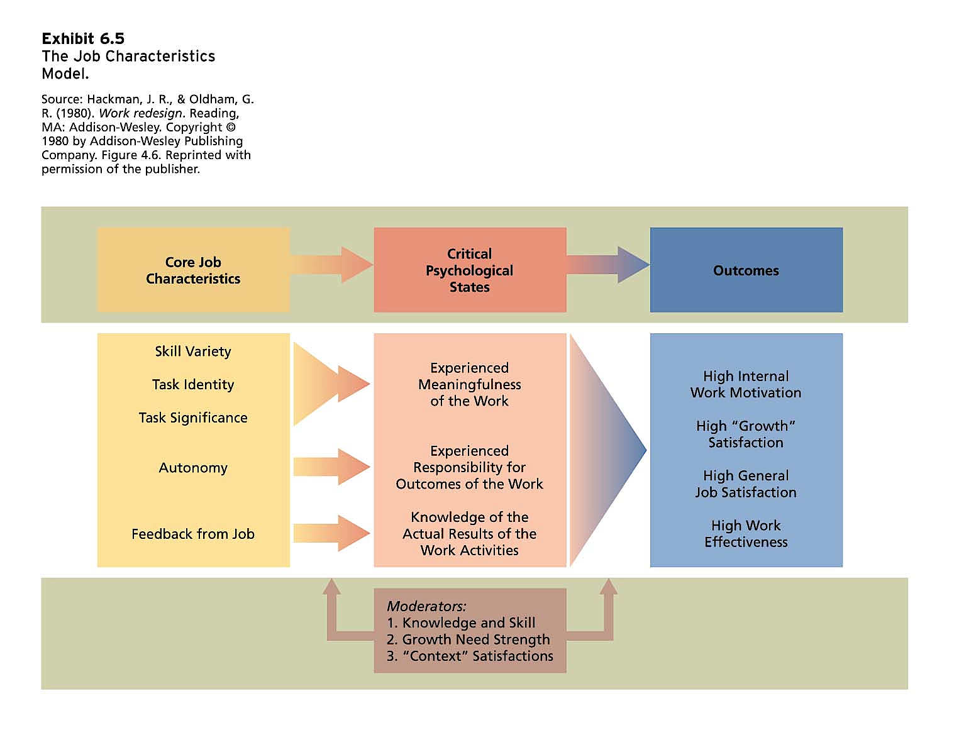
Motivating Potential Score
- Job Diagnostic Survey (JDS)
Skill Task Task
MPS = variety + identity + significance x Autonomy x Feedback
3

4) Job enrichment: Job design to increase the MPS (intrinsic motivation, quality of working life & job involvement – psychological identification with job and importance of work to one’s self image)
  - Combining tasks
  - Establishing external client relationships
  - Establishing internal client relationships
  - Reducing supervision or reliance on others
  - Forming work teams
  - Making feedback more direct

Problems:
- Poor diagnosis
  - Job enlargement (adding tasks to the same level)
- Lack of desire or skill
- Demand for rewards
- Union resistance
- Supervisory resistance

5) Work Design: Use of characteristics & attributes of the task, job and social/organizational environment to design the job

Motivational Characteristics:
Task characteristics:
Autonomy
Work scheduling autonomy
Work methods autonomy
Decision-making autonomy
Task variety
Significance
Task identity
Feedback from the job

Knowledge characteristics:
Information processing
Job complexity
Specialization
Problem solving
Skill variety

Social Characteristics:
Interdependence
Feedback from others
Social support
Interaction outside the organization

Work Context Characteristics:
Physical demands
Work conditions
Ergonomics
Equipment use

- Management by Objectives
An elaborate, systematic, ongoing program designed to facilitate goal establishment, goal accomplishment, and employee development.

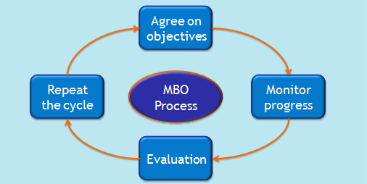
- Alternative Working Schedules
  - Flex-time (arrival & departure times are flexible)
  - Compressed workweek (fewer days/week but as many hours as usual)
  - Job and work sharing (JS: two part-time employees do the work of one fulltime) (WS: reducing the number of hours worked in reduced business activity times instead of laying people off)
  - Telecommuting (Work at home)

CASE STUDY JUNIOUR ACCOUNTANT P.211

Chapter 4: Values, Attitudes, and Work Behaviours

- Generations in Today’s Workplace
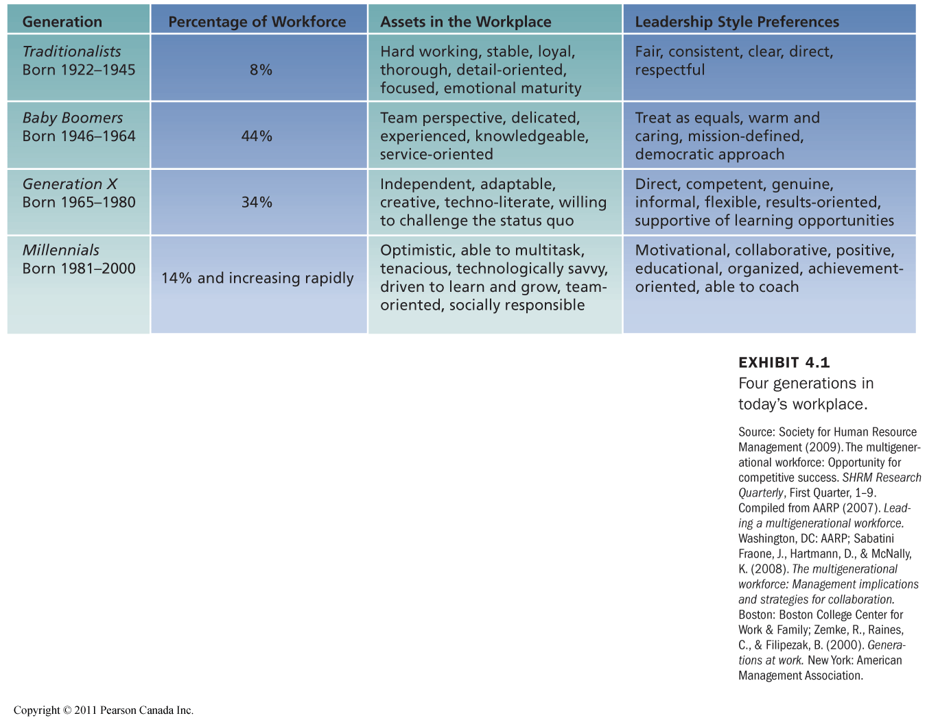

Culturally wise, a lack of understanding of cross-cultural differences can cause foreign assignments to terminate early and business negotiations to fail

- Hofstede’s Study
Visible differences among cultures

Power Distance: The extent to which an unequal distribution of power is accepted by society members

Uncertainty Avoidance: The extent to which people are uncomfortable with uncertain and ambiguous situations

Gender Roles (Masculinity/Femininity)

Individualism/Collectivism: Individualistic societies stress independence, individual initiative, and privacy. Collective cultures favour interdependence and loyalty to family or clan

Long-term/Short-term Orientation: Cultures with long term orientation tend to stress persistence, thrift, and close attention to status differences. Cultures with short term orientation stress personal steadiness and stability, face-saving, and social niceties.

Cross-Culture Value Comparisons
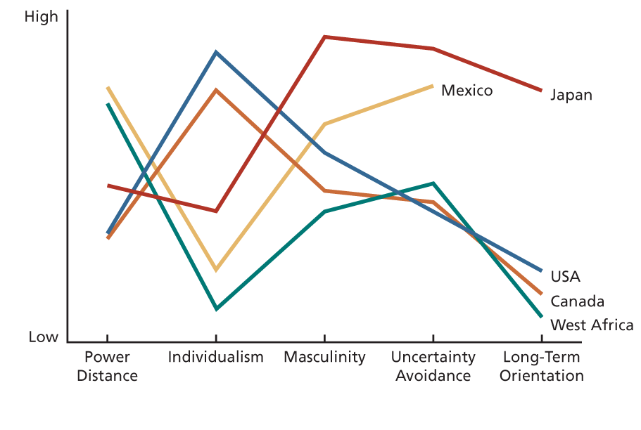

Implications of Cultural Variation
- Organizations need to tailor management practices to the home culture’s concerns
- An appreciation of cross-cultural differences in values is essential to understanding the needs and tastes of customers or clients around the world
- Companies need to select, train, and develop employees to have an appreciation of differences in cultural values and the implications

- Attitudes
Fairly stable evaluative tendencies to respond consistently to some specific target. They often influence our behavior. They are a function of what we think and what we feel

Belief + Value = Attitude -> Behaviour

Organizations often attempt to change employee attitudes. A communicator will try to use either emotional or rational persuasion to modify the beliefs or values that support an attitude.

Job Satisfaction
A collection of attitudes that workers have about their jobs
- Facet Satisfaction: tendency to be more or less satisfied with various facets of the job
- Overall satisfaction: summary indicator of a person’s attitude towards his or her job that cuts across the various facets

*The JDI is to see if JS is low. The MSQ is for if it’s already suspected
What Determines Job Satisfaction?

Discrepancy: Theory that states that job satisfaction stems from the discrepancy between the job outcomes wanted and the outcomes that are perceived to be obtained

Fairness
- Distributive: Occurs when people received the outcomes they think they deserve from their job

It involves the ultimate distribution of work rewards and resources. Individuals want “what’s fair”. The equity theory provides a way of understanding how people determine what is fair

Equity Theory: Job satisfaction stems from a comparison of the inputs one invests in a job and the outcomes one receives in comparison to the inputs and outcomes of another person or group.

My outcomes = Other’s outcomes
My inputs Other’s inputs

- Procedural: Occurs when the process used to determine work outcomes is seen as reasonable

It involves “how” the outcomes are decided and allocated. To promote procedural fairness;
  - Follow consistent procedures over time and across people.
  - Use accurate information and appear unbiased.
  - Allow two-way communication during the allocation process.
  - Welcome appeals of the procedure or allocation
- Interactional: Occurs when people feel that they have received respectful and informative communication about an outcome

Fair outcomes or procedures can be perceived as unfair when they are inadequately or uncaringly explained. Both procedural and interactional fairness can to some extent offset the negative effects of distributive unfairness.

Disposition: Some people are predisposed by virtue of their personalities to be more or less satisfied despite changes in discrepancy or fairness.

Research points to a dispositional link in job satisfaction. Extroverts tend to be more satisfied, as well as high consciousness, low neurotic and internals.

Mood and Emotion
- Affect: broad label for feelings that includes emotions and moods
    - Emotions are intense, often short-lived feelings caused by a particular event
    - Moods are less intense, longer-lived, and more diffuse feelings.

Affective Events Theory: Jobs consist of a series of events and happenings that have the potential to provoke emotions or to influence moods, depending on how we appraise these events and happenings. Emotions and moods can in turn influence job satisfaction

Emotional Contagion: tendency for moods and emotions to spread between people or throughout a group. (They tend to converge with interaction)

Emotional Regulation: requirement for people to conform to certain “display rules” in their job behaviour in spite of their true mood or emotions (emotional labour)

This may cause a higher burn-out rate; it takes a bigger toll on people.

How Discrepancy, Fairness, Disposition, Mood, and Emotion Affect Job Sati.
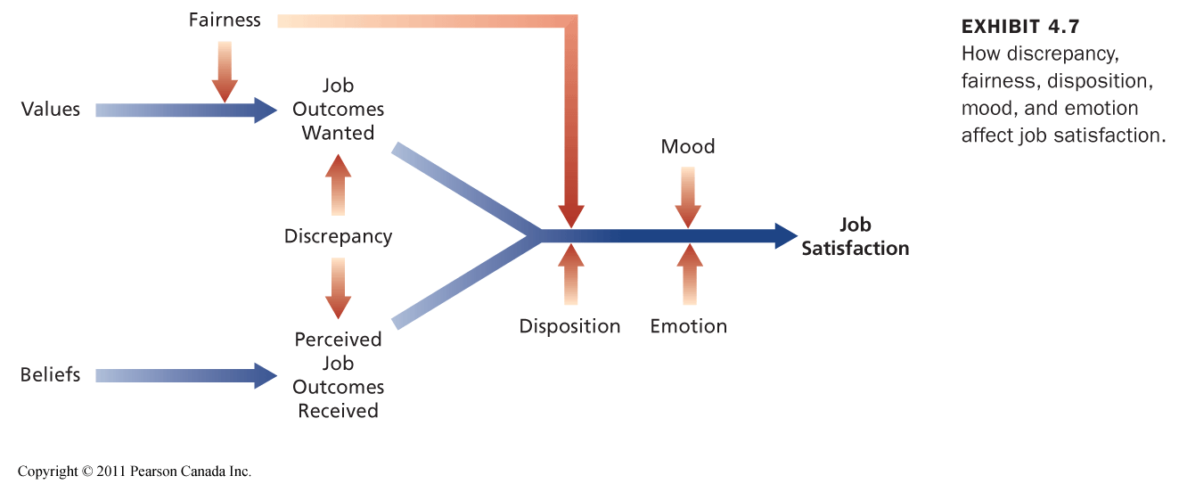

Other Contributors to Job Satisfaction
- Mentally Challenging Work
- Adequate Compensation
- Career Opportunities
- People (Friendly or Helpful Colleagues)

Consequences of Job Satisfaction
- Absence from work
- Turnover
- Performance
- Organizational citizenship behaviour
- Customer satisfaction and profit
- Organizational Commitment

Absence from Work
Absenteeism is an expensive behaviour. Less satisfied employees are more likely to be absent, although the connection is not very strong.

Model of Employee Turnover
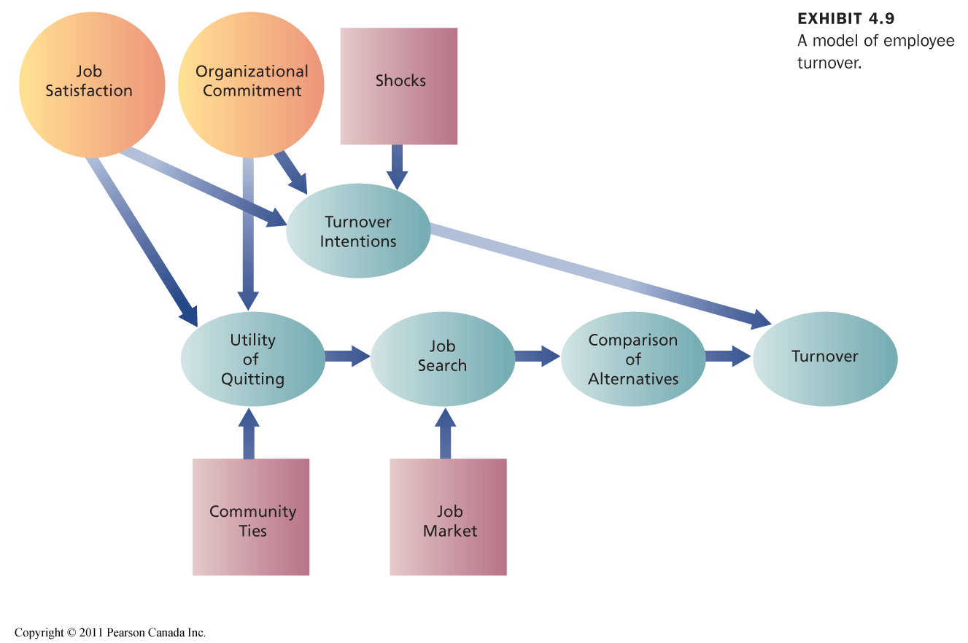

Honeymoon-Hangover Effect
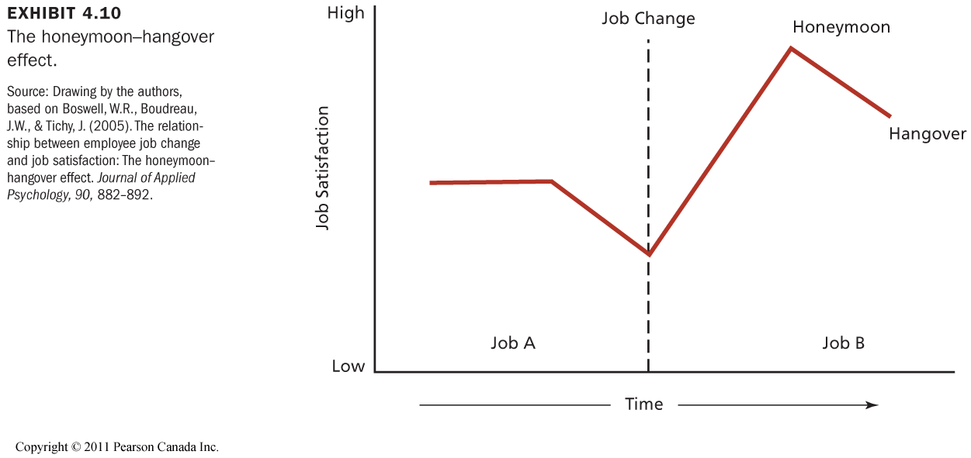
Benefits to Employee Turnover
- Hoping bad people leave, even though its costly
- Fresh ideas
- Most organizations have a max level (e.g. 20% turnover rate)

Performance
Job satisfaction is associated with higher job performance. However, it’s complicated; many factors influence motivation and performance. The most important factor is the content of the work itself. Performance could also contribute to job satisfaction.

Organizational Citizenship Behaviour
Voluntary, informal behaviour that contributes to organizational effectiveness. It is unlikely to be rewarded by the performance evaluation. (Feeling as a citizen of the organizational, being a part of it)

Job satisfaction contributes greatly to OCB. In return, OCB contributes to organizational productivity and efficiency and to reduced turnover.

Customer Satisfaction and Profit
Employee satisfaction leads to customer satisfaction, organizational effectiveness, and profitability.

How? It reduces absenteeism and turnover, contributing to the seamless delivery of service. OCB stimulates good teamwork, and it a good mood among employees can be contagious for customers.

Job satisfaction tends to be stable over time regardless of employer. Adolescence disposition correlates with satisfaction. Realist optimists tend to be most satisfied.

Organizational Commitment
Attitude that reflects the strength of the linkage between the employee and the organization.
- Affective Commitment: Want to be
- Continuance Commitment: Have to be
- Normative Commitment: Should be

Job satisfaction is a big contributor. Consequences are such as absenteeism, etc. As a result of organizational commitment, organizations have seen changes in the nature of commitment, its force, and multiplicity in relationships with leaders.

Chapter 3: Perception, Attributes, and Diversity

Perception – Components and Factors of Influence

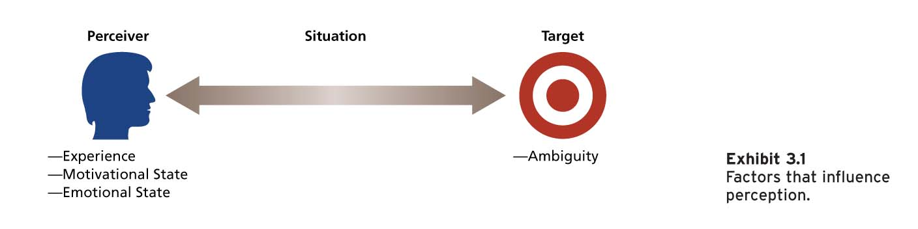

Perception is an interpretation from the senses. We are most open to cues from targets the first time they’re encountered.

Perceptual Defence: Tendency for the perceptual system to defend the perceiver against unpleasant emotions

Bruner’s Model of the Perceptual Process
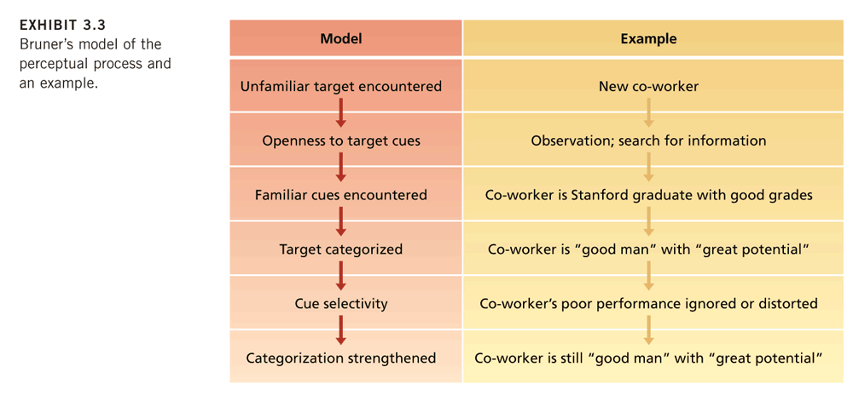

Perceptual Tendencies
- Selectivity: Don’t use all cues + give special emphasis to some
- Constancy: The same way over time and across situations
- Consistency: Select, ignore, and distort cues to form a homogenous picture

Perception Biases
- Primary effect: tendency for a perceiver to rely on early cues or first impressions`
- Regency effect: tendency for a perceiver to rely on recent cues or last impressions
- Central traits: personality characteristics of a target person that are of particular interest to the perceiver
- Implicit personality theory: personal theories that people have about which personality characteristics go together
- Projection: tendency for perceivers to attribute their own thoughts and feelings to others
- Stereotyping: tendency to generalize about people in a certain social category and ignore variations among them

Attribution
Process by which we assign causes or motives to explain people’s behaviour

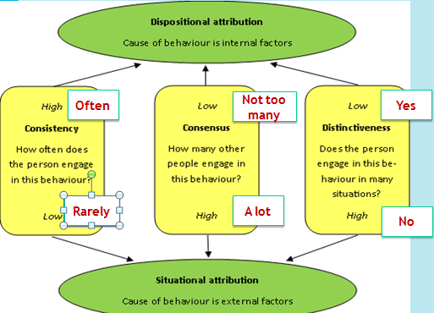

Biases in Attribution

Fundamental Attribution Error: tendency to overemphasize dispositional explanations for behaviour at the expense of situational explanations

Actor-Observer Effect: the propensity for actors and observers to view the causes of the actor’s behaviour differently

Self-Serving Bias: tendency to take credit for successful outcomes and to deny responsibility for failures

CASE STUDY MARY MARTIN ON FIRST CLASS

Person Perception and Workforce Diversity
Workforce Diversity: differences among recruits and employees in characteristics such as gender, race, age, religion, cultural background, physical ability, or sexual orientation

The Changing Workplace
It is becoming more diverse;
- The number of visible minorities in Canada is expected to double by 2017.
- In less than a decade, 48 % of the working-age population will be between the ages of 45 and 64.
- Many organizations are seeking to recruit more representatively.
- Many employees are required to interact with one another or work in teamwork.

Valuing Diversity
- Improved recruiting
- Improved marketing
- Improved competitiveness in global markets
- Resource-Acquisition
- Improved Creativity
- Improved Problem-Solving
- System Flexibility

Stereotypes and Workforce Diversity
A major barrier to valuing diversity is the stereotype. These have negative effects on how individuals are treated in organizations

Stereotype Threat
- When members of a social group
  - feel they might be judged or treated according to a stereotype and
  - that their behaviour or performance will confirm the stereotype.
- The activation of a salient negative stereotype threat in a testing situation has been found to result in lower cognitive ability and math test performance scores of minorities and women.

Racial and Ethnic Stereotypes
- Racial and ethnic stereotypes are pervasive, persistent, frequently negative, and often contradictory.
- Whites have been found to advance further in the hiring process than blacks.
- Career tracking based on racial or ethnic stereotyping is common.
- Organizations are reflections of the environments of which they are a part.

Gender Stereotypes
- Women are underrepresented in managerial and administrative jobs. (14.4 percent of corporate officer positions.)
- Stereotypes of women do not correspond well with stereotypes of businesspeople or managers. Successful managers are perceived as having traits and attitudes that are generally ascribed to men (leadership ability, competitiveness, self-confidence, ambitiousness, and objectivity)

Age Stereotypes
- Older workers are seen as having less capacity for performance:
- They are perceived as more rigid and dogmatic, and less adaptable to new corporate cultures.
- They are perceived as more honest, dependable, and trustworthy.
- These stereotypes are inaccurate:
  - Age seldom limits the capacity for development until post-employment years.
  - Research has found that age and job performance are unrelated.

Managing Workforce Diversity
- Select enough minority members to get them beyond token status and encourage teamwork that brings minority and majority members together.
- Ensure that those making career decisions about employees have accurate information about them.
- Train people to be aware of stereotypes.

Diversity Training Programs
Awareness training with skills training relevant to the needs of the org. Build senior management commitment and accountability. Conduct needs assessment. Emphasize team-building and group process training. Establish metrics and evaluate the effectiveness of diversity initiatives.
Chapter 2: Personality and Learning

Personality is the relatively stable set of psychological characteristics that influences that way an individual interacts with his or her environment, and how he or she feels, thinks, and behaves.

It is relatively stable from day to day. It may change, however, throughout years and experience. In business, we want personality fits.

Personality and Organizational Behaviour
Nature vs. Nurture Debate

This debate has lead to three approaches to explain behaviour:
- Dispositional: Nature
- Situational: Nurture
- Interactionist: Both

Personality and the Situation
The extent to which personality influences attitudes and behaviours depends on the situation.

Weak Situations: Roles are loosely defined, there are few rules and weak reinforcement and punishment contingencies
Ex: Meeting friends after school or a party. (Not socially constrained)

Strong Situations: Roles, rules, and contingencies are more defined
Ex: A funeral or in court.

Implications of the Interactionist Approach
- Some personality characteristics are useful in certain organizational situations
- There is no one best personality.
- Appreciate the advantages of employee diversity.
- The importance of fit - putting the right person in the right job, group, or organization.

Five-Factor Model of Personality
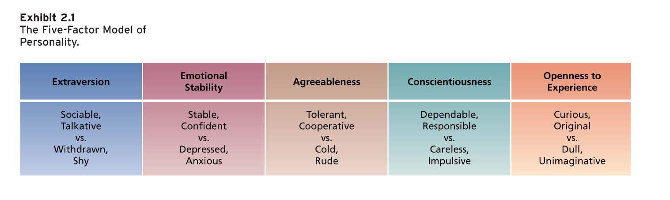

The model & job fit
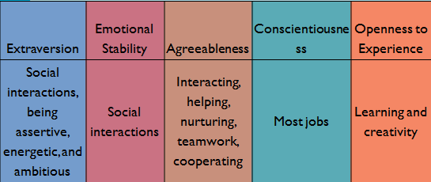
High emotional stability = low neuroticism
Conscientiousness best predicts job performance

Locus of Control
A set of beliefs about the source (control) of behaviour
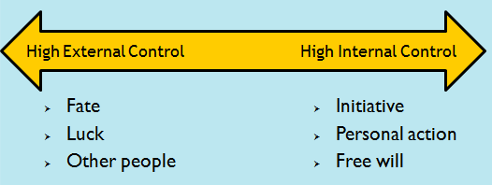

Learning
Practice & experience lead to a relatively permanent change in behavior.

What do employees learn?
- Practical skills
- Intrapersonal skills (personal skills, critical thinking)
- Interpersonal skills (communication, teamwork)
- Cultural awareness

How do employees learn?
- Operant Conditioning
- Social Cognitive Theory

Operant Conditioning Theory
The subject learns to operate on the environment to achieve certain consequences. Behaviour is controlled (or learned) by the consequences that follow it. We want to either increase or decrease the likelihood of behaviour.

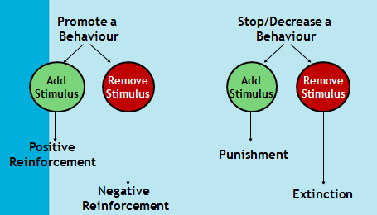

Reinforcement is the process by which stimuli strengthens behaviour. A reinforcer is a stimulus that follows some behaviour and increases or maintains the probability of that behaviour.
Positive Reinforcement: e.g. Stickers – After behaviour
Negative Reinforcement: e.g. to stop nagging – Before behaviour

Organizational Errors Involving Reinforcement
- Rewards are not made contingent on some specific desired behaviour.
- Failure to consider individual preferences for reinforcers.
- Important sources of reinforcement such as those administered by co-workers or intrinsic to the job are often neglected.
- Two important sources of reinforcement that managers often ignore are performance feedback and social recognition.

Performance Feedback: Involves providing quantitative or qualitative information on past performance for the purpose of changing or maintaining performance. It is most effective when it is:
- Conveyed in a positive manner
- Delivered immediately after observing performance
- Represented visually (graph or chart form)
- Specific to the behaviour that is being targeted for feedback

Social Recognition: Informal acknowledgement, attention, praise, approval, or genuine appreciation for work well done from one individual to another. When social recognition is made contingent on employee behaviour it can be an effective means for performance improvement.

Reinforcement and their effects
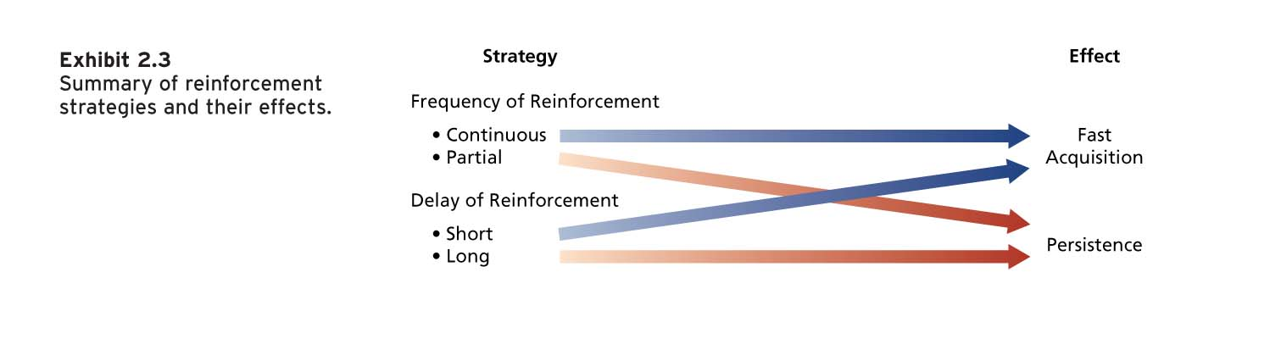
Reducing the Probability of Behaviour
- Extinction (Ignore Behaviour)
- Punishment: has a tendency to provoke a strong emotional reaction on the part of the punished individual. It isn’t actually learning, just learning to avoid punishment. It has to be aversive to be effective. Target the behaviour, not the person.

Social Cognitive Theory
People learn by observing the behaviour of others. People can regulate their own behaviour by thinking about the consequences of their actions, setting goals, monitoring performance, and rewarding themselves.

Human behaviour can best be explained though a system of triadic reciprocal causation:
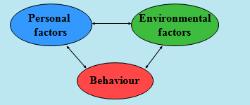

Observational Learning
The process of imitating the behaviour of others

- Involves self-reinforcement. Attractive, credible, competent, high-status people are most likely to be imitated. It is important that the model’s behaviour result in positive consequences and that it is vivid and memorable.

Self-Efficacy
Beliefs about your ability to perform successfully
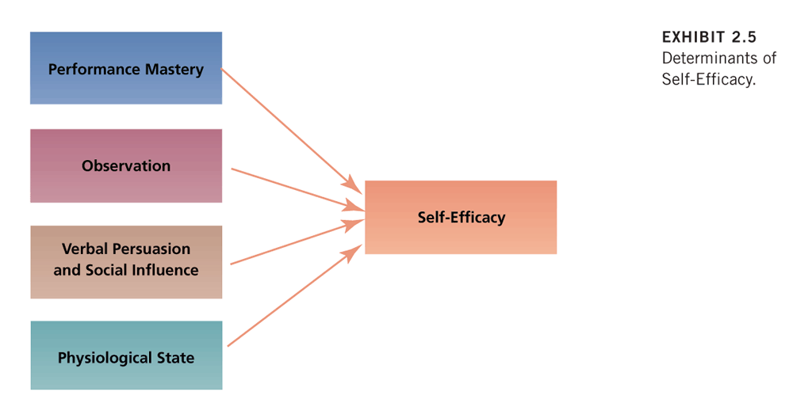

Self-Regulation
Use of learning principles to regulate one’s own behaviour

A key part of the process is people’s pursuit of self-set goals that guide behaviour. Discrepancy reduction and discrepancy production lie at the heart of the self-regulatory process.

Self-regulation involves the following activities:
- Collect self-observation data, Observe models, Set goals, Rehearse, Reinforce oneself

CASE STUDY P.68-69 COURIER CATS

