 | Factors Greater than one |  | Factors less than one
  Prefix | Factor | Symbol
  Peta | 10¹⁵ | P
  Tera | 10¹² | T
  Giga | 10⁹ | G
  Mega | 106 | M
  Kilo | 10³ | K
  Hecto | 10² | H
  Deca | 10 | da
  Prefix | Factor | Symbol
  Deci | 10⁻¹ | D
  Centi | 10⁻² | C
  Mili | 10-3 | M
  Micro | 10-6 | µ
  Nano | 10⁻⁹ | N
  Pico | 10⁻¹² | P
  Femto | 10⁻¹⁵ | f
  - Converting to decimals:
    - Always put dash above a number If it's repetitive.
  - Converting to fractions:
    - Numbers are copied as is, decimals are written as fractions.
  - Scientific Notation:
    - Only one number before the decimal and then all the rest are after it.
  - Rounding: In a 4 digit number plus digits after the decimal, ex: 3419.9816
Counting from the left to the right.
It's not always the same digit number, only saying 4th digit, etc etc here to make it easier.
  - Thousand: look at the 4th digit before the decimal. [Answer should be 4 digits]
  - Thousandth: look at the 3rd digit after the decimal (first digit after the decimal is a tenth). [Answer should be digits before the decimal plus 3 digits after the decimal]
  - Hundred: look at the 3rd digit before the decimal. [Answer should be 4 digits]
  - Hundredth: look at the 2nd digit after the decimal. [Answer should be whatever digits before the decimal plus the 2 digits after the decimal].
  - Ten: look at the 3rd number before the decimal. [Answer should be 4 digits]
  - One: look at the 4th number [first number before the decimal]
  - Tenth: first digit after the decimal.
  - Converting to Decimal:
    - They all use the same process, only difference is that you multiply them by their base. (Binary's base is 2, Octal's base is 8, Hexadecimal's base is 16)
    - Converting from Binary Numbers to Decimal:
      - Start counting from the right
      - Multiply the first digit from the right with 2⁰, the next digit with 2¹, the third digit with 2², etc. etc. until you've multiplied all the numbers.
      - Add the results of all the number you multiplied and you get your decimal number.
      - For Binary numbers with decimals:
        - For all the number before the decimal, follow the steps above.
        - For the numbers after the decimal, start counting from the left.
        - Multiply the first digit after the decimal with 2⁻¹, the next digit with 2⁻², the next digit with 2⁻³,etc etc.
        - Note we start with 2⁻¹ here and not 2⁰, and we count from the LEFT to the RIGHT compared to the first step (where we start counting from the RIGHT to the LEFT).
        - Add all the numbers you got after the decimal.
        - The answer is the sum of the numbers before the decimal and then you the decimal, then the sum of the numbers after the decimal.

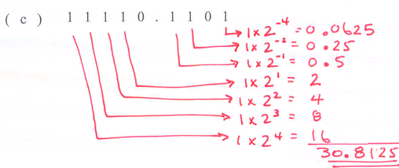
  - Converting from Hexadecimal numbers to decimal:
    - Start from the right.
    - Multiply that number with 16⁰, the next one with 16¹,the next one with 16², etc. etc.
    - Add the results of all the multiplications and your done.
    - Notes: It's the same as binary to decimal, only difference here is that you multiply by base 16 instead of 2.
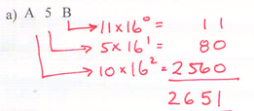

  - Converting to Binary:
    - They all use the same process, only difference is the number of dashes you put.
    - for octal conversion, there's no 8, hence only 3 dashes (1,2,4).
    - For hexadecimal conversion, there are 4 dashes (1,2,4,8).
    - Converting from Hexadecimal to Binary:
      - Put all the digits in numbers.
      - Put 4 dashes under every number that are numbered 1,2,4,8 (starting at the right, so 1 is on the furthest right).
      - Calculate every number.
      - Rewrite the answer which is all the ones and zeroes you got from the steps above.



