Extraction and Thin Layer Chromatography
Daniel Amos: 6853559
21/01/13
Introduction

Part A

Extraction of liquid dyes of different solubilities:

• In this experiment we will determine the methods of extracting a series of dyes.
• Using a separation of an organic phase and an aqueous phase, ether and water respectively, the goal is to determine the layer that each dye may separate to under given circumstances.
• Separating the dye to a specific layer would allow for extraction of impurities that would not follow the same path.

Mechanisms: Extraction of water soluble dyes.

- Separating Methylene Blue
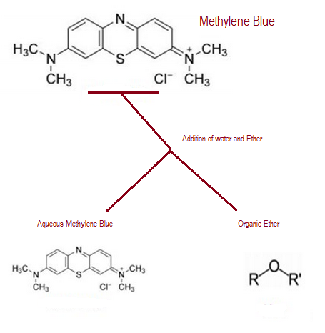
- Separating Methyl red
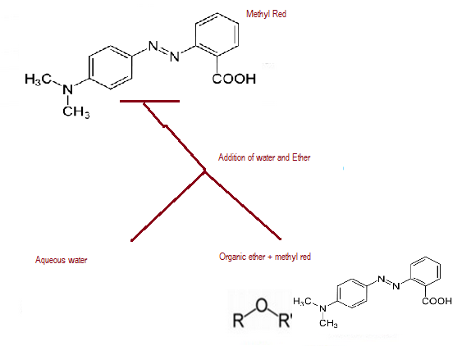

- Separating Methylene Blue and Methyl Red
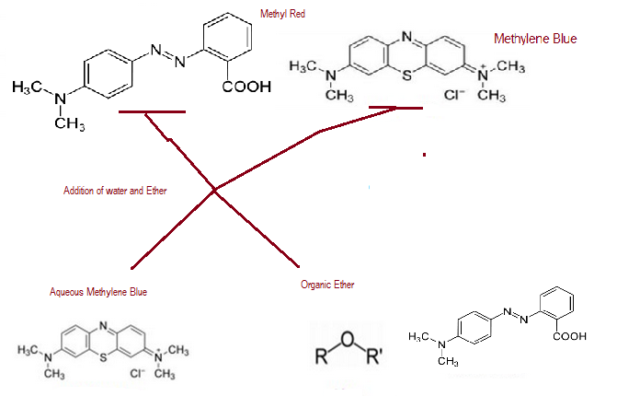

Mechanisms: The salting out effect

- Salting out Crystal Violet
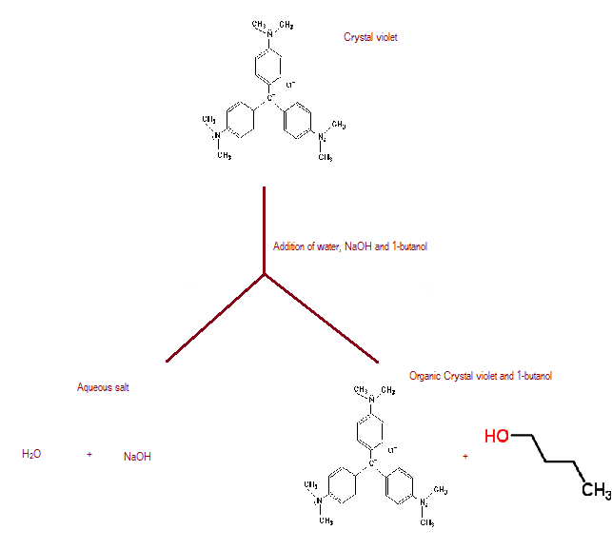

Part B

Using thin layer chromatography to identify the components of an unknown compound.

• In this experiment the composition of an unknown substance is determined using TLC plates and thin layer chromatography.
• The Rf level of individual components in a compound may be determined using thin layer chromatography by measuring the distance travelled by a sample of the compound.
• The Rf level is inversely proportional to the polarity of the molecule as the TLC plate being used is polar which makes movement difficult for polar molecules.
• Using the polarity of a compound with a reference to compare against one may determine its identity.

Part C
Effects of altering the solvent used in TLC

• In this experiment the eluent used for developing the TLC sticks is changed to study the effect.
• Normally the solvent used is a mix of a polar and a non-polar substance in order to create a balance. To use either one or the other would change the results of the test dramatically.
• As the TLC plate is already polar, the effect will be entirely dependent on the use of either the polar EtOAc or the non-polar hexanes.

Part D
Separating the mixture using reactive extraction in order to test the pure substance.

• In the final portion of the lab a separating funnel is used to filter the substance down.
• The process of reactive separation within the separating funnel is based on acid-base interaction which results in a change in charge when protons are removed or added.
• This method of separation may turn an organic acid into an ionic salt which easily dissolves in water, the result being separation into the aqueous layer.

Mechanism: reactive separation:
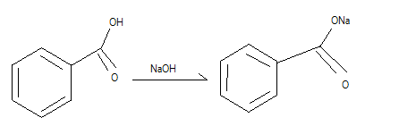

(See flow chart)
Procedure and observations

Part A

• 1ml of ether, 1ml of H₂O and 1 drop of 006M methylene blue were combined in a test tube.
• The contents of the test tube were mixed for 10 seconds before being allowed to settle.
• The test tube was observed to have formed a top layer containing the less dense organic fluid over the denser aqueous layer. The dye settled in the lower aqueous layer.

Appearance of layers: methylene blue | The blue resides in the lower aqueous layer.

• 1ml of ether, 1ml of H₂O and 1 drop of 0.006M methyl red were combined in a new test tube.
• The contents if the new test tube were shaken for 10 seconds before being allowed to settle.
• The test tube was layered in the same fashion though the red dye settled in the organic layer on top.

Appearance of layers: methyl red | The red resides in the upper hydrophobic layer.

• The contents of the two beakers were mixed then shaken for 10 seconds before settling.
• After settling, the organic layer on top contained the red dye and the lower aqueous layer contained the blue dye.

Appearance of layers: mixture | The blue resided in the bottom aqueous layer while the red formed a layer in between the aqueous and hydrophobic layers

• Two test tubes were prepared each containing 5ml of H₂O, 1 drop of 0.003M aqueous crystal violet and 0.5mL of 1-butanol.
• The test tubes were shaken until the violet was fully distributed through the layers.
• Solid NaCl was added to one of the test tubes until the aqueous layer was saturated.
• The salted tube was then shaken to dissolve the salt fully.
• Both test tubes settled into similar layers as before though one had been completely dyed (unsalted) while the other had only received dye in the organic layer as well as some excess dye precipitating on top.

Appearance of layers: unsalted | The whole beaker took the colour of the dye.
Appearance of layers: salted | The dye resides the organic layer as well as on top in a more concentrated precipitate.

Part B

• 10mL of a 2:8 ratio mixture of ethyl acetate and hexanes respectively was added to the developing jar.
• Two TLC plates were marked with a pencil to have three equally spaced lanes one centimetre from the base. The lanes were labeled for reference, combination and sample respectively.
• A 10mg sample containing unknown compound #2 was mixed into a test tube with 2ml of dichloromethane.
• This sample solution was spotted onto each TLC plate on the sample and middle lane.
• 2ml of the reference solution of biphenyl was placed in a separate test tube and spotted onto the TLC plates in the middle and reference lane of the first TLC plate.
• A second reference was prepared similarly containing benzophenyl which was placed on the second TLC plate.
• Both TLC plates were carefully placed in the developing jar and allowed to absorb fluid until the saturation line reached 1cm from the end.
• The plates were removed and the saturation level was marked with a pencil.
• Once dried, the TLC plates were examined under a UV lamp and the visible markings were circled with a pencil.
• Observations showed a distinct difference between both spots on the sample lane as well as the reference biphenly. Benzophenone reference was not observed.
(See figure 1)

Spot location: | Compound: | Rf (TLC1): | Rf (TLC2):
Top Spot | benzophenyl | 0.901 | 0.810
Bottom Spot | Not biphenyl | 0.188 | 0.320

Part C

• 10mL of ethyl acetate was added to the cleaned developing jar.
• Two new TLC plates were prepared and marked in the same fashion as part B.
• Each plate was dotted with the mixtures from part B in the same formation.
• The plates were then placed in the developing jar to saturate before being removed when the level was 1 cm from the end.
• Each plate’s saturation levels were marked with a pencil.
• Once dried, each plate was examined and marked under a UV lamp.
• All spots on the TLC plate were observed to be concentrated in one point at the end of the plate. Distinction could not be made between the individual elements of the test.
(See figure 2)

Spot location: | Rf (TLC1): | Rf (TLC2):
Top Spot | 0.939 | 0.888

• 10mL of hexanes were added to the cleaned developing jar.
• The same procedure was followed to develop two more TLC plates with the compounds from part B • Once developed and marked the TLC plated were observed for differences.
• Observation showed that while both spots in the sample had moved with relative ease though showing some decrease in Rf, the sample spot has been halted entirely and showed almost no Rf at all.
(See figure 3)

Spot location: | Rf (TLC1): | Rf (TLC2):
Top Spot | 0.790 | 0.750
Bottom Spot | 0.310 | 0.400

Part D

• The remaining fluid in the unknown sample test tube was transferred to a 50ml Erlenmeyer flack.
• 10mL of dichloromethane was added to the same flask.
• The contents of the Erlenmeyer flask was transferred to a separatory funnel
• The flask was then rinsed with an addition 5mL of dichloromethane and the rinse was transferred to the separatory funnel.
• 10ml of 2M NaOH aq solution was added to the separatory funnel.
• The separatory funnel was mixed for 30 seconds while gas was routinely released to avoid pressure build up.
• The separatory funnel was placed on a woken rack to sit while the layers formed.
• The lower phase of the separatory funnel was drained into a clean 50mL Erlenmeyer flask.
• The upper layer of the funnel was drained into a 125ml Erlenmeyer flask.
• The lower layer was transferred to the separatory funnel twice more, each time adding 10mL of 2M NaOH aq solution, mixing the funnel, and separating the layers.
• The cleaned developing jar is filled with 10mL of the 2:8 sample of ethyl acetate and hexane solution.
• Two TLC plates are prepared, this time dotted with the original sample as the reference, and the separated sample as the sample spot.
• The TLC plate was observed to have only one spot in the substance lane for the purified substance while the reference would have shown both the marker for that substance and the impurity.
(Part D not completed in lab)

Discussion

Part A

The blue was absorbed in the aqueous layer when the mixture settled, this proves that is it hydrophilic and likely polar. The red on the other hand remained in the top organic layer as it has a non-polar molecule and is hydrophobic.
When the two were mixed, each dye remained in its given layer and was thusly separated efficiently from the other. Thus this is a good method of separating the dyes.
The unsalted test tube was completely dyed by the purple colour, while the salted tube rejected it entirely causing it to only occupy the organic layer. Additional dye precipitated on top of the layer due to oversaturation of the organic layer. This is likely due to the saturation of the aqueous layer with salt that forms a stronger bond than the dye, thus not allowing the dye to bond with water.
In this experiment the red dye was challenging to see, this could cause one to miss it all together as it only added a light change in hue to its layer. A fix for this would be the addition of additional red in the procedure.

Part B

A major error was made in the procedure of part B of the lab; only one of the reference samples had been used causing both tests to show similar results. This error was caused by a lack of proper organization and communication between lab partners and could have been avoided with proper labelling. As a result of this error there are only reference values for one potential compound,
The result of Part B's TLC plates showed a difference between the compound being tested and the biphenyl reference, this leads to the assumption that that reference compound was not in unknown sample #2. We can thus deduce that the biphenyl was not present as either the top or bottom spot of the substance. This leaves bensophenone as the only other potion for the substance though it is unclear whether it may be the upper or lower spot. The conclusion that may be made is that one spot is benzophenone.

Part C

The same error in part B was repeated in part C in which only the reference for biphenyl was used and observed.
The changes in part C of the experiment based on the different elutants are based on the polarity of the elutants used. Because normally a mixture of polar and non –polar elutant is used, both the polar and non-polar molecules are moved, although the more polar molecules are slowed by the polar TLC surface.
In the case of using only the polar EtOAC, because both the surface and the fluid is polar, the molecules with higher polarity have an easier time moving along the surface, this results in an increase in their Rf levels. The resulting observation was of all molecules being clumped by the end of the surface.
When using only the non-polar hexanes, the charged molecules had no attraction to the fluid and remained stuck to the base of the polar surface of the pas not moving. In this case the non-polar molecules were still able to move along the surface with ease. The result being non polar molecule being hardly changed while the polar molecules remain still or hardly moved.

Part D

The intent of Part D was to isolate the test substance through reactive extraction. This test was not completed in the given lab time. This was due to failing to have fully developed the TLC plates for part D before the time limit. This error could have been avoided through faster completion and observation of the preceding tests to allow for more time.
The result of this test should have been the purification of unknown substance #2 and the subsequent test of its Rf values. Observations would have included the TLC plate for the substance being tested showing one distinct dot which represented the Rf value of the unknown substance.
The process of extracting the substance included using an acid reaction remove a proton from the substance, this process would allow it to move to the aqueous layer in order to be isolated. The purification process was repeated three times to allow for increased accuracy in the purification of the substance. Use of the separating funnel in part D was a key skill in the success of the experiment. Proper filtration as well as mixing and handling of the mixture was key in receiving positive results.

Questions

1 Altering the polarity of the solvent system affects the result of a TLC be changing how easily it can move the substance being measured. A higher polarity solvent will cause polar molecules to move easier across the plate surface and thus increase their Rf value. This was tested in part C of this lab when te eluting fluid was split up and tested individuall rather than as a whole. These changes were abserved and proven as the polar fluid and non polar fluid had individual effects on the substances based on their polarity.
2 (See figure 4 for line drawings)
a. The Benzyl Alcohol would have the lowest Rf value as it is the most polar. Benzyl alcohol has a hydroxyl group attached to a single carbon ring, which is a highly polar formation.
b. The Aniline would be the most polar (least Rf) molecule with an NH₃ group on one carbon ring.
c. The Benzoic acid is the most polar molecule and would receive the lowest RF due to its acidic COOH group and single carbon ring.
3 Ethanol is miscible in water and will not form layers when mixed with water, for this reason there would be no possible separation in a water ethanol mix. This will cause an inability to move any compounds between states as there is only one state in the mixture.
4 Adding NaOH to this mixture would cause a decrease in the blue saturation as it would bond with and saturate the water molecules. This would force blue to precipitate out of the aqueous layer. This 'salting out effect' was tested in part A of the lab; the result of salting out the aqueous layer was the diss allowance of any additional substance to enter the aqueous phase. In this case the blue would precipitate as its own layer as it is polar and unable to enter an organic phase.
5 K_{D} = W₁/V₁ / W₂/V₂ = 10

Let X represent the mass extracted into ether and Z represent the mass extracted into water.
X + Z = 1.8
Z = 1.8 - X

K_{D} = X_{g/100 ml ether} / Z_{g/100ml water}
10 = X / 1.8 – X
X = 1.64g

There will be 1.64 grams extracted by the ether.

7 If the student were to drop a single drop of water into the mixture it would sink through the top layer if it was organic. If the top is aqueous then the water will immediately dissipate. This would reveal whether the aqueous layer was on the top or the bottom depending on where the drop stopped.
8 Using an acid, the benzyl amine could be converted into a salt that may become miscible in water; this process would eventually separate all of the amine into the aqueous layer leaving only the nophlathene. This method of reactive extraction was performed in this lab for the separation of the unknown substance from its impurities.

