Concordia University
Department of Economics
ECON 203 – INTRODUCTION TO MACROECONOMICS
Fall 2012 Midterm Exam VERSION A

Instructor: AncaAlecsandru

STUDENT NAME: _____________________________________________________

STUDENT NUMBER: __________________________________________________

Please read all instructions carefully.

- This is a 60 minute-exam. The questions are worth 100 marks altogether.
- Answers all questions.

You are allowed to use a non-programmable calculator. You may use either a pen or pencil to provide your answers.
Part I - Multiple choice questions (3 marks per question)

- Which of the following best defines (1) an advance in technology and (2) the impact of an advance in technology?
- It refers to the ability to produce more output with more resources; it shifts the Aggregate Supply function to the right.
- It refers to the ability to produce more output with a fixed quantity of resources; it shifts the Aggregate Supply function to the right.
- It refers to the ability to produce the same output with a smaller quantity of resources; it shifts the Aggregate Supply function to the left.
- It refers to the ability to produce the same output with a larger quantity of resources; it shifts the Aggregate Supply function to the right.

- A fall in the Canadian price level will cause:
- both exports and imports to decrease.
- exports to decrease and imports to increase.
- both exports and imports to increase.
- exports to increase and imports to decrease.

- Despite some problems, higher real GDP per person does imply higher living standards because it tends to be positively associated with:
- crime, pollution, and economic inequality.
- better education, health and life expectancy.
- poverty, depletion of non renewable resources, and congestion.
- unemployment, availability of goods and services, and better education.

- Other things equal, a decrease in Germany's exports due to recession in Greece will:
- lower the marginal propensity to import in Germany.
- have no effect on equilibrium GDP in Germany , because imports will change by an offsetting amount.
- decrease aggregate expenditures and decrease equilibrium GDP in Germany.
- increase aggregate expenditures and increase equilibrium GDP in Germany.

- Other things remaining the same, an increase in taxes:
- increases aggregate expenditure.
- leaves aggregate expenditure unchanged.
- decreases budget balance.
- decreases savings.

- A $1 increase in government spending will have a larger impact upon national income than a $1 cut in lump sum taxes, because:
  - the government prints the money it spends.
  - not all of a tax cut is spent.
  - when taxes are cut, so too is government spending.
  - taxes are fixed.

- Refer to figure below. The diagram shows, other things remaining equal, the government's budget balance will ____ in a recession and _________ in a boom.
  - decline, grow
  - grow, decline
  - grow, grow
  - decline, decline
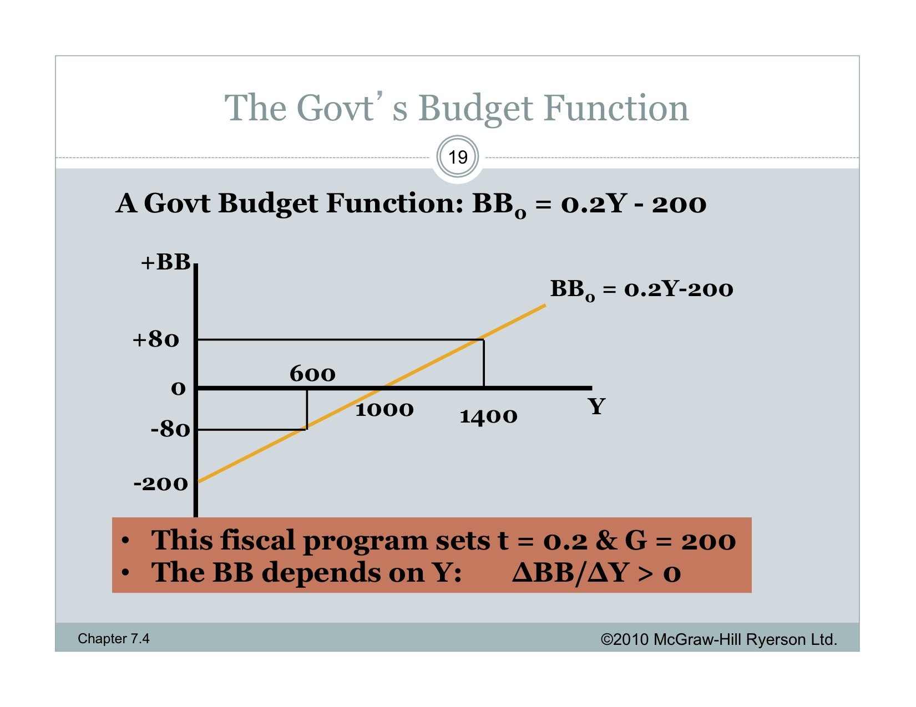

- The direction of discretionary fiscal policy cannot be examined by the simple look at the changes in the actual budget deficits or surpluses. This is because:
  - those changes may reflect the changes in the general price level.
  - those changes may reflect changes in the tax revenues as a result of change in GDP.
  - those changes may reflect the changes in the tax revenues as a result of change in imports.
  - it is impossible to calculate the changes in the actual budget deficits or surpluses.

- If aggregate demand exceeds potential output:
  - an economy's resources are over-utilized.
  - an economy's resources are under-utilized.
  - an economy's resources are fully employed.
  - the pattern of resource use cannot be determined without knowing short-run aggregate supply.

- Empirical evidence for Canada suggests that if actual GDP grows by 2 percent a year and potential GDP grows by 3 percent a year:
  - the unemployment rate will be unchanged.
  - the unemployment rate will fall by 1 percentage point.
  - the unemployment rate will rise by ½ of one percentage point.
  - the economy will experience and inflationary gap.

Part II – Answer all questions

True/False
Explain whether this statement is true or false. Marks are based solely on explanation. No marks will be awarded by simply stating “true” or “false” without explanation.

- If transfer payments are increased at all levels of income, the aggregate expenditure function will shift downward.
Answer: False.
Transfer payments are not included in the value of GDP. However, when the disposable income increases as a result of an increase in transfer payments, consumption will increase (on both domestically produced and imported goods). AE may increase as a result.
Also, if the government increases taxes or decreases G to cover the increase in transfer payments, aggregate expenditure may decrease, as the consumers have less disposable income.

- If the CPI at the end of 2003 was 124 and at the end of 2004 it was 130, the annual rate of inflation in 2004 was 6 percent.
Answer: (130-124)/124= 4.8%
Current events

1. “More than half of businesses in a new survey say they plan to invest, in the next 12 months. Most firms that aren’t planning on a big investment would like to, but cite constraints in working capital, access to credit and caution over an uncertain global economy.”

(“What “dead money”? Businesses boosting capital investment”, The Globe and Mail, Oct 2012)

Define “investment”.
Refer to the excerpt above to explain how an increase in investment changes the employment and inflation in the economy. (You could also illustrate the changes graphically, using the AD-AS model.) (5 marks)

From the article: “The poll found that 56 per cent of businesses plan to invest in the coming year, mostly in new machinery and equipment, with the most common goals being to boost productivity and develop new markets.”
AS
P

AD=C+I+G+NX

Real GDP (Y)

2. “The unemployment rate for December was 7.5 per cent. […] A plausible estimate for the unemployment rate associated with potential output is probably around 7 per cent or so. (The Conference Board of Canada’s projection for 2013 is 6.8 per cent.)

(“Don’t settle for new “natural” jobless rate of 7 per cent”, The Globe and Mail, Feb 2012)

Refer to the excerpt above to explain whether there is an output gap in Canada. What types of unemployment are included in the natural rate of unemployment?
Explain what policy action the government could take to return output and employment to their potential.
Explain what would lead to reductions in the natural rate of unemployment in the long-run.
(5marks)

Answer: “The policy challenge during recessions is to stimulate demand in order to return output and employment back to potential, and this has been the priority of fiscal and monetary policy for the last three years.” The expansionary fiscal policy would be to increase G or decrease t.
The natural rate of unemployment includes structural, frictional and seasonal unemployment.
“There’s no reason for us to be satisfied with a ‘natural’ unemployment rate of 7 per cent, but long-term reductions in unemployment are less a matter of stimulating demand than of improving the functioning of the labour market.”
Quotes from the same article.

Problem #1 Policies (Total=25 marks)

The MPC for a closed economy is 0.75 and the net tax rate t = 0.2. Autonomous expenditure by households and business sectors is 200 and government expenditure is 500.

- Find the equilibrium output in this economy. Show your calculations. (5 marks)

Ans: At equilibrium, AE=Y meaning C+I+G=Y, C₀+MPC(1-t)Y+I₀+G=Y
Numerically, Y=200+0.75(1-0.2)Y+500, which means that Y=700/0.4=1750

- What is the value of the autonomous expenditure multiplier? (5 marks)

Ans: 1/[1-MPC(1-t)]=1/(1-0.75*0.8)=2.5

- Provide a brief intuitive description (no rounds necessary) for why the multiplier in (ii) is larger than 1. (5 marks)

Ans: The increase in autonomous spending will generate income and more spending, which again, will generate income and increased demand.

- Assume the economy starts to trade with other countries, and the value of exports is 100 and the imports function is 10+0.1Y. Calculate the new government budget balance. (5 marks)
Ans: At equilibrium, AE=Y meaning C+I+G=Y, C₀+MPC(1-t)Y+I₀+G+X-Z=Y
Numerically,
Y=200+0.75(1-0.2)Y+500+100-10-0.1Y, which means that Y=790/0.5=1580
BB=t*Y-G or taxes-G or NT-G=0.2*1580-500=-184 (deficit)

- If the current income is 5% below its targeted level, what changes in government expenditure are needed to achieve the potential? Use for the current level of income your result from point (iv). (5 marks)

Ans: Y=1580 is 95% of the potential Y, meaning that the output gap is around 83 and the needed increase in G should be 83/the multiplier, meaning 41.5.
For Y=1980, the increase in G should be around 52.

Problem # 2 Unemployment and Inflation (total: 25 marks)

Year | Real  GDP  (Bil $) | Consumer Price Index | Labour  Force  (000) | Employment  (000)
2002 | 1,112 | 105 | 12,400 | 11,200
2003 | 1,252 | 114 | 13,850 | 12,650

- What were the annual rate of growth in real GDP and the inflation rate in Canada in 2003 comparing with 2002? (5 marks)
Economic growth rate=(1252-1112)/1112 *100=12.6%
Inflation rate= (114-105)/105*100=8.57%
- Calculate the rates of unemployment for 2002 and 2003. (5 marks)

2002: (12,400-11,200)/12,400*100=9.67%
2003: (13,850-12,650)/13,850 *100=8.66%

- Suppose 1,200 part-time workers looking for full time jobs are going back to school, full time. Calculate the new unemployment rate for 2003. (5 marks)
Part-time workers are considered employed. When they go to school full time, they drop from the labour force; the number of unemployed is the same in the economy, only the labour force and the number of employed workers decrease by 1,200.
2003: (13,850-1,200-12,650+1,200)/(13,850-1,200) *100=9.48%

- Following a recession, high unemployment rates may persistent even when output increases in an economy. Explain why. (5 marks)

Producers may still be pessimistic about the future of the economy and delay hiring new workers; instead, they overuse the existing resources.

- Assume that the inflation rate based on the core CPI is 9.7%, greater than the inflation rate you calculated at (i). What does this suggest?
Start by defining the core CPI and then explain how this can be possible. (In class we compared the actual inflation rates in Canada for July 2012, based on the total CPI and the core CPI.) (5 marks)

The core CPI includes goods and services that the average consumer buys during one year. The core CPI excludes from the total CPI the goods that have volatile prices: gas, energy, food and vegetables, transportation, mortgage payments.
The reason for the inflation rate based on the total CPI to be smaller than the inflation rate based on the core CPI is that gas, energy prices must have decreased while other prices have increased. The core CPI did not account for that decrease in prices, as it excludes these gas, energy etc. Therefore the inflation rate based on the core CPI was greater.

