Angiosperms
Background:
- Woody and herbaceous
- Seed is no longer naked; enclosed in a fruit
- Cones are now flowers
- Double fertilize: another sperm and a polar nuclei form an endosperm as well as the normal zygote as found in gymnosperms
Terms to know
- Perennial: originates from roots of previous years
- Annual: 1 life cycle every year
Major parts
- Corolla: Flower petals
- Calyx: Flower sepals
- Perianth: Sepals and petals
- Stamen: Produces pollen; filament + anther
- Carpel: Produces ovules; stigma + stile + ovary
- Pistil: One or cluster of carpels
- Pollination: Transfer of pollen from anther to stigma
History: Early angiosperms
- Earliest found in the cretaceous approximately 120 mybp
- Characterised by multiple symmetrical flower parts; likely beetle pollinated
- Flowering plants and insects alike advanced about 65 mybp after dinosaur extinction
- “abominable mystery” by Darwin suggested that they may have evolved from extinct gymnosperms dating back 200 mybp called seed ferns; convergent evolution
- Oleanane was discovered by Moldewan which is a phytochemical found in flower plants as a defense substrate against insects; not found in conifers
Diversity
- Greater diversity then any other group of plants due to coevolution with; (a) pollinators, (b) herbivores and (c) seed dispersers
- Pollen exchange is almost 100%, as pollinators become dependent on nectar and pollen for food, the plant affects the insect’s evolution
Plant adaptations for pollinators
Food reward: pollen provides protein to pollinator
Honey guides: UV pigments (flavonoids) seen by bees are found on petals to act as a target
Color to accommodate pollinator vision
Scent: Attract night flyers

Characteristic | Example | Description
Honey guide | 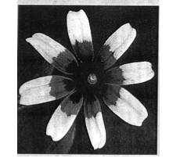 | Under UV bullseye appears which can be seen by honey bees
Colour | 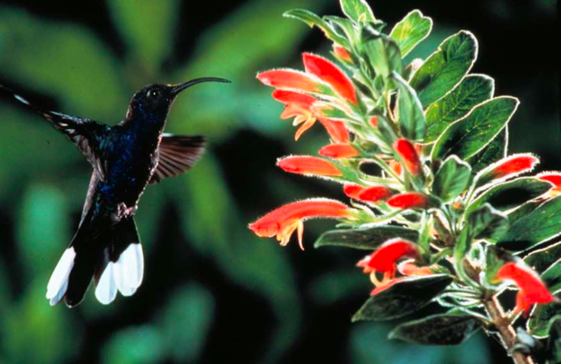 | Hummingbirds are attracted to red/orange; bills may ever adapt to certain flowers
Scent | 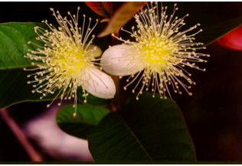 | Bland color but strong perfume to attract bats
“cheaters” attract pollinators with no reward such as skunk cabbage; no mutually beneficial co-evolution

- Idea that herbivores provide potent selection of plants; plants escape by developing toxic compounds they then radiate; insect adapts then this new species radiates onto the plant and the process repeats
- Ovary of flower becomes pericarp in fruit, assuring that the dispersal is done without damaging the seed; achieved by birds and mammals
Disperser Type | Description
Generalist | - Prefer small seeded fruits with a high sugar content  - Not co-evolved
Specialized | - Prefer large seeded fruit with higher protein and fat content  - Co-evolution is possible
Flower evolution
Primitive flowers | Advanced flowers
- Multiple stamen and pistils  - Separate parts  - Symmetric  - Superior ovary  - Beetle pollinated | - Reduced number of parts  - Fussed into tube  - Asymmetrical  - Inferior Ovary  - Bee or butterfly pollinated

Monocot | Dicot
- Linear leaf  - Parralel veins  - No radial growth  - Grasses, palms, cat tails | - Rounded leaf  - Network vein  - Radial growth  - Maple, daisy

Evolution of Crops
All crop species are domesticated by farmers in subtropical areas, known as the center of origins. Center of origins is where domestication occurred; greatest diversity of crop populations.

Region | Common Crops
A1 east | Wheat, oats, barley, rye, peas, olive, mustard, apple, pear
A2 African | Millet, yams, coffee
B1, china | Soya, peach, apricots
B2, SE Asia | Rice, banana, mango, sugar cane
Crop germplasm concept
A gene pool- crop species
B gene pool- near relatives
C gene pool- distant relatives
Crop evolution by farmer selection
- Hybridization of wild species within a gene
- Increase in ploidy level
- Catastrophic sexual change
Maize
- Wild ancestor from Mexico
- Originally created by catastrophic sexual change
- Farmer selection created large ear( doubling of seed rows)

Leaves
Arrangement
Simple: Single blade or leaflet
Pinnate: Single leaf that has been divided into multiple; such as legumes
Major types of anatomy
Type | Picture | Description
C3 (normal) | 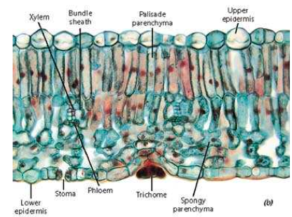 | - All photosynthetic material in middle  - Loosely packed lower cells
C4 | 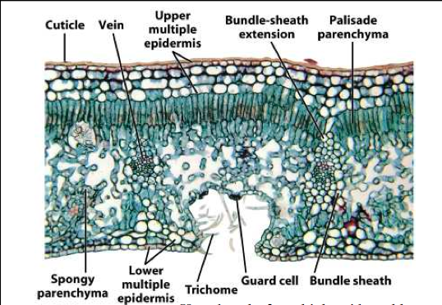 | - Upper epidermis is reinforced  - UV protected

Light Reactions
- Converts light energy into ATP
- Occurs in thylakoid membrane
- 3 steps: light harvesting, electron transport, phytophorylation & chemiosmosis
- Light Harvesting
- Only visible light is biochemically useful, absorbed by double bonds in pigments
- Absorbed by higher plants by chl a, b and carotenoids
- Absorbed by lower plants by chl c, d, phycocyanin and phycoerithrin
- Electron transport
- Accessory pigments absorb light and deliver to “trap”
- Light absorbing “antenna” composed of photosystems 1 and 2; photon absorbed by pigment, energy converted to electronic excitation; energy migrates through array of pigments; trap uses energy to drive electron transport
- Photosystem 1 absorbtion at 700 nm; 2 at 680 nm
- 2 light reactions used to boost electrons; high energy allows removal of e- from water to later reduce CO2 to carbohydrate; water splits and waste product is O₂
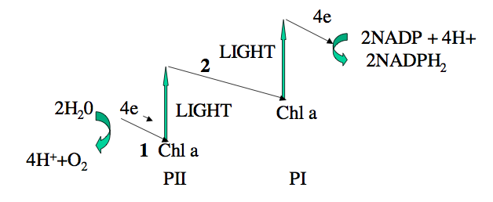
Why two reactions?
Needed to reduce to NADP

- Photophosphorylation
- Some energy in downhill e- flow is conserved by synthesis of ATP
- 2 ATP synthesis sites: water splitting and PQ (plastoquinone)
- Coupling of electron flow to ATP synthesis is achieved by chemiosmosis, which involves energy capture through H+ ion gradient
- Chemiosmosis: electron transport leads to H+ pumping into thylakoid space, PH gradient formed by high [H] inside and low outside (electric gradient; + inside, - outside); gradient causes spontaneous movement of H+ through CFI; energy makes ATP from ADP
- 2 coupling sites: Water splitting releases H+ inside thylakoid and plastoquinone is reduced on the outside of the membrane and oxidized inside

Dark reactions
- ATP and NADPH made in light reaction used up to reduces CO2 to sugar
- Occurs in stroma of the chloroplasts
- 3 variants: C3, C4, CAM
- C3 or calvin cycle
- First product of CO₂
- 3 ATPs and 2 NADPH₂s are needed for each CO₂ reduction
- Rubisco makes up 50% of leaf protein
- Photorespiration: O2 replaces CO2 at rubisco active site, O2 consumed and CO₂ is released; no energy conserved; C2 is recycled into serine, stimulated by high temperature; can be surpressed by CO₂
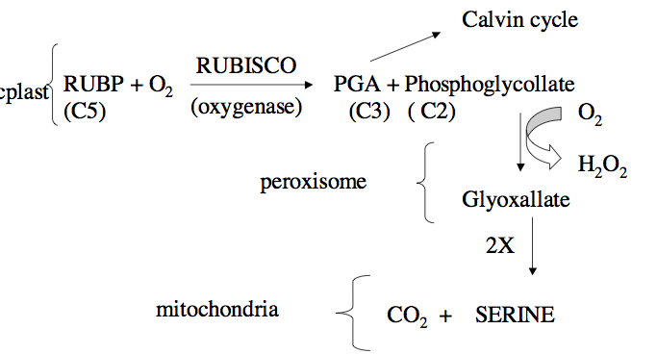

- C4
- Discovered in Australia in sugar cane
- Found in highly reproductive plants
- Subtropical plants with Krantz anatomy
- Stomata stays closed for longer time periods
- Decarboxylation reaction raises CO₂ concentration is bundle sheath and suppresses photorespiration
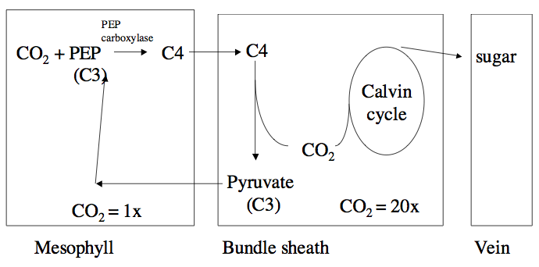
- 5 ATP and 2 NADPH used/CO₂

C3 | C4
- Low light  - High humidity  - Lower temperature | - High light  - Low humidity  - Higher temperature

- CAM photosynthesis
- Dessert plants adapted to extreme dryness; Plants and thick and fleshy like cactus
- C3 anatomy, C4 biochemistry
- Tomato open only at night to conserve water
- Water loss reduced by 10x, slows growth rate, some plants cycle between CAM(dry) and C3(wet)
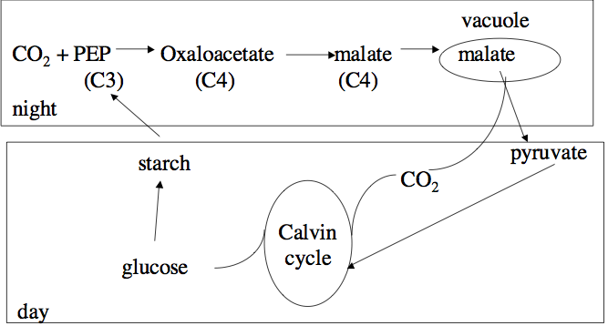

Plant Metabolites

Chemical ecology
- Study of chemical mediated interactions between organisms
- Protection against insects as feeders, growth reducers, toxins
- Creates biochemical interference with other plants “allelopathy”
- Provide protection against fungi
- Positive communication in legume modules or pollination
Evolution of secondary plant metabolites
- Herbivore provides potent selection of plants; co evolutionary arms race
- Plants escape by producing toxins and radiates them; insects adapt
- Continues to form biosynthetic pathways
- Examples: heliconaid Butterfly and passion flower; cyanogenic glycosides protect the plant, heliconaid larvae adapt to specific glycosides

Type | Derived from | Description
Phenolics | Phenylalanine | - Phenyl groups; carbon no nitrogen  - Unsaturated benzene ring with OH group; coffee
Alkaloids | Amino acids | - Heterocyclic ring with nitrogen  - Neurologically active; morphine
Terpanoid | Mevalonate | - Acetates  - 5 carbon units; pine tree

Characteristics
- Unique chemotaxonomic distribution
- Stored in glands and vacuoles
- Produced in large amounts
- Biologically active

Ethnobotany
- Study of traditional use of plants by different cultures
- Pharmalogical activity of plant extracts by isolation of active phytochemicals
- Quinine found in tropical trees allowed colonial period to be possible; gave rise to synthetic drugs such as chloroquine and malerone
- Curare causes muscle paralysis but does not affect the brain or breathing; used in delicate surgeries
- Physistigma is used as an eye drop to reduce ocular pressure; causes gaging reflex if consumed
- Reserpine was first hypotensive agent; inhibits uptake of amines (dopamine) into vesicles in neurons by inhibiting ATP dependent transporter
- Digoxin comes from fox glove; used for congestive heart failure
Nutriceuticals
- Foods containing phytochemicals conferring health benefits
- Flax: contains lignans and PUFAs, red wine extract; said to be the reason the French don’t get as much cardiovascular disease

Nutrient uptake and roots

Type | Picture | Description
Tap | 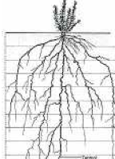 | - Typical of dicots with deep primary roots and many laterals
Fibrous | 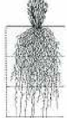 | - Monocots with adventitious roots from stem
Specialty | 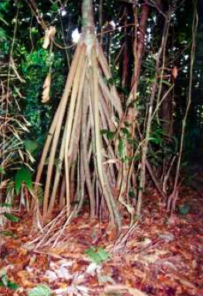

Root tip tissue
- Dead lignified cells for protection
- Cell division zone with apical meristem near cap giving rise to 3 differentiated meristems which divide to form differentiated cells
- protoderm – epidermis
- ground meristem – forms parenchyma
- procambium- forms vascular tissues
Cell elongation
- IAA hormone diffuses from the procambium to small cells in longation zone where:
- stimulates an ATPase that pumps H+ out into the cell wall and K+ from outside in; K entry increases osmotic pressure, H softens cell walls and allows osmotic expansion
- Activates genes for new cell wall synthesis
Differentiation zones
- Cortex
- epidermis provides protection
- parenchyma stores water and starch
- endodermis makes selection of ions to enter the root
- Steele
- Phloem-sugar transport from leaf to root
- Xylem – water and mineral transport to leaf
Ion and water uptake
- Root hairs increase surface area and water and mineral absorption
- Move extracellularly to endodermis where cells are lined with sticky calsparian strip
- Endodermis actively absorbs through plasma membrane (active transport)
- Plasma membrane selects only certain minerals to be transported to leaf in xylem
Fertilizers
- NPK are usually most limiting nutrients
- High N is for temperate zones, high K for leafy vegetables and high P for tropical agriculture

Nitrogen fixation
- Plants prefer NO₃ as N source which is converted to ammonia enzymatically
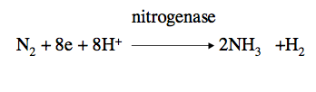
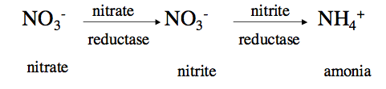

- Bacterial symbionts form nodules that perform nitrogen fixation
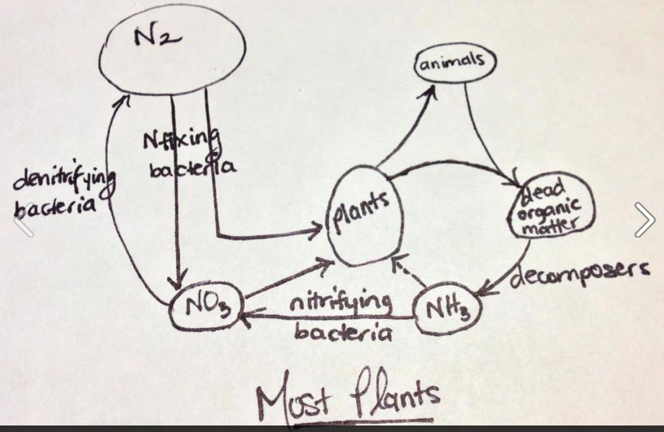

Transport in stems
- Xylem transports water and minerals to leaf (essentially passive using stomata as control)
- Phloem transports sugar from leafs to non photosynthetic parts (active)
Phloem and sugar transport
- Sieve tubes with little structure
- Companion cells provide energy for sugar transport through mitochondria
- Transport is from leafs (source) to non photosynthetic tissue (sink)
Pressure Flow
- Companion cells load sucrose from leafs by active transport to sieve tubes
- High sucrose leads to osmosis and high pressure in sieve tube
- Unloading at “sink: may occur passively or actively
- Lower sucrose at sink leads to lower osmotic pressure
- Sap sugar flows from high pressure to low
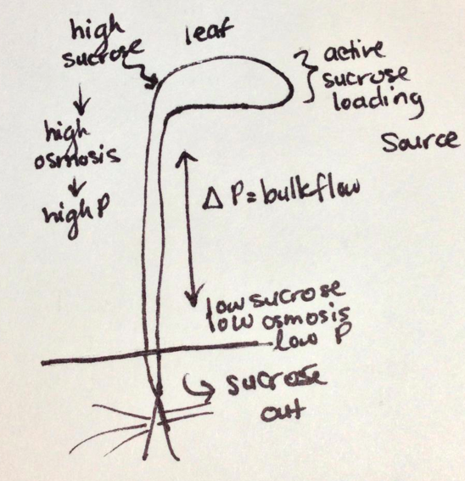
Stomata
- Control water evaporation to prevent desiccation
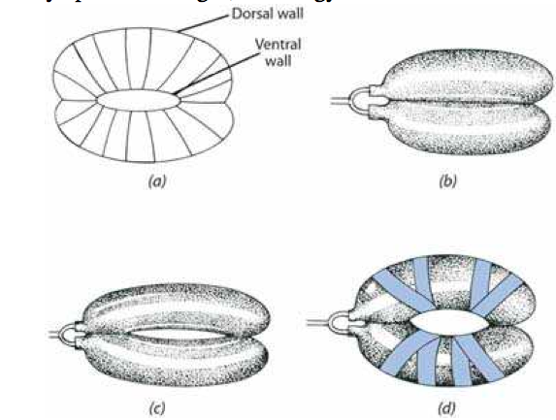
- Open when turgid

Secondary growth
- Procambium in vascular bundles grows laterally and fuses in a ring in second year to form cambium ring
- Cambium produces a layer of phloem and xylem annually
- Annual rings of xylem visible in wood but old phloem is crushed
- Cork cambium forms and produces outer bark and phelloderm
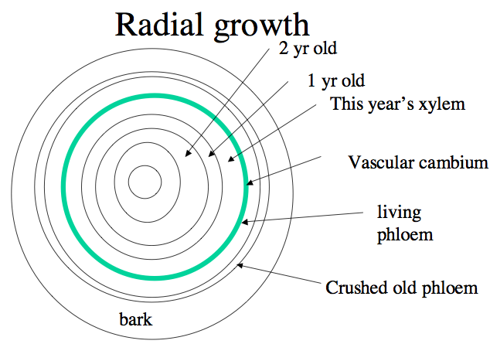

Environmental physiology
- 1935 discovered that lettuce seed germination was stimulated by light
- 1955 discovered red light was most effective
- Phytochrome is a protein with light absorbing phycobillin pigment
- The pigment changes between cis and trans
- Phytochrome is not a hormone but a photoreceptor
- The hormone GA activates de novo synthesis of enzymes for breakdown of starch
- Sugar is released and feeds the embryo
Early growth of plants
- Controlled by Gibberellin- seed germination
- IAA- stem and root elongation
- Cytokinin- cell division
- Ethylene is a gaseous hormone responsible for maturation of fruits
Climacteric
- During ripening there is a rapid rise in ethylene production which stimulates rapid rise in breathing (CO₂ release)
- Hydrolytic enzyme soften cell walls
- Can be delayed in low O₂ environments or high CO₂
- After storage ethylene is added to initiate ripening
Abscissic acid (ABA)
- Dormancy hormone increased during fall or winter
- Decreased in the spring and summer
- Extreme amounts close stomata

Plant Biotechnology
Early generation crop
- Triticale: cross between tetraploid wheat and diploid rye
- To make fertile rye chromosome, it was treated with colchicine
- Triticale has 30% higher yield than wheat and disease resistance of rye
Rapeseed and canola
- Rapeseed was toxic, containing 2 toxins: erucic acid is linked to heart disease and glucosinolate

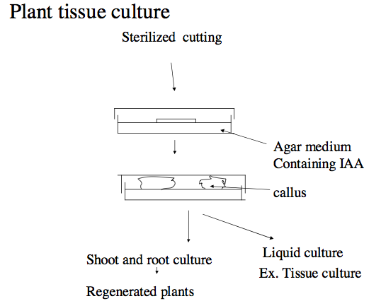
Method used in Vancouver to make taxol

Transform with agrobacterium to regenerate the plant by adding hormones; trans gene will be expressed in regenerated plants
Not dangerous to human health but could be dangerous ecologically
Major problem with GMO's is that there is a total ban on them in Europe and once we start using them they tend to contaminate all conventional crops so the Europeans wont allow importation

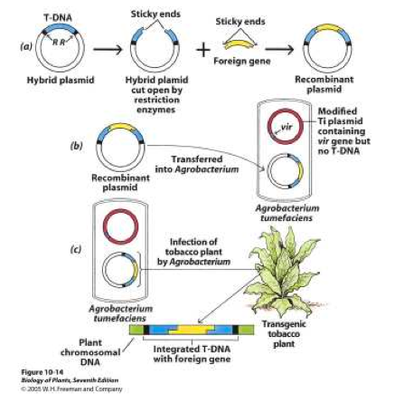

Application to natural products
- Production of complex medicinal compounds not easily synthesized in the lab
- High value medicine in low yield (taxol)
- Biosynthetic pathway study: vincristine
Vinca alkaloid pathway
- Vincristine and vinblastine are dimeric alkaloids from Madagascar periwinkle
- Effective therapy for hodgkins disease and leukemia
- Low yield in nature= expensive
Biotechnology applications
- Insect and disease resistance in maize
- Controlled ripening
- Reducing mustard oils in canola
- Molecular farming
Controlled ripening in tomatoes; 2 ways
- Endless summer
- Tomatoes have 1 gene necessary for ethylene synthesis; turned it around and put it back in; anti sense gene that produces messenger RNA that produces complimentary gene; double helix will form and turn off the gene; can be controlled
- Flavr Savr
- Targets cell wall instead of the ethylene; epgase gene is a pectin destroyer which softens the cell wall
Golden rice; neutraceutical
- Modified rice for vitamin A
- Vitamin A deficiency is leading cause of blindness around the world; rice was thought to help minimize this
- Issue was that there are many other essential nutrients still missing; engineering to containing more minerals to be a more complete food
- Used gun method to insert gene
Molecular Pharming
- Production of human and other protein therapeutics in plants
- Edible vaccines, blood clotting for factor 8

