Introduction to Business Management Final Exam Review

Part 1: Match the term with the description.

Part 2: Discussion Topics.

- Leadership and Motivation Theory Joint Characteristics

Leadership Theory:
- The process of influencing individuals or groups toward the achievement of goals

- The seven traits associated with successful leadership are drive, desire to lead, honesty and integrity, self-confidence, intelligence, job-relevant knowledge, and extraversion

- The Fielder model of contingency theory of leadership assumes that different situations require different leadership styles

- Hersey and Blanchard’s situational leadership theory states that successful leadership is achieved by selecting a leadership style that matches the level of the follower’s readiness. It also states that leaders must give up control as followers become more competent.

- Charismatic leadership increases motivation, and leads to greater employee satisfaction

Motivation Theory:
- Motivation is the processes that account for an individual’s willingness to exert high levels of effort to reach organizational goals, conditioned by the effort’s ability to satisfy some individual need

- Motivation works best when individual needs are compatible with organizational goals

- Maslow’s Hierarchy of Needs theory categorized needs into five different levels

- Individuals must satisfy lower-order needs before they can satisfy higher order needs

- Satisfied needs will no longer motivate

- Motivating a person depends on knowing at what level that person is on the hierarchy

- Maslow’s Hierarchy of Needs:

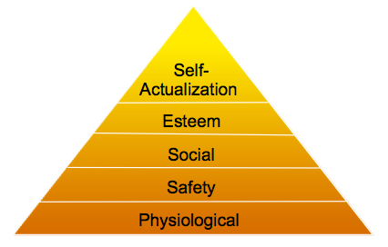

- McGregor’s Theory X and Theory Y states that motivation is maximized by participative decision making, interesting jobs, and good group relations

- Theory X: Employees have little ambition, dislike work, avoid responsibility, and require close supervision

- Theory Y: Employees can exercise self-direction, desire responsibility, and enjoy working

- Men tend to require more self-governing than women do

- Women desire learning opportunities, flexible work schedules, and good interpersonal relations

- Ways of motivating employees: recognizing individual differences, match people to jobs, use of goals, ensuring goals are attainable, individualized rewards, money etc.

Joint Characteristics:

Motivation is goal-oriented, and is what helps a person to achieve specific objectives. Motivation should drive the individual to work hard and perform to accomplish these set out tasks. A leader must have the right traits in order to motivate and drive employees to achieve these goals. A leader needs to have the ability to understand where each employee stands on Maslow’s Hierarchy of Needs, in order to know how to motivate each person to his or her specifications. In other words, leadership is used as a way of motivating others. Being a good leader and role model goes hand in hand with having successful, motivated employees. As employees success rate increases, leaders must need to know how to continue to keep them motivated, and as well give them more room to self-regulate.

- Scheduling Term
- Scheduling is detailing what activities have to be done, the order in which they are to be complete, who is to do each, and when they are to be completed by

- PERT Network is a flow chart diagram that depicts the sequence of activities needed to complete a project and the time or costs associated with each activity

- Events: End points that represent the completion of major activities in PERT Network

- Activities: The time of resources needed to progress from one event to another in a PERT Network

- Slack Time: The amount of time an individual activity can be delayed without delaying the whole project

- Critical Path: The longest or most time-consuming sequence of events and activities in a PERT Network

- Breakeven Analysis Input Term
- A technique for identifying the point at which total revenue is just sufficient to cover total costs

- Widely used resource allocation technique to help managers determine breakeven points

- Points out the relationship between costs, revenues, and profits

- The two main types of costs are fixed costs and variable costs

- Fixed costs: Expenses that don’t chance regardless of volume

- Variable costs: Expenses that change in proportion to output and include raw materials, labor costs, and energy costs

- The Breakeven formula:
Breakeven = Total Fixed Costs/ Unit Price – Unit Variable Costs
- Scenario Planning Term
- A consistent view of what the future is likely to be

- Developing scenarios can also be described as contingency planning

- The intent of scenario planning is not to try to predict the future but to reduce uncertainty by playing out potential situations scenarios ranging from optimistic to pessimistic

- Scenario planning is useful in anticipating some events, but not all, due to the fact that surprises cannot be foreseen

- Organizational Design Characteristic Term
- The process of developing or changing an organizations structure

- It involves decisions about six key elements: work specialization, departmentalization, chain of command, span of control, centralization and decentralization, and formalization

- Work Specialization: The degree to which activities in an organization are subdivided into separate job tasks; also known as division of labor

- Departmentalization: The basis on which jobs are grouped together

- Chain of Command: The continuous line of authority that extends from the top of the organization to the lowest level and clarifies who reposts to whom

- Span of Control: The number of employees a manager can efficiently and effectively manage

- Centralization: The degree to which decision making is concentrated at a single point in the organization

- Decentralization: The degree to which lower-level employees provide input or actually make decisions

- Formalization: The degree to which jobs within the organization are standardized and the extent to which employee behavior is guided by rules and procedures

- Human Resource Analysis Term
- Human Resources are the set of individuals who make up the workforce of an organization, business sector, or economy

- The professional discipline and business function that oversees an organizations Human Recourses is called Human Resource Management

- Human Resource planning is the process by which managers ensure that they have the right number and kinds of people in the right places, and at the right times, who are capable of effectively and efficiently performing assigned tasks

- Selection Test Measurement in Operations Terms
- The selection process is the process of screening job applicants to ensure that the most appropriate candidates are hired

- Errors in hiring can have far-reaching implications, however hiring the right people can pay off

- Selection exercises prediction, which means it seeks to predict which applicants will be successful if hired

- Validity: The proven relationship that exists between the selection device, and some relevant job criterion

- Reliability: The ability of a selection device to measure the same thing consistently

- Human Bargaining Term
- The process between an organizations management and a trade union representing its employees, for negotiating wages, working hours, working conditions, and other matters of mutual interest.

- To the management, this process presents (usually) one set of people to negotiate with; to the employees, it gives greatly enhanced bargaining-power

- Human Resource bargaining is the fundamental principle on which the trade union system is based

Part 3 (worth 60%): Written Passages (Only have to pick 3 of the 6):

- Management Control
- Management is defined as coordinating work activities so that they are completed efficiently and effectively with and through other people

- Controlling is defined as the process of monitoring activities to ensure that they are being accomplished as planned and of correcting any significant deviations

- Step 3 of the control process is taking Managerial Action.

- Courses of Action:
Doing Nothing: Only if deviation is insignificant

Correcting Actual (current) Performance: immediate or basic corrective action

Revising the Standard: Determining whether the standard is realistic, fair, and achievable

- Types of Managemenct Control

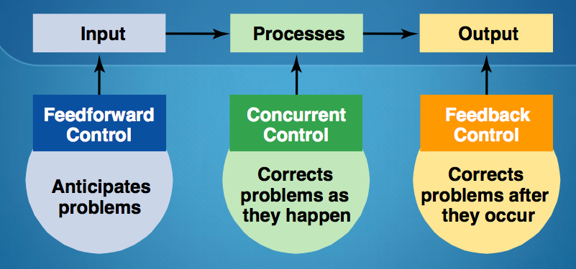
Managers can implement controls before an activity begins (feedforward control), during the time of the activity (concurrent control) and after the activity has been completed (feedback control).

- Financial/ Information controls: Management Information Systems (MIS): a system used to provide management with needed information on a regular basis

- Managers need financial controls and accurate information to achieve goals of profit creation. Managers can use financial/ information controls to monitor performance

- Traditional financial control measures include ratio analysis and budget analysis

- Motivation Theory (on one specific theory)

Theory #1: Maslow’s Hierarchy of Needs Theory
- Maslow’s Hierarchy of Needs theory categorized needs into five different levels

- Individuals must satisfy lower-order needs before they can satisfy higher order needs

- Satisfied needs will no longer motivate

- Motivating a person depends on knowing at what level that person is on the hierarchy

- Maslow’s Hierarchy of Needs:

Theory #2: McGregor’s Theory X and Theory Y
- McGregor’s Theory X and Theory Y states that motivation is maximized by participative decision making, interesting jobs, and good group relations

- Theory X: Employees have little ambition, dislike work, avoid responsibility, and require close supervision

- Theory Y: Employees can exercise self-direction, desire responsibility, and enjoy working

- Motivation is maximized by participative decision making, interesting jobs, and good group relations

Theory #3: Herzberg’s Motivation-Hygiene Theory
- Job satisfaction and job dissatisfaction are created by different factors

- Hygiene factors; Extrinsic (environmental) factors that create job dissatisfaction

- Motivation: Intrinsic (physiological) factors that create job satisfaction

- The theory attempted to explain why job satisfaction does not result in increased performance

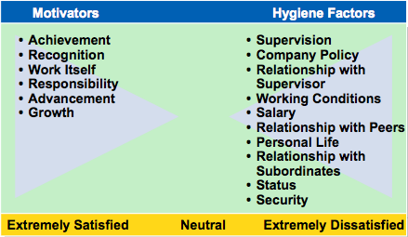
- The opposite of satisfaction is not dissatisfaction, but rather no satisfaction

Theory #4: McClelland’s Three-Needs Theory
- Three acquired (not innate) needs- achievement, power, and affiliation-are major motives in work

- Need for Achievement (nAch) is the drive to succeed and excel in relation to a set of standards

- Need for Power (nPow) is the need to make others behave in a way that they would not have behaved otherwise

- Need for Affiliation (nAff) is the desire for friendly and close interpersonal relationships

Theory #5: Goal Setting Theory
- The proposition that specific goals increase performance and that difficult goals, when accepted, result in higher performance than do easy goals

- Working toward a goal is a major source of job motivation

- The specificity of the goal itself acts as an internal stimulus

- Factors that influence the goal-performance relationship are Feedback, Goal Commitment, Self-Efficacy, and National Culture

Theory #6: Reinforcement Theory
- The theory that behavior is a function of its consequences

- Reinforcers are consequences (benefits) immediately following a behavior that increase the probability that the behavior will be repeated

Theory #7: Job Design Theory
- How tasks can be combined to form complete jobs

- Factors influencing job design:
Changing organizational environment/structure
The organizations technology
Employee’s skills, abilities, and preferences

- Job Enlargement is increasing the scope (number of tasks) in a job

- Job Enrichment is increasing responsibility and autonomy (depth) in a job

Theory #8: Job Characteristics Model (JCM)
- A framework for designing motivating jobs

- There are five primary job characteristics

- 1. Skill Variety: how many skills can talents are needed?

- 2. Task Identity: does the job produce a complete work?

- 3. Task Significance: How important is the job?

- 4. Autonomy: How much independence does the jobholder have?

- 5. Feedback: Do workers know how well they are doing?

Theory #9: Equity Theory
- Proposes that employees perceive what they get from a job situation (outcomes) in relation to what they put in (inputs) and then compare their inputs-outcomes ratio with the inputs-outcomes ratios of relevant others
- If the ratios are perceived as equal then a state of equity (fairness) exists

- If the ratios are perceived as unequal, inequity exists and the person feels under-or over-rewarded

- When inequities occur, employees will attempt to do something to rebalance the ratios (seek justice)

- Distributive Justice is the perceived fairness of the amount and allocation of rewards among individuals (i.e who received what?)

- Procedural Justice is the perceived fairness of the process used to determine the distribution of rewards (i.e how who received what)

Theory #10: Expectancy Theory
- Individuals act based on the expectation that a given outcome will follow and whether that outcome is attractive

- The key to the expectancy theory is understanding and managing employee goals and the linkages among and between effort, performance, and rewards

- Effort: Employee abilities and training/ development

- Performance: Valid appraisal systems

- Rewards (goals): Understanding employee needs

- Simplified Expectancy Model
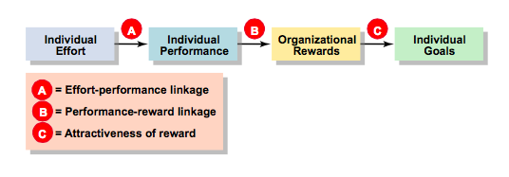
- Expectancy effort-performance linkage: The perceived probability that an individual’s effort will result in a certain level of performance

- Instrumentality: The perception that a particular level of performance will result in attaining a desired outcome (reward)

- Valence: The attractiveness/importance of the performance reward (outcome) to the individual

3. The Planning Process
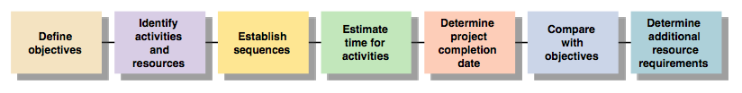
- Planning is the primary management function because it establishes the basis for all other functions

- Goals: Desired outcomes for individuals, groups, or entire organizations

- Plans: Documents that outline how goals are going to be met and that describe resource allocations, schedules, and other necessary actions to accomplish goals

4. Human Resource Management and Job Analysis
- Human Resource Management includes all activities used to attract and retain employees and to ensure they perform at a high level in meeting organizational goals

- Strategic Human Resource Management is the process by which managers design the components of an Human Resource Management system or process to be consistent with: Each other, other elements of the organizational architecture, and the organization’s strategy and goals

- Components of a Human Resource Management System:
Recruitment and Selection
Training and Development
Performance Appraisal
Pay and Benefits
Labor Relations

- Human Resource Management Planning: All activities that managers use to forecast their current and future Human Resources needs (demand and supply forecasts)

- Job Analysis is the process of identifying the tasks, duties, and responsibilities that make up a job (job description) and the knowledge, skills, and abilities needed to perform the job (job specifications)

- Job Analysis is an assessment that defines a job and the behaviors necessary to perform the job including knowledge, skills, and abilities

- Requires conducting interviews, engaging in direct observation, and collecting the self-reports of employees and their managers

5. Organizational Design
- Organizational Structure is the formal arrangement of jobs within an organization

- Simple Structure: A structure with low departmentalization, wide spans of control, authority, centralized in a single person, and little formalization

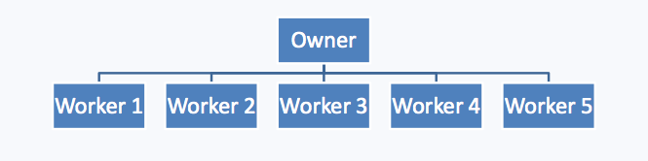
- Functional Structure: A structure that groups similar or related occupational specialties together

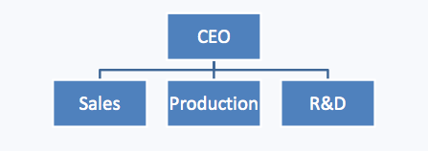

- Divisional Structure: A structure that consists of separate business units of divisions
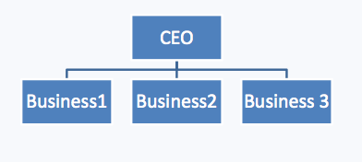

- Team Structure: The entire organization is made up of work groups or teams. Focusing tightly on controlling costs requires a mechanistic structure for the organization



