PSYC FINAL
Motivation: a need or desire that energizes behavior and directs it towards a goal. If Necessary its physiological, if desirable its cognitive.
Theories of motivation:
- Instincts : unlearned, complex, fixed throughout species
- Non Human: Bowerbirds
- Humans: rooting response & grasp reflex
- Adaptive: disgust

- Drive reduction: goal is homeostasis; steady balanced internal state (Tº, heart rate) To do this, when a need increases, the drive will reduce it increses.
- Drive: aroused state that occurs cuz of physiological needs.
- Need: lack or deprivation that energizes that drive to reduce the need
Need Drive Behavior EX: Sleep Tried Go to sleep
Incentives: positive or negative stimuli that motivates behavior
Need + Incentives STRONG Drive Behaviors more likely
Ex: Sleep+ comfy bed REALY tried Go to sleep sooner
Negative incentive: Sleep + Wet sleeping bag Not as tired Go to sleep later
Ex: Food Hungry Eat
Positive incentive: Food Smell cookies Really hungry Eat lots / sooner
BUT Drive reduction doesn’t fully explain Motivation: People often act in ways that INCREASE rather than DECREASE drive. (Diets)

- Optimum arousal: We are motivated to reach an optimal sate of alertness/ activation (instead of a biological based balance) Ex: Toddlers explore
Yerkes-Dodson law: Performance improves with physiological or mental arousal but only to a point. Ex: Curb: Performance is bet at Medium Arousal
Eyewitness testimony Application: When would we expect EWT to be most reliable.
- Anxiety: unpleasant emotional state where we fear something bad is about to happen. Induced by stressful situations and typically accompanied by physiological arousal.
Risk takers (sensation seeking): People differ in terms of the level of stimulation they enjoy and seek out based on gender, age and individual diffs. Ex: Base Jumpin

4. Maslow’s hierarchy of needs:
Can be over come ( hunger strike)
Interesting cross-cultural effects on subjective ratings of well-being
- Developing countries: financial satisfaction
- Wealthier countries: home-life satisfaction

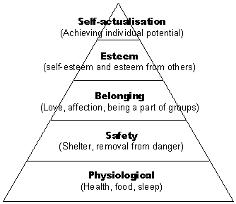
Hunger
Physiological consequences: Less active and weight loss
Psychological consequences: Loss interest in other activates and obsesses with food.

1. Stomach: contraction correlate with hunger pangs. But doesn’t explain hunger because people with removed stomach still get hungry and we can feel hungrey with a full stomach (old people).

2. Brain: Hypothalamus monitors levels of hunger hormones.
Activity in lateral hypothalamus: Leads to Hunger. Destruction = we stop eating.
Activity in ventromedial hypothalamus: inhibits hunger. Destruction = overeating.

Body:
Blood glucose: when it’s low your hungry. Insulin from pancreas processes it.
Leptin: protein secreted by fat cells that inhibits hunger and increases metabolism
Orexin: Released from Lateral hypothalamus when glucose drops.
Ghrelin: secreted by empty stomach and triggers hunger
PYY: Hormone in digestive track that inhibits hunger (temporarily)

Psychology of hunger:
Memory: plays role in Hunger and satiety. Amnesiacs can eat several meals. For us passage of time increases expectation of eating.
Stimulation/ emotions: Carbs increase serotonin levels witch calm us down.

Experience:
- It is adaptive to be wary of new foods.
- Learned taste aversion
- Cultural prefrences: repeated exposure increases appreciation for nrew food and exposure to novel food increases chance of trying other new foods.

Interaction of experience and situation: pregnant women develop strong tast aversions and cravings. Strongest un first trimester when fetus is most suscepteible to damage by toxins

Eating disorders:
Anorexia nervosa: Distorted body image and excessive limitation of food intake. (90% of female mostly teens)

Bulimia nervosa: binge and purge by vomiting fasting or excessive laxatives but weight fluctuates around normal leaves. Leads to anxiety and depression.

Explanation for eating disorders:
- Learned focus on weight or appearance by mothers.
- Childhood obesity and low self esteem (BN)
- High achieving competitive families (AN)
- Genetic links
- Evolutionary selection (natural selection)
- Cultural influences (highest rates in North America)

Sex
4.Sexual motivation: allows survival of the species (Kinseay reposts mid 1900s)
Physiological psychological and cultural factors. Hunger is necessary for survival sex isn’t.
Physiology of sex: 4 stages similar in men and women

1. Excitement: genitals engorge with blood. Vagina expands and secretes lubricant breast and nipples enlarge.

2. Plateau: Breathing, HB, BP, muscle tension continues to increase. Penis fully engorged and secrets pre ejaculation fluid. Vaginal secretion continues and clitoris retracts.

3.Orgasm: Muscle contraction through the body continued increase in breathing HR and BP. Orgasms are similar in men and women (cant tell witch gender is describing orgasms in written descriptions/ pet scans show same subcortical brain areas active during orgasm in both sexes) Vagina expands and narrows to help sperm into uterus. Uterus contracts similar in childbirth witch increases retention of deposited sperms

4.Resolution: Blood spreads away form genitals and no orgasm is possible its longer for males.

Sexual disorders:
- Motivational: lack of sexual energy or lack or arousablility
- Physiological: Premature ejaculation, erectile dysfunction and Orgasmic disorder

Sex Hormons: early in development, these direct development of sex characteristics and are later involved in sexual behavior.

- Estrogen: Peaks at ovulation, it increases sexual receptivity. (During ovulation, women are more attracted to men with more masculine faces and judge men with symmetrically bodies to have better smelling body odor.
- Testosterone: Drives male sexual activities, castrated rats lose sexual interest). But levels aren’t as strongly implicated in behavior as in women.
(Testosterone drives women’s sexual activity more then estrogen)

Non-Human animals: “advertise” ovulation (Conspicuous ovulation) with a change in body odor called “Estradiol surge”. Male become fierce and competitive. They mate a lot and typically get pregnant. (Humans don’t advertise, BUT do unconsciously wear tighter clothes and show more skin.)

Singh & Bronstad: Aske women with regular menstrual cycles ( not on pill) to wear a t-Shit for 3 nights during ovulation and do same when no ovulating.
Men rated ovulating T-Shirt more sexy and pleasant.

Psychologies of sex:
- External stimuli’s: Most people become aroused watching erotic material. It can affect our judgment of; Appropriate behavior, typical attractiveness, Sexual satisfaction. (Measured by brain imaging an various body measures.)
- Internal stimuli’s: Genital arousal during dreaming (even non-sexual). 95% of people have sexual fantasies at some point. Men’s are more frequent, more psychical based and less romantic.

Sex during Adolescence: US > Europe,

Factors that decrease:
- High intelligence
- Religion
- Father’s presence
- Community service

Factors that increase:
- Ignorance: don’t know about the birth control or protection. ( Sex Ed delays chances of having sex, and increases chance of practicing safe sex.)
- Embarrassment: don’t talk to anyone so remain uninformed.
- Guilt: less likely to carry condoms.
- Alcohol: Less use of condoms, poorer judgment, less inhibition.
- Media: Commonly portrayed causal sex, and rare safe sex.

STD’s: 66% = under 26 years of age. Girls= very susceptible. 40% of sexually active women between 14 and 19 have STDs. If you have sex 30 times using a 98% effective prevention method, your chances of getting and STD are 50% .

Sexual orientation: Rates of homosexuality depend on method and population but range around 1-10%. Homosexuality was considered a psychiatric illness by APA till 1973. Its more accepted but still ahs high rates of depression and suicide.

Origen: NOT learned form modeling of homosexual parents or bad childhood experiences. Can be due to functional and structural brain diffrences. (hypothatmus) or genetic links (twins)

Fraternal Birth order effect: Mother has many sons.. the younger ones have a greater chance of being homosexual.* Biology outweighs experience! Understanding = less discrimination

Index/ring the same = female Index shorter the ring = male. Or athletic girl

Motivation and work: May seem desirable not to work, but unemployment is linked to lower self-esteem and well being.

Industrial organization psych:

Human factors psychology: Explores how machines and environments can be designed to optimally fit human capabilities
Personnel psychology: Applies psychological methods and knowledge to select and evaluate workers. Identification of skills characteristic of successful employees. Depends on job: match strengths to particular job
Organizational psychology: Investigates how work environments and management styles influence worker motivation, satisfaction, productivity
Job interviews: informal interviews are much less effective than:
- Aptitude test
- Job knowledge tests
– Work samples
– References re past job performance
• Informal interviews typically lead to a ‘gut’ feeling
Causes of interviewer bias;
- Interviews focus on future intentions. This is not as good a predictor of future behavior as past behavior is.
- Interviewers don’t get to follow unsuccessful hires (biased sample)
- Assume people are how they seem in the interview
- Preconceptions, moods of interviewer influence judgment of applicants
Better interviews: Structured
- All applicants get the same questions: Med school, midwifery interviews
- Interviewer takes notes to decrease memory distortions and makes ratings to decrease bias (2x better prediction of job performance than unstructured interviews )
Emotions:
Purpose:
- Focus attention on relevant information
- Drive our behaviour
- Influence performance (Yerkes-Dodson law)
- u
Components of emotion:
- Physiological effects (physiology) – e.g., pounding heart, nausea, lack of energy
- Expressive behaviours (behaviour) – e.g., walking speed, facial expressions, tears
- Conscious experience (cognition) – e.g., thoughts, expectations, feelings
Theories of Emotions:

1. James-Lange Theory (1800’s) : Physiological effects precede conscious experience All emotions develop from (& can be reduced to) physiological reactions to stimuli Ex:You are swimming and see a shark. You swim quickly to the boat & climb in, heart pounding. Only then do the emotions of fear (and relief) wash over you.
2. Cannon-Bard Theory: Physiological arousal and emotional experience occur simultaneously. Physiological response isn’t specific enough to drive emotion
Ex: heart pounds for anger, love, fear • Stimulus triggering emotion sends message to: – cortex, leading to subjective emotional response – sympathetic NS, leading to physiological response
3. Two-factor theory: Physiological and cognitive factors combine to form emotion
– Similar to J-L theory in saying emotional experience grows from physiological factors
– Similar to C-B theory in saying emotions are physiologically similar (so we need a cognitive interpretation of the physiological response)
Sympathetic | ANS | Parasympathetic
Pupils dilate | Eyes | Pupils contract
Decreases | Salivation | Increases
Sweats | Skin | Sweat dries
Increases | Breathing | Decreases
Accelerates | Heart | Slows
Inhibited | Digestion | Activated
Secretion of stress hormones | Adrenal Glands | Hormone secretion decreases

Physiological Emotional responses:
Similarities: Perspiration, HR, breathing similar for fear, anger, sexual arousal
Differences: Brain activity
- Amygdala: Fear
- Right prefrontal cortex: disgust, sadness/depression
- Left prefrontal cortex: happy, positive moods (Linked to nucleus accumbens: active during pleasurable experiences)
Cognition and Emotion: Emotions affect thoughts, perceptions of our lives. Thoughts affect emotions too!
Existing emotions influence subsequent emotions:
EX: arousal from seeing your team win hockey game anger in riot
EX: sadness from learning grandma died moderates happiness at finding out that you made the swim team
Spill over effect: arousal response from one event spills over into our response to the next event
Emotion without/before cognition:
Fast and slow emotional routes: Amygdala can be activated by emotional stimuli even if we’re unaware that we’ve seen them! Basic emotions (e.g., fear, likes) are more likely to take the ‘low road’ than more complex emotions (e.g. guilt, love), which are heavily influenced by our cognitive appraisals of the situation
Slow (high road): Sensory organ thalamus cortex amygdala
Fast (low road): Sensory organthalamusamygdala
Non-verbal emotional expression: We are able to read and express emotions using facial expressions, body language, voice analysis,...
Women > men :
- Emotional sensitivity
- Emotional literacy
- Emotional responsiveness (ads)
- Empathetic displays
We are not very good at telling when emotions are sincere (Chance levels): But we can be taught to use cues and get better at detecting deceit
Universality of emotional expressions: There are 7 universal emotions. Different cultures express emotions with the same facial expressions but they do differ in terms of how emotionally expressive they are. EX: Japanese < American when in public.
Expressions affect emotions: Feeling blue? Smile! It Improves mood, Find comics funnier and Recall shappier memories
Engaging facial muscles influences mood: We feel sad when looking at sad pictures, but even sadder when asked to make eyebrows take ‘sad’ form
Fear: Baby table experiment.
- Adaptive
- Genetic links: Identical twins’ average fearfulness levels more similar than fraternal twins.
- Can be learned through experience and observation.
Describing Emotions:
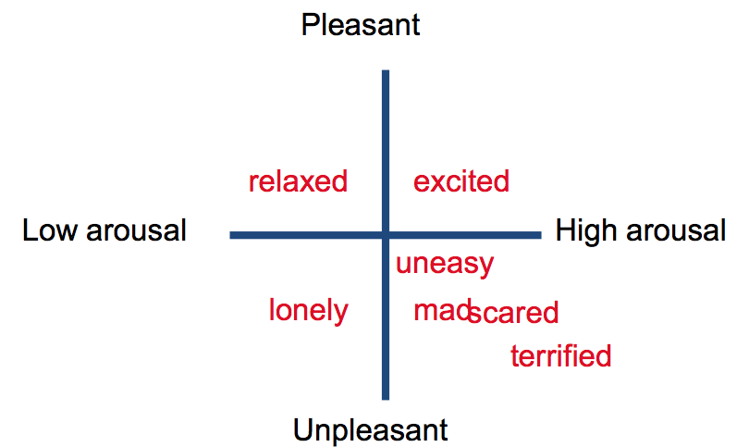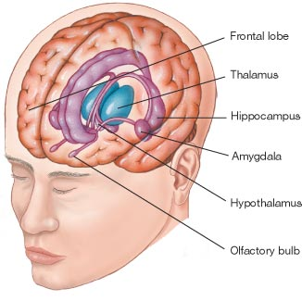
Learning fear: Amygdala: If removed, animals do not learn to fear new stimuli If damaged in humans, can maintain memory of learning fear, but do not experience it. Active when exposed to scary stimuli.
Happiness/Adaptation: Our subjective judgments of happiness influenced by both
Adaptation: recent experience influences reaction to events. Ex: Get computer= happy. Computer breaks = really sad to go back to school PCs even tho u weren’t sad before when u used them
Comparison: You have ur own computer, everyone else has Mac Book=your sad.
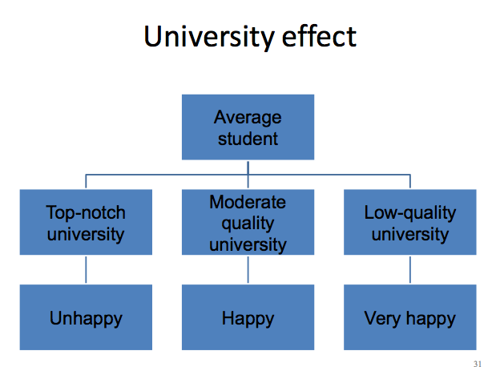

Take-home message: Emotions are complex and are influenced by:
- Environment/experience
- Genetics/biology
- Social/cultural factors

