Psychology midterm #2
Consciousness:
State of consciousness: awareness of ourselves and our environment. Like a spotlight on aspects of our daily life. (internal or external focus on passes present and future)
Cognitive neuroscience: studies brain and mental process.
- Most processing occurs beyond our consciousness.
- Behavior and mental states can conflict or separate (blind who act like they can see or hollow face illusion; we see convex but touch concave)
Selective attention: Limited amount we can consciously process at any one time. But certain things capture our attention. (our name at a cocktail party, driver talking on phones vs passengers, change blindness, pop out phenomenon)
Conscious vs automatic processing: We tune out a lot in our consciousness but take it in somewhere. (hear your name at a cocktail party, you can think back to what was said before)
Sleep and dreams:
Circadian Rhythm: biological clock, 24 hours cycle, influences wakefulness, body temperature and memory. Changes with age. Young people active later while old are active earlier. (starts around 20, but is earlier for women )
- Structures: Suprachiasmatic nucleus (SCN) in the Hypothalamus controls the CR by controlling release of melatonin by pineal gland.
- Chemicals:
- Melatonin: sleep inducing hormone (production increases with darkness, decreases with light)
- Adenosine: inhibitory neurotransmitter causes drowsiness (accumulates during day, declines during night)
“Morning light on retina stimulates suprachiasmatic nucleus in hypothalamus to decrease melatonin production.”
Jet lag: Disruption of CR (reset clock by exposing yourself to light or taking melatonin pills)
Caffeine and CR:
Adenosine binds to neurons and decreases their activity (= drowsiness)
Caffeine fits adenosine receptors, makes them fire. (Agonist)
Pituitary gland responds to increased firing releasing hormones that make adrenal glands produce adrenaline. (stimulates sympathetic nervous system)
Sleep: 1/3 of life. Most people need 7-9 hours ( culture, individual, age, and genes)
Without sleep:

Immune functions and concentration deteriorate.
Risk of accidents increases.
Fatigues sub. Death
Bad learning and memory
Increased appetite
Irritability and ADHD
Impaired judgment
Hallucinations
Type two diabetes
Increased heart rate/ heart disease
Tremors/ aches
Reduces reaction time
Growth suspension
Obesity
Decreased Temperature
Sleep theories:
- Protective: Dangerous to be out at night
- Restorative: body and brain have time to repair themselves
- Cognitive: Better memory and Creativity after sleep
- Growth: GH released by pituitary gland during sleep
Measuring sleep: Left and right eye movement, Muscle tension, and Brain waves.
Sleep stages (90 mins cycles):
Awake and relaxed: Alfa waves (large amplitude, slow and regular)
Stage 1-2 Early light sleep: Theta waves (high amplitude slow and Irregular)
Stage 3-4 Deep sleep: Delta waves (large amplitude, slow)
After stage 4, cycle moves backwards to stage 1; Beta waves 15-40 cps. This is dreaming (low amplitude, fast, regular)
Cycles of sleep stages:
REM sleep cycles become lengthier as night progresses
Stage 4 occurs earlier in the night.
Discussion and review of major concepts
Priming task: measures how good brain is at making associations. (How?) How do you think this works in the brain?
2. How do we dream? Our brains are especially good at making sense of random associations during REM sleep. What evidence do they give in support of this?
3. Why do we dream? To learn. Evidence: Sample of convenience? Paired associate task? Logic task?
Drugs and Consciousness
Psychoactive Drug: Chemical substance that alters perception and mood.
Dependence and addiction:
- Tolerance: when you use a drug reputedly, your body anticipates it and counteracts its effects. You need more drugs to get the same effect.
- Withdrawal: You can tell when the drug is no longer in your body. Your body is still counteracting its effect, but the drug is no longer there.
- Dependence: Absence of a drug may lead to a feeling of physical pain, intense craving (physical dependence) and negative emotions ( psychological dependence)
- Addiction: You compulsively crave the drug, despite its adverse psychological and physical consequences.

3 categories of psychoactive drugs:
Depressants: reduce neural activity and slow body functions. - Alcohol, barbiturates, opiates
Stimulants: excite neural activity and speed up body functions. - Caffeine, nicotine, cocaine, ecstasy, amphetamines, methamphetamines
Hallucinogens: distort perceptions, evoke sensory image (absence of Sensory input) - LSD (acid), THC (marijuana)
Alcohol:
- Enhances inhibitory pathways (GABA), interferes with excitatory pathways
- Lowers inhibitions (cortex); placebo effect: when you think you drank
- Disrupts memory formation (hippocampus) – interferes with REM
- Reduces self-awareness (frontal lobe)
- Exaggerates emotions (amygdala)
- Slows neural processing (multiple areas) – reaction time, slurred speech
- Decreases coordination and balance (cerebellum)
- Increases sexual desire but decreases sexual ability (hypothalamus)
- Diuretic (pituitary gland, hypothalamus) – Inhibits secretion of hormone that signals kidneys to absorb water
- Induces sleepiness/coma/death (medulla)
Cocaine: induces immediate euphoria followed by a crash.
“Cocaine blocks reuptake of Dopamine, Norepinephrine and Serotonin by binding to the sites that normally reabsorb neurotransmitter molecules. The extra neurotransmitter molecules therefore remain in the synapse, intensifying their normal mood altering effects and producing a euphoric rush. When the cocaine level drops, the absence of these neurotransmitters produces a crash.”

Ecstasy (MDMA):
- Stimulant and mild hallucinogen
- Euphoric high
- Can damage “serotonin producing neurons” - permanent low mood - impaired memory

Alcohol | Depressant | Initial high fallowed by relocation and disinhibiting | Depression, memory loss, organ damage, impaired reactions
Heroin | Stimulant | Rush of euphoria, relief from pains | Depressed physiology, agonizing withdrawal
Caffeine | Stimulant | Increased alertness and wakefulness | Anxiety, restlessness, insomnia. Uncomfortable withdrawal in high doses.
Methamphetamine | Stimulant | Euphoria, alertness, energy | Irritability, insomnia, hypertension, seizures
Cocaine | Stimulant | Rush of euphoria confidence energy | Cardiovascular stress, suspiciousness, depressive crash.
Nicotine | Stimulant | Arousal, relaxation, sense of well being | Heart disease, cancer from tars
Ecstasy (MDMA) | Stimulant mild hallucinogen | Emotional elevation, disinhibition | Dehydration, overheating, depressed moods, cognitive and immune functions.
Marijuana | Mild hallucinogen | Enhanced sensation, relief of pain, distortion of time, relocation | Impaired learning and memory, increased risk of psychological disorders, lung damage from smoke.

Factors that influence drug use:
Biological: genetic tendencies, dopamine reward circuit.
Psychological: Lack sense of purpose, stress, psychological disorders (depression).
Social-cultural influences: urban environment, drug using cultural groups, Peers.

Learning
Learning: relatively permanent change in behavior due to experience. Have to be able to adapt to our environment.
- Experiences = Changes in the nervous system (chemical or physical)
- Allows us to adapt our behaviors to the environment
- Interactions among the motor, sensory, and memory systems
Types of learning:
A) Habituation: Decline in responsiveness after repeated presentations of a stimulus. Stimulus becomes familiar. Simple reflexive behaviors or sensations . Demonstrates memory. Useful in animal and infant studies (baby gets board). Can be short or long term. Specific to stimulous.
Habituation Paradigm:
Can infants discriminate differences in grating density? Repeatedly show one grating, then show the other.
Does the infant look longer (dishabituate)? Response decreases with repeated stimulation
With time there is partial recovery (baby responds a bit again)
With enough time there is full recovery (baby responds as much as the first time)

B) Classical conditioning:
Learned association between:
a neutral stimulus + a meaningful stimulus.
The learned association elicits a response to the neutral stimulus.
Ex: Ivan Pavlov (1849-1936); ‘Pavlovian conditioning’
Digestion research
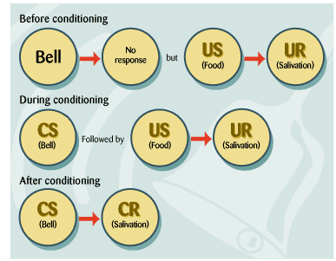
Unconditioned (US): automatically provokes a response (UR)
Conditioned (CS): does not provoke the response
*During conditioning, pair CS and US repeatedly
Test of learning: Does the CS alone produce a response?

Little Albert:

1. Before training
US: noise UR: crying
CS: Rat CR : ?
2. Conditioning
CS:Rat US: noise UR: crying
3. After Conditioning
CS: Rat CR: crying
4. Second-order Conditioning
CS2: Cages CS: Rat CR: crying
CS2: Cage CR: crying
Ex: Ethan automatically shows signs of arousal when he sees images of scantily dressed women. Pictures of beer labels, on the other hand, do not elicit a reflexive response. Brand X Beer shows scantily dressed women in their commercials. After repeated pairings of the images of women with pictures of Brand X Beer labels, Ethan shows signs of arousal when he sees Brand X Beer labels.
Identify the US, CS, UR, CR.

Real life application: Classical conditioning helps us prepare for a stimulus
• Taste aversions
• Phobias
• Drugs
• Physiological compensatory responses
Drugs and Classical conditioning: Compensatory response. Withdrawal worse when in setting where drug was taken
Critical components:
- Drug
- Physiological effects
- Environmental characteristics/events
- Homeostasis attempts
Acquisition (initial learning): Order is important: Learning is best when CS is followed by US.
1. Forward conditioning: CS presented before US. CS stays on until US is presented. Most effective, especially when the delay is short. Ex: a bell begins to ring and continues to ring until food is presented.
2. Simultaneous conditioning - CS and US presented together. Not very effective. Ex: bell rings when food is presented. Both begin, are, and end at the same time.
3. Backward conditioning - US occurs before CS. Ex: food presented, then bell rings. Not very effective, although some exceptions (pain).
Extinction: Present CS without US. Lose CR to CS.
*Spontaneous recovery. With passage of time CS will occur again (though weaker)
Generalization: CR to range of CS-like stimuli
- US: shock
- CS: 500Hz tone
- CR: fear of tones
- Other CS: = 300-700Hz
- Generalization gradient
Discrimination: CR is very specific to CS. Opposite of generalization
- Pair 500Hz (CS+) with shock (US), but not 600Hz (CS-)
- CS- also learned
- Negative contingency
Summary:
Classical conditioning involves learning an association between two stimuli
This association can help you prepare for one stimulus (US) by knowing it typically occurs with the other stimulus (CS). This preparation is shown by the CR.
The CR is often, but not always, the same behaviour as the US (But it is in response to a different stimulus)
C) Operant conditioning: Association between a behavior and a consequence.
“Rewarded behavior is likely to recur” - Thorndike’s Law of Effect
1) A baseline rate of behavior is observed.
2) A consequence of the behavior is introduced.
3) As the result of the consequence, there is a change in the rate of occurrence of the behavior.
Can lead to complex behavior:
• Behaviour is emitted semi-randomly and then modified by its consequences
• Learn contingency between behavior and its consequences
– e.g., sounds words in infants
Types of Consequences: does behavior increase of decrease?

Increases = Reinforcement
Decrease = Punishment

Is behavior affected by ADDITION or REMOVAL of stimulus?

Addition = Positive
Removal = Negative

Timing of consequences: Learn best when consequences is delivered right after the behavior. (Prevents confusion)
Lil Albert is condition to be scared of little white rats, Birds conditioned to peak a red key for food.
Generalization: Albert associates little white rat to bunny/teddy bear. Bird will press blue and green key too.
Discrimination: Teach Lil Albert the different between little white rats and bunny/ teddies. Teach Bird that food come when he presses red key but not green or blue.
Extinction: Stop delivering loud noise with the little white rat; Lil albert stops being scared of the rat. Stop delivering food after peaking red key: bird will stop peaking completely
Shaping: Behaviors that happen by chance and subject learn to repeat it . But some complex behavior may never happen by chance. We can reinforce successive approximations 2 get the desired behavior. Ex: Mother teaching baby to say “mama”
Primary reinforcement: rooted in biology. Unlearnd. Gain comport of end discomfort. Ex: Eat, Drink, Sleep, Sex, Warmth.
2th reinforcement: Learned through association with primary reinforcement. Ex: Money, Good Grades, Praise.
2th/condition reinforcement: repeated pairing of natural reinforce with stimulus.
Schedules of reinforcement:
Continuous: Reinforce every time behavior accrues
Partial/ intermittent: Reinforce sometimes when behavior accrues
- Fixed ratio (FR): reinforces after given number of correct responses Ex: Get a free coffee after buying 9
- Variable ratio (VR): reinforces after an unpredictable number of correct responses Ex: Win at slots after pulling handle average of 100 times
- Fixed interval (FI): reinforces for first correct response after a set time period Ex: Check mail; arrives after 24 hours
- Variable interval (VI): reinforces for first correct response after an unpredictable time period Ex: Check email; SMS every 10 mins on averag .
Humphrey’s paradox: Best resistance to extinction = start with Continuous and finish with Partial. Ex: FR25 vs FR250
C) Operant and cognition condition
Skinner was against the belief that cognitive processes play a major role in conditioning. But there’s evidence they do.
Toman’s rats: mental map
First the rats learn to follow the tunnel that leads to the food
When the tunnel to the reward is blocked, the rats follow their metal map and choose the tunnel that leads in the direction where they know the food to be.
With no food there is some reduction in errors, but not as great as it was with food. Despite the higher error scores prior to the instruction of food, the group who got food only on the 11th trial immediately begins to do as well as the group that always got food. The interpretation is that some learning went on within the first 10 trials witch did not show in performance until the food incentive activated it.
E) Observational learning / Modeling
Imitating someone else’s behavior, or noticing the consequences of their behavior. Mirror neurons. (babies)
- Helps us Learn new behaviors
- Determine when to make or avoid making certain responses, depending on the observed consequences of those behaviours
- Learn rules that can be applied to new situations
To learn through modeling we must…
- Pay attention to the model
- Remember what was observed
- Be able to reproduce the modeled behavior
- Be motivated to display it.
We are more likely to reproduce an observed behavior if:
- We observed the model being rewarded for behavior (kids abusing doll)
- The model is attractive, trustworthy, capable, admired, powerful, status.
Memory
Memory: Learning that has lasted and been stored. Learning that needs to be retrieved to be accessed. Memory is critical for survival / we also need to forget.
Automatic/ effortless memory:
• Time – Where did you last see your cell phone?
• Space – What part of the page did you finish on?
• Frequency – How many times have you seen your friend today?
• Familiar information – Hard to ‘turn off’ well-practiced skills = Stroop effect Ex: reading colors vs seeing them
Models / Theories: Abstractly describe the general way the mind processes information
Diagrams: boxes represent components of mind while arrows represent flow of information
*Models tested by testing the hypotheses they generate on real people
Information-processing models: View the mind as a computer. Ex: Encoding (type). Storage (save). Retrieval (search and open)
Modal Model of the minds/ Information processing model:

Sensory Input Sensory Store Short term store (STS) Long term store (LTS)
Decay Forgetting Forgetting
Problems with A&S Multi Store Model: They suggest that memory item being transferred into LTM increases with the time it resides in STM. But simply keeping a memory item in STM doesn’t mean it will end up in LTM. What MATTERS is the processing the item undergoes in the STM.
Modification of the model: Baddeley & Hitch (1974)
STM doesn’t just hold memories, it works on them = Working Memory (WM)
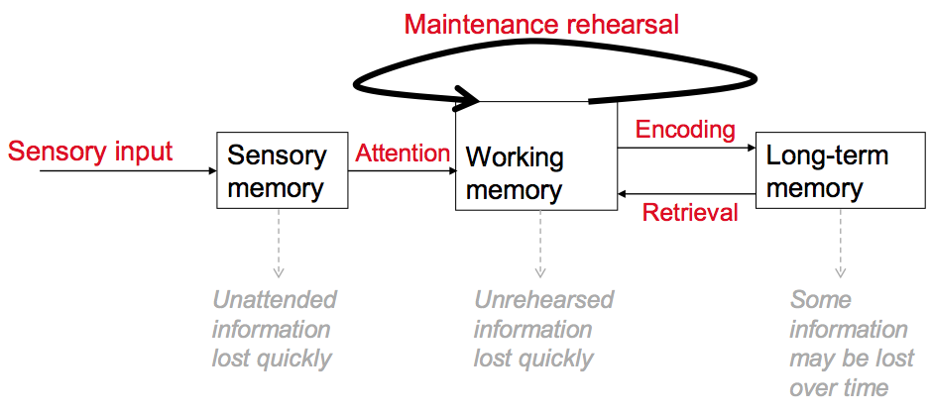
Sensory Memory: Trace of ENTIRE sensory input. Accessible even when not attending input. Have to attend to move it to WM.
- Auditory: 3-4 seconds. Echoic memory “what did I just say?”
- Visual: Less then 1 second. Iconic memory.

Iconic Memory: Sperling 1960. Showed subjects a square made of letters.
- When shown very briefly ; only about 50% of letters reported
- When played tone right after image disappeared to cue which row to report, could report very accurately.
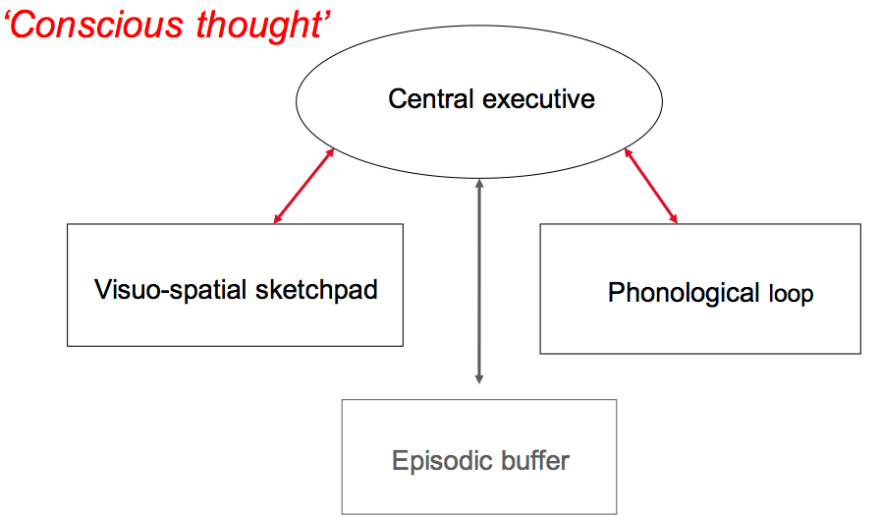
Long-term memory: Stores everything we know. Huge capacity! Passive, not active. Long duration.
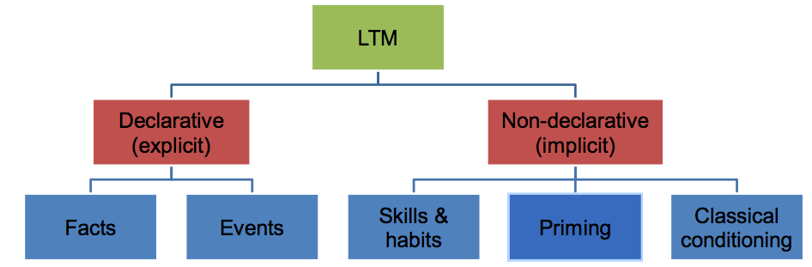

Phonological loop: We rehearse to remember.
Evidence for rehearsal: Brain areas active during verbal memory tasks are the same as those active during speech and listening. & Serial position curve.
Limited capacity of WM: Limited by how many things we can hold in WM, but can do parallel processing of different modes.
- For phonological items, 7 +/- 2 items. (5-9 in auditory)
- Digit span on IQ tests : Memory span depends on items, chunking...
Without rehearsal, information can’t be held in WM very long (max 15-30 seconds, depending on modality)
Visuo-spatial sketchpad: Someone asks you for directions from campus to parliament buildings. Maybe they want to know what side of the street parliament will be on. What do you do mentally to give directions? (imagine yourself there) - Test of metal rotation. (The more image is rotated the longer its takes to identify)
Evidence: Damage to areas involved in visual abilities interferes with doing similar tasks in WM. Patient with brain damage that interfered with his ability to identify objects by sight. Had difficulty answering questions that would require picturing objects in WM. Ex: does a bear have a long or short tail?
Dual-task performance in WM: It’s easy to do two things at once as long as they don’t use the same component of WM. Ex: rotate the letter b 180° and repeat the following numbers (1, 5, 2, 8, 3) – what letter is it? Vs. Rotate the letter b 180° and count the number of corners on the letter - what letter is it?
So remembering a series of patterns on a set of dominos won’t interfere with remembering a set of numbers. (Unless you try to code it verbally)
Provides strong evidence for the different components of WM
Tips for strong memory:
• Practice makes perfect; Practice retrieving while encoding.
• Expand rehearsal; Spread out learning. Disadvantage of summer course.
• Organize it; Levels of processing.
Organization:
- Mnemonics; ‘Never Eat Shredded Wheat’
- Visualization; Associate a vision with list words
- Chunking;12504896020 = 1-250-489-6020
- Hierarchies; Remember what you need to buy at the store by breaking it down: 3 dairy items, 7 fruits, 1 bread item, 2 cleaning items

Levels of processing
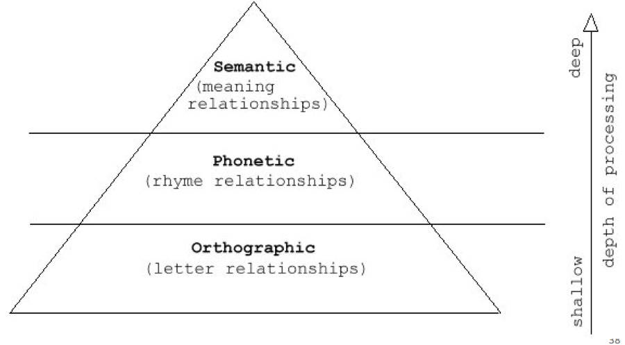
More tips for strong memories: Elaboration requires deeper processing of information, so it can help you remember.
- Rework: put in your own words. Talk about it with someone
- Method of loci: Link material (list) to a familiar place/route
- Imagery: create image of what you want to remember (mind map) elaborate on it by encoding it visually. Encode in two modes (verbal and visual)
Hippocampus and memory: H.M (Henry Gustav Molaison)Hippocampus was removed in 1953 as a cure for his epilepsy. Shortly after the operation, developed memory problems. H.M. could not form new long-term memories
– Hippocampus plays a role in forming LT memories because He could remember things for short periods of time
– Hippocampus not involved in forming ST memories (WM) because He maintained memories of events before the surgery
- Hippocampus is not the area where LT memories are stored or accessed; it is the area that converts ST memories (WM) to LT memories
- Hippocampus not crucial for many functions aside from memory because His other mental functions were all basically normal
- Declarative LT memories are formed in the hippocampus, but procedural (non-declarative) LT memories are not because H.M. could not remember facts, names, images and other pieces of information associated with declarative long-term memories formed after the surgery, but he could remember motor skills learned after the operation
* Evidence from other studies that the cerebellum is crucial for these, at least for reflexive memories like classical conditioning
But memory doesn’t just happen in one place in the brain
Long-term potentiation (LTP): Memory mechanism.
- Synapses change as we learn and then require less stimulation to fire next time
- Neurotransmitters and proteins allow this change in sensitivity, so researchers are trying to influence these to influence memory (Alzheimers, etc.)
Implications: Formation of declarative (remember learning it) and non-declarative memories is done by separate processes in our brain
- Our brain functions as several entities-each area has its own specialized functions (areas interact to create a whole mental process)
- We don’t know where LT memories are stored (may not be in any specific area, but broken up and assembled when needed
Flashbulb memory: Strong emotion at the time of encoding helps us form stronger memories. But long-term stress can interfere with forming memories. (Mouse)
Where were you when… you heard about Canada’s first Olympics gold? 9/11?
Getting information out of LTM: Recall vs. Recognition
Recall: report items previously studied
Recognition: select items previously studied
*Recalling harder then Recognition, but recognition is very susceptible to false memory effect.
Retrieval cues and context effects:
Memories formed as networks. To retrieve the info: It helps if you can cue the memories of the learning context. Ex: Your memory of this material will be linked to memories of the classroom, who was sitting beside you, your emotional state, the time of day,
State-dependent learning: we remember best in the same setting that we learned Ex: Scuba divers, Marijuana/alcohol
Moods: Forms a cycle. Ex: When you’re depressed you’re more likely to remember sad memories. And when you’re happy you’re likely to remember happy memeories.
Forgetting
Forgetting: We need to forget, but often forget what we don’t want to.
Encoding failure: If we don’t pay attention during encoding due to distraction or irrelevant info, the memory wont be stored. Ex: Meet someone ; forget their name.
Storage Decay: Unused info gets lost/deleted; “use it or lose it” Ex: Keyboard
Retrieval failure: Tip of the Tongue phenomenon
Retroactive interference: New information makes it harder to remember something you learned earlier Ex: What is your old postal code?
Proactive interference: Something you learned earlier makes it harder to learn new information Ex: Harder to learn to drive automatic after learning stick shift
Scripts: Top-down structures used in memory of familiar events. Consists of a series of slots that are filled. Ex: Laundry story
Manipulation of suggestibility: See event. Expose false information Ask memories of the event.
- Look at the daylight savings time study (p. 100)
- Read Sleep Disorders and Dreams(p. 101-107)
- Read Hypnosis (p. 108-112)
- Read Near-death experiences (p. 126-128)
- Read Memory Construction (p. 356-364)
- Read Improving Memory (p. 364-365)

