Thursday October 4th 2012
PSY 1102 – Developing Through the Life Span Part 3 – 1 HOUR 20 MIN 50 M/C
Questions based on textbook and lectures
Everything we’ve covered; Intro and Chapter 4 and Chapter 5
-What we do helps us develop morality
Social Development
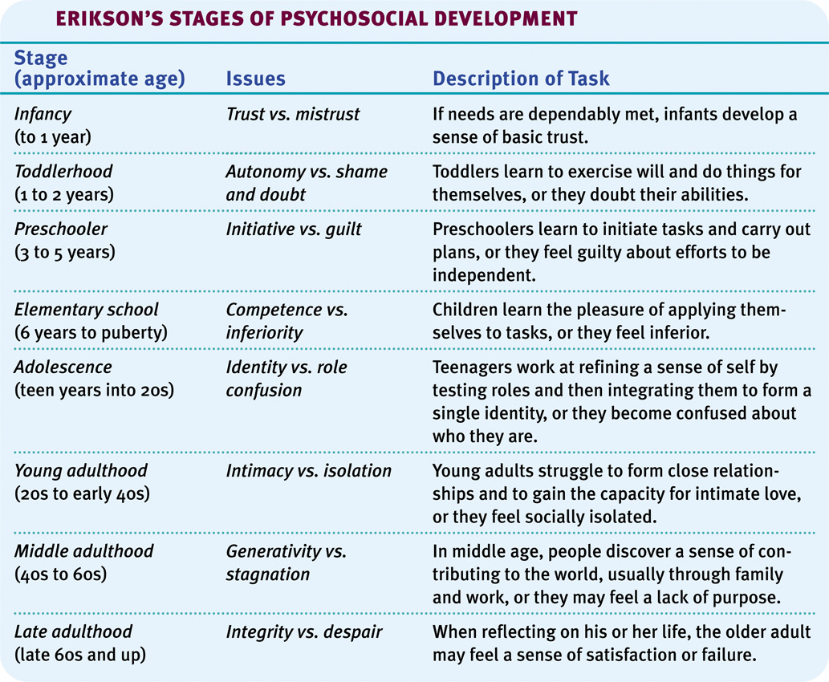
Parent and Peer Influence:
-Although teens become independent of their parents as they grow older, they nevertheless relate to their parents on a number of things, including religiosity and career choices. Peer approval and relationships are also very important.
-More like peers in terms of the way they dress, the way they talk.
-Frontal lobe not as well developed; more emotional more irrational, not the big storm or ‘turmoil’
-Positive relationships with their parents and peers

Emerging Adulthood
-Emerging adulthood spans ages 18-25. During this time, young adults may live with their parents and attend college or work. On average, emerging adults marry in their mid-twenties.
-Risky behaviours peak; sex, reckless driving, drugs, DUI
-Social factors contribute to this longer period of time; people stay in school, establish jobs wait longer before getting married and having children; affects how many children you may have if you begin having kids later in life; not as fertile.
Adulthood;
-Although adulthood begins sometime after a person’s mid-twenties, defining adulthood into stages is more difficult than defining the stages of childhood or adolescence.
-Changes related to life events trigger change whereas with children it is the age that triggers change
Physical Development
-The peak of physical performance occurs around 20 years of age, after which it declines imperceptibly for most of us.
Middle Adulthood
-Muscular strength, reaction time, sensory abilities and cardiac output begin to decline after the mid-twenties. Around age 50, women go through menopause and men experience decreased levels of hormones and fertility.
Old Age:
- In 2006, Within a decade, the largest household age group will be seniors, and the smallest will be 15-34 years.
- Seniors will be the largest group of people in Canada by 2016; fastest growing demographic;
- People prefer to die at the age of 91
Old Age: Sensory Abilities
-After age 70, hearing, distance perception, and the sense of smell diminish, as do muscle strength, reaction time, as do muscle strength, reaction time, and stamina. After 80, neural processes slow down, especially for complex tasks
-At age 70, our motor abilities also decline. A 70-year-old is no match for a 20-year-old individual. Fatal accidents also increase around this age.
-Immune systems tend to be weaker; yet elderly so not as likely to develop colds, more susceptible to fatal illnesses, life threatening illnesses like pneumonia
-If you exercise your ability to be active your capacity and tolerance expands
Cognitive Development:
-Do cognitive abilities like memory, creativity, and intelligence decline with age the same way physical abilities do?
Aging and Memory
-As we age, we remember some things well. These include recent past events and events that happened a decade or two back. However, recalling names becomes increasingly difficult.
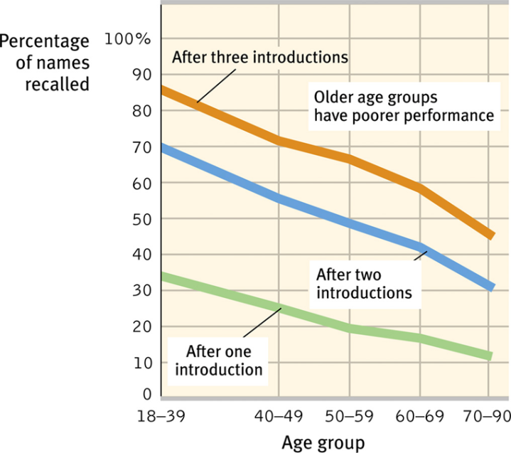
-Recognition memory does not decline with age, and material that is meaningful is recalled better than meaningless material.
Aging and Intelligence:
-It is believed today that fluid intelligence (ability to reason speedily) declines with age, but crystalline intelligence (accumulated knowledge and skills) does not. We gain vocabulary and knowledge but lose recall memory and process more slowly.
-Fluid intelligence= problem solving/conflict resolution declines over time
-Crystalline intelligence= accumulated awareness of history remains the same over time
-Cross-sectional studies taking groups from each age group and tests them all; doesn’t take in fact that these people have different levels of education different backgrounds
-Longitudal study tests you at each age; demonstrates intelligence stays the same; doesn’t take in account the fact there is dropout, we don’t know the ones that disappear it’s the ones who are super active and read often ;
-It’s not helpful to look at just intelligence; there are certain aspects of intelligence that remain the same and certain aspects that
Social Development:
-Many differences between the young and old are not simply based on physical and cognitive abilities, but may instead be based on life events associated with family, relationships, and work
Adulthood’s Ages and Stages
-Psychologists doubt that adults pass through an orderly sequence of age-bound stages. Mid-life crises at 40 are less likely to occur than crises triggered by major events (divorce, new marriage).
-Research doesn’t support mid-life crisis ; no evidence of emotional instability
-No set age for changes on adults’ internal clocks
Adulthood’s Commitments
-Love and work are defining themes in adult life. Evolutionary psychologists believe that commitment has survival value. Parents that stay together are likely to lead a viable future generation.
-What do people like most about marriage?
(35%) The relationship
(15%) Sense of security
(9%) Partner traits
(5%) Sense of family
(2%) Children
-One study suggested: the stability of marriage is the best predictor of dying or staying alive
-Marital distress appears to affect the physiology of men and women
-Preliminary evidence suggests that a happy marriage may boost immune system functioning
-Relationships effect our stress levels; long-term stress puts a big load on your immune system, makes you more susceptible to catching long-term diseases
-Happiness stems from working in a job that fits your interests and provides you with a sense of competence and accomplishment; jobs are central to our sense of self
-People who are very unhappy with themselves tend to be unhappy with their jobs and tend to be very ill
-People change paths and majors; may not use what they are learning in university right away; people change their work commitments
Well-Being Across the Life Span
-Well-being and people’s feelings of satisfaction are stable across the life span.
Successful Aging:
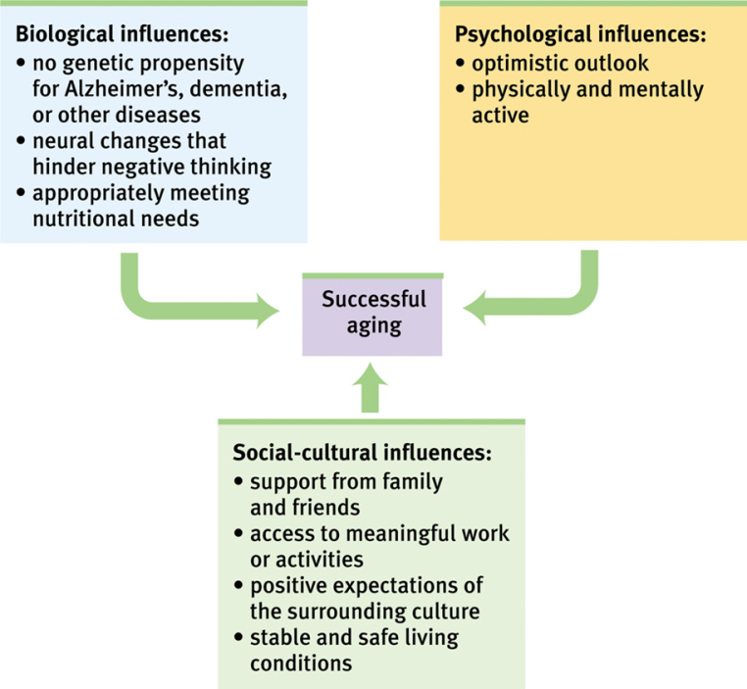
-70 today is not 70; thirty years ago
Death and Dying:
-The “normal” range of reactions or grief stages after the death of a loved one varies widely. Grief is more severe if death occurs unexpectedly. People who view their lives with a sense of integrity (in Erikson’s terms) see life as meaningful and worthwhile.
REFLECTIONS ON 2 MAJOR DEVELOPMENTAL ISSUES: Continuity and Stages
-Researchers who view development as a slow, continuous process are generally those who emphasize experience and learning. Those with a biological perspective, on the other hand, view maturation and development as a series of genetically predisposed steps or stages. These include psychologists like Piaget, Kohlberg and Erikson. –Develop at fixed stages based on age
Stability and Change
-Lifelong development requires both stability and change. Personality gradually stabilizes as people age. However, this does not mean that our traits do not change over a lifetime. Some temperaments are more stable than others.

