PSY 1102 – Promoting Health Chapter 12 Tuesday October 30th 2012
Promoting Health
-Promoting health is generally described as the absence of disease. We only think of health when we are diseased. However, health psychologists say that promoting health begins by preventing illness and enhancing well-being, which is a constant endeavor.
Coping With Stress
-Reducing stress by changing evens that cause stress or by changing how we react to stress is called problem-focused coping (ex. Not procrastinating; something you can change)
-Emotion-focused coping is when we cannot change a stressful situation, and we respond by attending to our own emotional needs. (ex. Exercising, meditation, listening to music, warm bath) the best option when you have no control over a situation in which you took action
Perceived Control
-Research with rats and humans indicates that the absence of control over stressors is a predictor of health problems
-Having control over our environment has a huge impact on our health
Explanatory Style
-People with an optimistic (instead of pessimistic) explanatory style tend to have more control over stressors, cope better with stressful events, have better moods, and have a stronger immune system.
-Can be overly optimistic; not recognize warning signs in a situation (too extreme)
-Optimistic people tend to outlive pessimistic people; those who laugh more are less likely to have heart disease
Social Support
-Supportive family members,, marriage partners, and close friends help people cope with stress. Their immune functioning calms the cardiovascular system and lowers blood pressure.
-Going out with friends= short term coping strategy, coupled with behavioural phenomenon keeps us stuck in the bottom right hand quadrant . We are built to work hard for long/short periods of time before taking a break to undergo stress relievers. It is suspected that individuals who don’t have secure attachment cannot undergo a strong social support.
-People who are married tend to be less stressful compared to those single and non-married
-Pets can have calming effect; just as effective as talking to a friend helps put things in perspective
Managing Stress Effects
-Having a sense of control, an optimistic explanatory style, and social support can reduce stress and improve health.
Aerobic Exercises
-Many studies suggest that aerobic exercise can elevate mood and well-being because aerobic exercise raises energy, increases self-confidence, and lowers tension, depression, and anxiety.
-Seems to boost neurotransmitters associated with elevated moods
Biofeedback, Relaxation, and Meditation
-Biofeedback systems use electronic devices to inform people about their psychological responses and gives them the chance to bring their response to a healthier range. Helps control specific areas of muscle tension; decrease heart rate, blood pressure, to change physiological factors in your body.
-Relaxation and meditation have similar effects in reducing tension and anxiety
Life style Modification
-Modifying a Type-A lifestyle may reduce the recurrence of heart attacks. Chew slower, talk slower, MANAGE ANGER BETTER. People who change their lifestyle have reduced risk of heart attack.
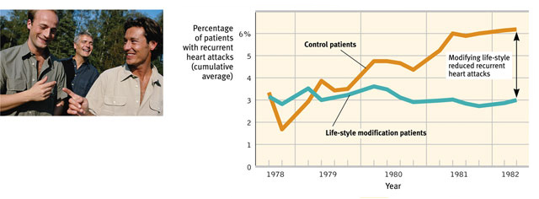
Spirituality and Faith Communities
-Regular religious attendance has been a reliable predictor of a longer life span with a reduced risk of dying.
-Being part of a community and a world view that is extremely beneficial (comforting)

Intervening Factors
-Investigators suggest there are three factors that connect religious involvement and better health
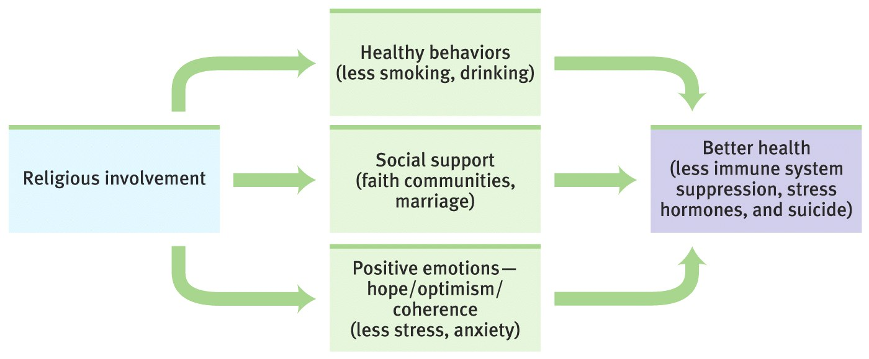
Complementary and alternative medicine (CAM)
-People are not likely to stay in state of crisis; may attribute to treatment or may not
-Placebo effect: taking medication and psychologically believing it is helping, therefore you feel better. Used as much as possible; popular method to help give back control. (Teenagers especially)
-Need to be validated; once validated are no longer alternative treatments; become scientifically validated

