PSY 1102 Thursday Oct. 25th 2012
Stress & Health
Psychological states cause physical illness. Stress is any circumstance (real or perceived) that threatens a person’s well-being.
Stress can be adaptive. In a fearful or stress- causing situation, we can run away and save our lives. Stress can be maladaptive. If it is prolonged (chronic stress), it increases our risk of illness and health problems.
Stress & Stressors
Stress is a slippery concept. At times it is the stimulus (missing an appointment) and at other times it is a response (sweating while taking a test).
Stress is not merely a stimulus or a response. It is a process by which we appraise and cope with environmental threats and challenges.

The Stress Response System
Cannon proposed that the stress response (fast) was a fight-or-flight response marked by the outpouring of epinephrine and norepinephrine from the inner adrenal glands, increasing heart and respiration rates, mobilizing sugar and fat, and dulling pain.
General Adaption Syndrome
According to Selye, a stress response to any kind of stimulation is similar. The stressed individual goes through three phases.
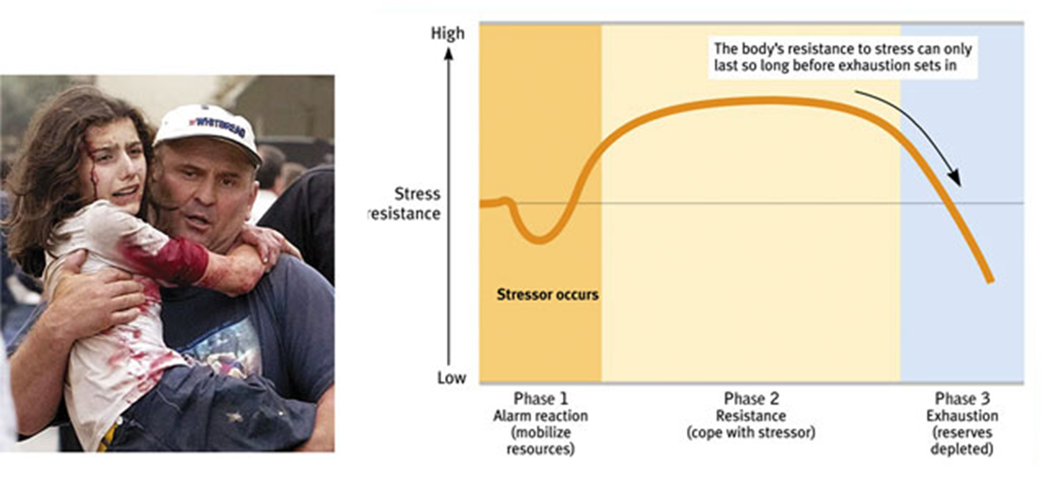
Catastrophic Events: Catastrophic events like earthquakes, combat stress, and floods lead individuals to become depressed, sleepless, and anxious.
The death of a loved one, a divorce, a loss of job, or a promotion may leave individuals vulnerable to disease.
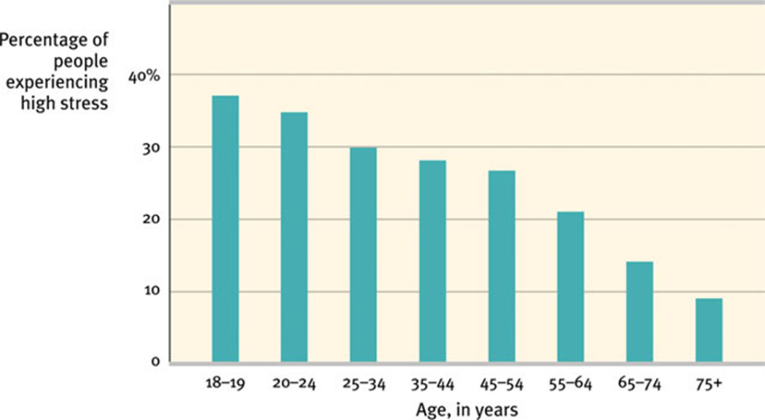
Rush hour traffic, long lines, job stress, and becoming burnt-out are the most significant sources of stress and can damage health.

Stress & The Heart
Stress that leads to elevated blood pressure may result in coronary heart disease, a clogging of the vessels that nourish the heart muscle.
Personality & Stress
Type A is a term used for competitive, hard-driving, impatient, verbally aggressive, and anger-prone people. Type B refers to easygoing, relaxed people (Friedman and Rosenman, 1974).
Type A personalities are more likely to develop coronary heart disease.
Pessimistic adult men are twice as likely to develop heart disease over a 10-year period (Kubzansky et al., 2001).
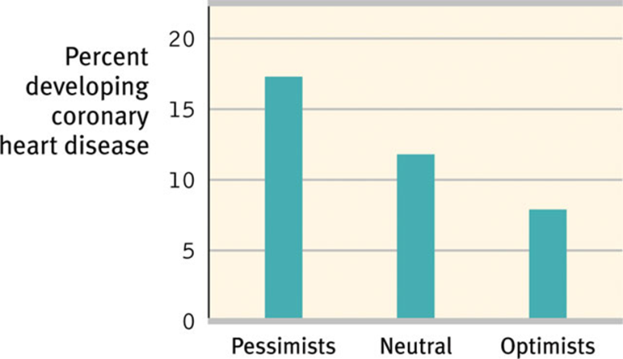
Stress & Susceptibility to Disease
A psychophysiological illness is any stress-related physical illness such as hypertension and some headaches.
Psychoneuroimmunology (PNI) is a developing field in which the health effects of psychological, neural, and endocrine processes on the immune system are studied.
Psychoneuroimmunology
B lymphocytes fight bacterial infections, T lymphocytes attack cancer cells and viruses, and microphages ingest foreign substances. During stress, energy is mobilized away from the immune system making it vulnerable.
Stress & Colds
People with the highest life stress scores were also the most vulnerable when exposed to an experimental cold virus.

Stress and AIDS
Stress and negative emotions may accelerate the progression from human immunodeficiency virus (HIV) to acquired immune deficiency syndrome (AIDS).
Stress and Cancer
Stress does not create cancer cells. Researchers disagree on whether stress influences the progression of cancer. However, they do agree that avoiding stress and having a hopeful attitude cannot reverse advanced cancer.
-Stress can have a variety of health related consequences
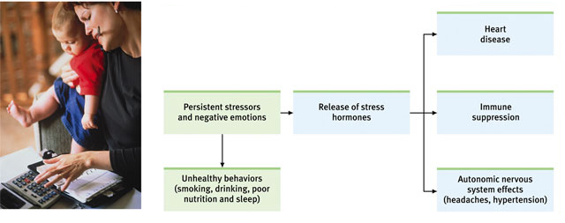
Behavioural Medicine
Psychologists and physicians have developed an interdisciplinary field of behavioral medicine that integrates behavioral knowledge with medical knowledge.
Mind and body interact; everything psychological is simultaneously physiological.

