Financial Accounting lecture 1- Notes

Accounting identifies and records the economic events of an organization and communicates to interested users; which consists of two categories.
- Internal users: managers, employees, and others who plan, organize, and run the company.
- External users: people who don’t work for the company like investors, lenders, creditors, customers, employees, labour unions, taxing authorities and regulators.
For accounting information to have value, preparers must have high ethical standards:
- Actions are legal and responsible
- Consider organization’s interests
Accountants, other professionals, and most companies have rules or codes of conduct to guide ethical behavior (rules of conduct).

Forms of Business Organizations:

- Proprietorship: a type of organization that is owned by one person who has control over their business, simple to set up and unlimited liability.
- Partnership: an organization that is owned by more then one person which is formalized in a written agreement and each partner has unlimited liability.
- Corporations: an organization that separates legal entity owned by shareholders, which can be public or private. Owners enjoy limited liability and indefinite life.

Three types of Business Activates:

- Financial activates: obtaining and repaying funds to finance the operations of the business like borrowing money/repaying loans (debt) and selling/ repurchasing shared (equity). Different forms of debt are bank indebtedness, bank loans, and non-current debt such as mortgages, bonds, and leases.

- Investing activities: purchase or sale of long-lived assets needed to operate the company such as purchase/ sale of long-term investments and purchase or sale of long-lived assets such as property, plant and equipment and intangible assets.

- Operating activates: the main day-to-day activated of the business like revenues, expenses and related accounts (accounts receivable/ payable).

Financial statements:
- Income statement: reports revenues and expenses for a specific period of time
- Revenues: arise from the sale of a product or service and result in an inflow of assets
- Expenses: costs of assets consumed or services used to generate revenues
- Profit (loss) = Revenues - expenses

- Statement of changes in equity: reports the changes in each component of equity during a period of time
- Shows the changes in each component of shareholders’ equity for the period
- Share capital: amounts contributed by shareholders and may have common and preferred classes
- Retained earnings / deficit: cumulative profit retained in the company and less dividends paid to shareholders

- Statement of financial position: shows the assets, liabilities and shareholders’ equity at a specific point in time
- Assets: Resources owned by a business
- Liabilities: Obligations of the business
- Shareholders’ equity: Share capital and retained earnings
- Accounting equation: Assets = Liabilities + Shareholders’ Equity

- Statement of cash flows: shows, for a specific period of time, how company obtained cash and how that cash was used
- Reports the effect on cash of the company’s:
  - Operating activates
  - Investing activities
  - Financing activities
- Shows net increase or decrease in cash for the period

Relationships between statements:
Statements are interrelated: results from some statements are used as data in other statements
Examples:
- Profit from income statement is reported in statement of changes in equity
- Ending balances of shareholders’ equity is reported in both statements of financial position and changes in equity
- Statement of cash flows is related to statement of financial position

Annual report:
Publicly traded companies must prepare an annual report each year
Includes financial and nonfinancial information about the company:
- Financial: management discussion and analysis (“MD&A”) statement of management responsibility, auditors’ report, financial statements and notes
- Nonfinancial: company’s mission and goals, products, people

Generally Accepted Accounting Principles (GAAP):
Rules and practices for the preparation of financial statements
Different for publicly traded and private corporations:
- Publicly-traded corporations use International Financial Reporting Standards (IFRS)
- Private corporations may use IFRS or Accounting Standards for Private Enterprises (ASPE)
Proprietorships and partnerships do not have to use IFRS or ASPE as statements are prepared for internal users only

Chapter 2- Notes
Classified Statement of Financial Position:

Assets

Current assets: assets expected to be converted to cash or used in the business within one year or one operating cycle:
- Operating cycle is the average time it takes to go from cash to cash in producing revenue
Usually listed in order of liquidity: reverse order of liquidity also possible
Examples include cash, short-term (trading) investments, accounts receivable, merchandise inventory, and prepaid expenses

Non-Current assets: assets not expected to be converted to cash or used in the business within one year or one operating cycle. All assets not considered current
Examples: Long-term investment, property, plant, and equipment, intangible assets and goodwill.

Long-term investments: Investments in:
- Debt securities: loans, notes, bonds, mortgages
- Equity securities: shares of other companies
These assets normally are not sold within the next year.

Tangible assets: with relatively long useful lives, which is used in operating the business. Examples are land, buildings, and equipment
- Usually listed in order of permanency
Non-current assets that do not have physical substance and represent a privilege or a right held by the company
Examples:
- Patents, copyrights, trademarks, licenses
- Goodwill: excess price paid on acquisition of another company
- Generate a future value to the company

Depreciation: allocation of the purchase price of property, plant, and equipment over there estimated useful lives:
  - Companies systematically assign a portion of the cost of an asset to expense each year
  - Under IFRS, this allocation is referred to as depreciation for property, plant, and equipment, and amortization for intangible assets
  - Under ASPE, amortization is often used instead of depreciation
- The cost of long-lived assets with indefinite lives is not depreciated (e.g. land)
- Accumulated depreciation account shows the total amount of depreciation taken to date
- The difference between the cost of the asset and its accumulated depreciation is referred to as the carrying amount of the asset

Liabilities and shareholders equity:

Current liabilities: Obligations that are to be paid within the coming year or one operating cycle
Examples: bank indebtedness, accounts payable, accrued liabilities, bank loan/notes payable and current maturities of long-term debt

Non-Current liabilities: Debts expected to be paid or settled after one year
Examples: bank loan/notes payable, lease obligations, pension and benefit obligations and deferred income tax liabilities
- Usually accompanied by extensive notes to the financial statements

Shareholders Equity:
- Share capital: investment of cash (or other assets) in the company by shareholders in exchange for preferred or common shares
- Retained earnings: cumulative profits kept for use in the company

Using the financial statements

Specific tools can be used to analyze the financial statements
Ratio analysis expresses the relationships between selected financial statement data
Use comparisons to aid in analyses:
- Intracompany comparisons cover two or more years for the same company
- Intercompany comparisons between the company and a competitor
- Industry average comparison based on averages for the particular industry

Liquidity Ratios: Measure a company’s short-term ability of to pay its obligations that will come due within the next year

Working capital = Current assets- Current liabilities
Current ratio = Current assets/ Current liabilities (usually higher than 1 but less than 2)

Solvency Rations: Measure a company’s ability to survive over a long period of time:
- The higher the percentage of debt to total assets, the greater the risk that debts cannot be repaid when they are due

Debt to total assets = total liabilities/ total assets (should be as low as possible)

Profitability Ratios: Measure a company’s operating success of for a given period of time

Earning per share = profit available to common shareholders/ weighted average number of common shares

Price-earnings ratio = market price per share/ earnings per share (higher than 1)

Conceptual framework of accounting, which guides decisions about
- What to present in financial statements]
- Alternative ways of reporting economic events
- Appropriate ways of communicating this information

Conceptual Framework for Financial Reporting:
Five main sections:
- Objective of financial reporting
- Qualitative characteristics of useful financial information
- Underlying assumptions
- Elements of financial statements
- Measurement of the elements of financial statements

Objective of Financial Reporting:
To provide financial information that is useful to existing and potential investors, lenders and other creditors. Who are making decisions about providing resources to a company?
- Buying, selling, holding equity and debt
- Providing or settling loans or other credit
Financial information is provided by a general purpose financial statements using accrual accounting

Qualitative Characteristics of Accounting Information
Relevance:
- Information has relevance if it makes a difference in users’ decisions
- May have predictive value and/or confirmatory value
- Materiality is important: will information influence the decisions of users?
Faithful representation:
- Information should reflect economic reality
- It must be complete, verifiable and free from material error

Enhancing Qualities of Useful Information:
- Comparability: users can identify and understand similarities and differences in items
- Verifiability: independent consensus that information is faithfully represented
- Timeliness: available before it loses its usefulness in decision-making
- Understandability: classified, characterized and presented clearly and concisely

Cost Constraint:
Ensures that the value of the information provided by financial reporting is greater than the cost of providing it
- The benefits of financial reporting should justify the costs of providing and using it

Going Concern Assumption
- The business will continue operating in the foreseeable future
- The key assumption – provides a foundation for accounting
- Provides justification for using cost as the value of certain assets

Elements of Financial Statements:
- Assets
- Liabilities
- Equity
- Revenues
- Expenses
The t-diagram, which is separated in debt and credit
A= L+E and Total DT = Total CT

Measurements of Elements:
Accountants have developed principles that describe when and how the elements of financial statements should be:
- Recognized
- Measured, and
- Reported
Known as generally accepted accounting principles

Generally Accepted Accounting Principles:
- Historical cost: assets and liabilities should be recorded at their cost when acquired. Not only at time of purchase, but throughout the life of each asset and liability
- Fair value: certain assets and liabilities should be recorded and reported at fair value
- In choosing between these two, apply the concepts of relevance and representational faithfulness

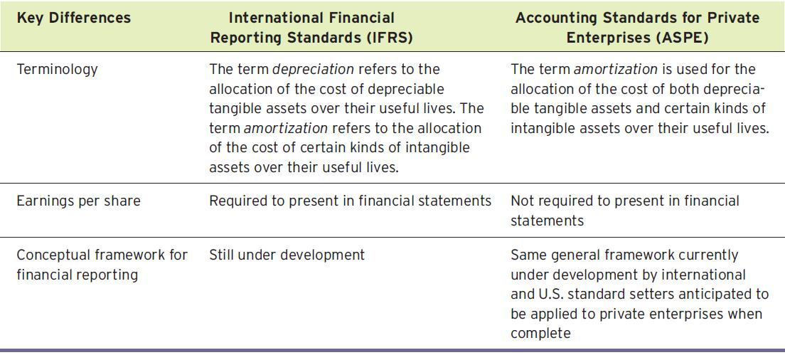

Chapter 4- Notes

Timing Issues:

Companies need immediate feedback on how well they are doing
Accounting divides the economic life of a business into artificial time periods
- Month, quarter, year
- Many transactions affect more than one time period

Revenue Recognition
Revenue is recognized when:
- Sales or performance effort is substantially complete
- Amount is determinable (measureable)
- Collection is reasonably assured
In a merchandising company:
- When merchandise is sold (point of sale)
In a service company:
- When the service is performed

Expense Recognition:
Expenses are recognized when:
- Due to ordinary activity, a decrease in future economic benefits occurs
- Related to a decrease in an asset or an increase in a liability
- It can be measured reliably
Tied to changes in assets and liabilities
Often (but not always) coincides with revenue recognition

Accrual Basis of Accounting:
Transactions affecting a company’s financial statements are recorded in the period the events occur, rather than when cash is received or paid
- Revenue is recorded when earned, rather than when cash is received
- Expenses are recorded when goods or services are consumed, rather than when cash is paid

Adjusting Entries: adjusting entries are made to adjust or update accounts at the end of the accounting period
Required because the trial balance may not contain complete and up-to-date data
- Some items are not recorded daily
- Some costs are not recorded during the accounting period, as they expire due to the passage of time
- Some items may be unrecorded

Types of Adjusting Entries:
Prepayments:
- Prepaid expenses: Costs that are paid for in cash before they are used
- When the cost is incurred, an asset (prepaid) is increased (to show the future service or benefit) and cash is decreased
Expire with the passage of time or through use
- Not practical to record this expiration on a daily basis, so done when statements are prepared
Adjusting entry increases an expense account and decreases the asset (prepaid) account

- Unearned revenues: Cash that has been received before revenue is earned
- When the cash is received, a liability account (unearned revenue) is increased and cash is increased
The opposite of prepaid expenses
Adjusting entry decreases the liability (unearned revenue) account and increases a revenue account
- Reflects the amount of revenue earned in the period and the remaining liability at the end of the period

Accruals: accruals have not been recognized at all until an adjustment is made
- Accrued revenues: Revenues that have been earned, but not received in cash
- Adjusting entry results in an increase to both an asset and a revenue account

- Accrued expenses: expenses that have been incurred, but not yet paid or recorded
- Adjusting entry results in an increase to both an expense and a liability account
Basic relationships:
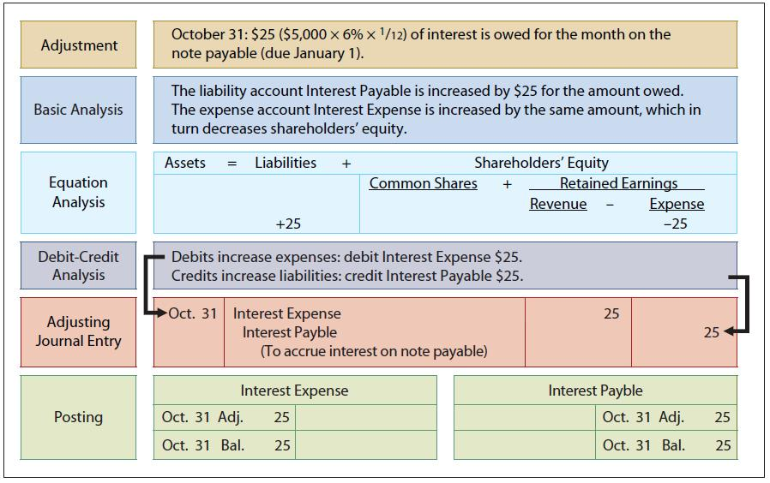

Adjusted Trial Balance:
- Prepared after all adjusting entries have been journalized and posted
- Shows the balances of all accounts at the end of the accounting period
- Including those accounts that have been adjusted
- Proves the equality of total debit balances and total credit balances after the adjusting entries have been made
- The main source for preparation of financial statements

Closing the Books:
Revenue and expense accounts are subdivisions of retained earnings
- Considered to be temporary accounts
Statement of financial position accounts carry forward into the future
- Considered to be permanent accounts
Closing entries
- Temporary account balances are transferred to Retained Earnings
- Produce a zero balance in the temporary accounts to prepare them for the next period’s activity

Difference between temporary and permanent accounts:
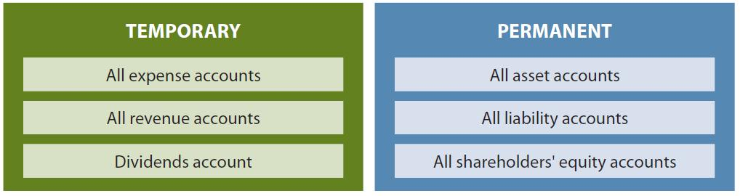

The Closing Process:
- Close revenue accounts:
- Debit each revenue account for its balance and credit Income Summary
- Close expense accounts:
- Debit Income Summary and credit each expense account for its balance
- Close Income Summary:
- Debit (or credit) Income Summary for the balance in the account and credit (debit) Retained Earnings
- Close Dividends account:
- Debit Retained Earnings and credit Dividends account for the balance
Illustrates:
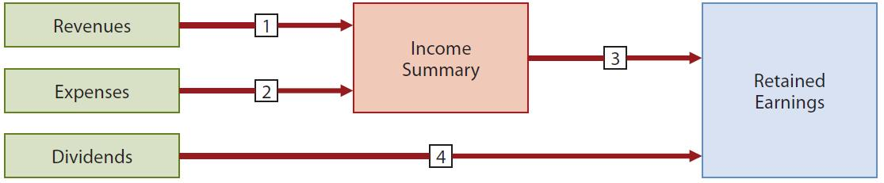

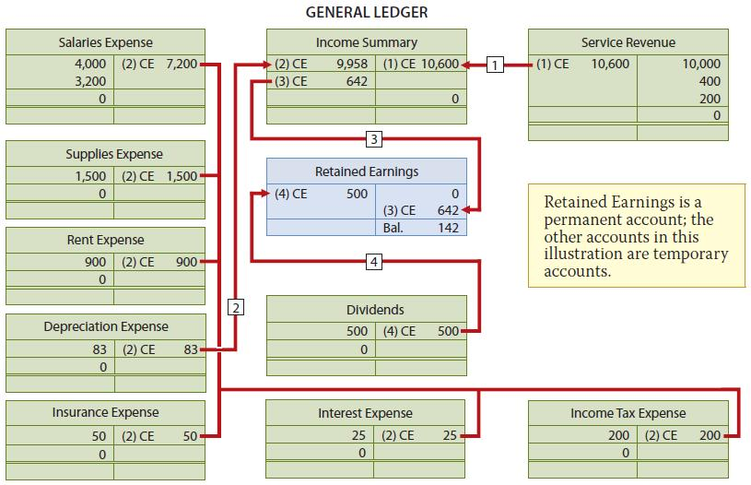

Other Comprehensive Income (OCI) and Accumulated Other Comprehensive Income
For companies reporting under IFRS only
- Companies reporting under ASPE do not recognize OCI
May have complex items that determine OCI rather than profit
- Similar to revenues and expenses
Items in OCI plus profit = comprehensive income

Post-Closing Trail Balance:
Lists all permanent accounts and their balances
- After all closing entries are journalized and posted
Proves the equality of total debit balances and total credit balances after the closing entries have been made

Accounting Cycle:
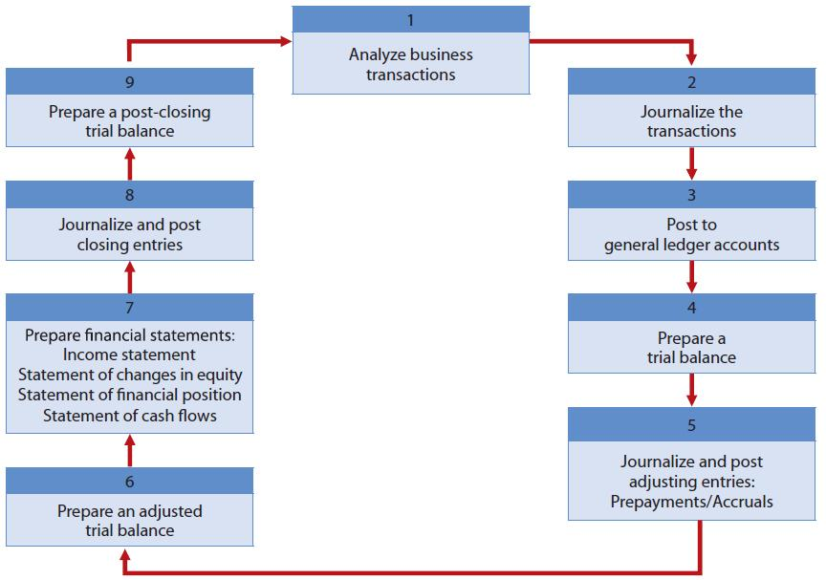

Chapter 6- Notes

Determining inventory Quanities
- Whether companies use a periodic or perpetual system, physical inventory must still be counted at the end of the period:
- To check the accuracy of the perpetual inventory records
- To determine the amount of inventory lost to shrinkage or theft
- To ensure inventory is properly counted, companies must have a good system of internal control:
- Employees who perform the count should not have responsibility for custody or record-keeping
- Counter establishes validity of item
- Second count by another employee or auditor
- Pre-numbered tags

Determining Ownership
- Need to consider ownership of goods when taking inventory
- Goods in transit at the end of the period make the determination of ownership more complicated:
- Determine who has legal title to goods in transit
- Include in inventory if company has legal title
- Apply freight/shipping concepts from Chapter 5:
- FOB shipping point versus FOB destination
- Ownership of consigned goods remains with the owner (the consignor), not the holder of the goods (the consignee)
- Goods taken home “on approval” by a customer are still owned by the company

Inventory Cost Determination methods
- Once inventory quantities are counted, must apply unit costs to determine total cost of inventory
- Units of the same inventory can be purchased at different prices
- Which costs should be used?

Specific Identification
- Tracks physical flow of goods
- Used in perpetual system only
- Can only be used where
  - Actual costs of each item can be determined
  - Goods are easily distinguishable
  - Or for goods produced and segregated for specific projects
Cost Formulas
- Cost formulas assume a flow of costs that may not be the same as the actual flow of goods
- FIFO (First-in, first-out): cost of first item purchased is cost of first item sold
- Average: cost is determined using a moving (weighted) average of the cost of the items purchased

- FIFO (First-in, First-out)
- Merchandise inventory is recorded at most recent (current) cost in the current assets section of statement of financial position
- Cost of goods sold is recorded as an expense at oldest inventory cost on income statement
- Ending inventory and cost of goods sold under FIFO are the same for periodic and perpetual inventory systems
- Average
- Used when physical flow of inventory cannot be measured
- Under a perpetual inventory system, a new weighted (called moving) average is calculated after each purchase
- Used to record cost of goods sold and ending inventory
Choice of Cost Determination Method
- Choose a method that best
  - Represents physical flow of goods,
  - Reports ending inventory at recent cost, and
- Use the same method for inventories of similar nature and usage

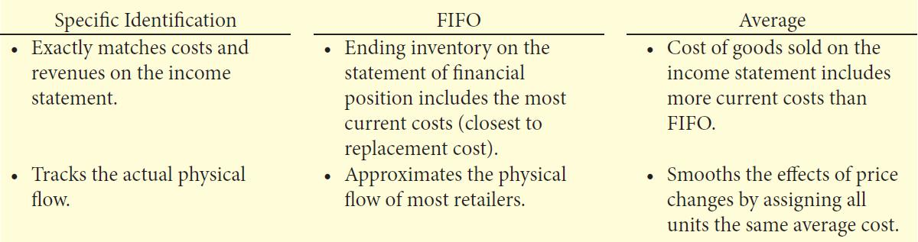
Inventory Errors:
- Errors can occur in accounting for inventory
  - Incorrect counting or costing
  - Transfer of title not recognized
- Errors affect both
  - Statement of financial position – through merchandise inventory
  - Income statement – through cost of goods sold

Summary of Effects of errors
- An error in ending inventory of the current period will have a reverse effect on profit in the next accounting period
- An error in ending inventory affects retained earnings of the same period
  - But not the next period, as the error reverses (your error will change to the next year reversed)
  - Ig there is an error in the sales then the beg inventory will increase but it would reduce the gross profit/profit by the (end invetory)

Valuing inventory at the lower of cost and Net Realizable Value
- When the net realizable (fair) value is less than cost, the value is written down
- The lower of cost and net realizable value (LCNRV) rule
- Net realizable value is selling price less any costs to make ready for sale

LCNRV Rule
- Apply rule to individual inventory items
- Reduce inventory by crediting it for the amount of write-down, debit is to cost of goods sold
- Reverse write-down if value subsequently recovers
  - When conditions that caused the write-down have changed

Reporting Inventory

