ANP 1106

Integumentary System (Skin system)

The Structure of Skin
- 2 distinct regions
  - Epidermis which is more superficial
  - Dermis which is more deep
- Epidermis
  - Made of 4 types of cell
  - Keratinocytes
    - Produce keratin ( a protein that makes our skin waterproof, etc.)
    - Live for about 1 month
  - Melanocytes
    - Spider shaped cells
    - Deepest layer of epidermis
    - Produce melanin
    - Melanin accumulate is granules called melanasomes
    - The Melanosomes move along actin filaments via motor proteins and is delivered to keratinocytes
    - Melanin accumulates of the side of the keratinocytes that is exposed to the sun,
    - Main purpose is to protect the nuclei of the skin cells from getting cancer due to exposure to UV light
    - The more UV light you are exposed to the more melanin your skin produces and people with darker skin usually have more melanocytes.
  - Dendritic Cells
    - Star shaped cells
    - Come from bone marrow original
    - Also known as Langerhans Cells
    - Injest foreign materials
    - Key activators of the immune system
    - Their processes surround keratinocytes
  - Tactile Cells
    - Spiky circle shaped cell
    - Few in number
    - Present where the epidermis becomes the dermis
    - Also known as Merkel Cells
    - Usually near disc like sensory nerve endings.
      - With a nerve ending it is called a Tactile or Merkel disc and acts as a receptor for touch.
  - Four Main Layers of Thin Skin
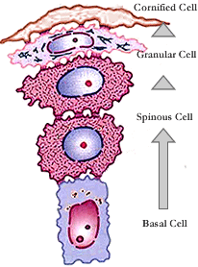
    - Stratum corneum
      - Most superficial
      - 20-30 layers
      - Flat sacs filled with keratin
    - Stratum granulosum
      - 5 layers
      - Flat cells with dying organelles that are filled with keratin
    - Stratum spinosum
      - Several layers of keratinocytes connected with desmosomes
      - Also have thick bundles of intermediate filaments that are made of pre-keratin.
    - Stratum basale
      - Deepest layer
      - 1 layer of mitotically active stem cells
      - New cells are superficial to the stem cells
      - A few melanocytes and Merkel cells are sprinkled throughout it
  - Thin Skin vs. Thick Skin
    - Thick skin is the tougher skin that covers the palms and soles
      - Thicker because it has an extra layer called:
      - Stratum Lucidum.
        - Situated after the stratum corneum
        - Clear
        - 2-3 layers of clear, flat, dead keratinocytes
    - Thin skin is all other skin on the body.
- Dermis
  - Cell types (as per in all CT)
    - Fibroblasts
    - Macrophages
    - Some Mast Cells
    - White Blood Cell
  - Semi-fluid matrix heavily embedded with collagen, elastin and reticular fibers
  - Richly supplied with nerve fibers, blood & lymphatic vessels
  - Also hair follicles, oil & sweat glands
  - 2 main layers
    - Papillary Layer
      - Thin and superficial
      - A woven mat of Areolar CT with blood vessels
      - Phagocytes and other defensive cells are able to move through due to looseness
      - Indents of Dermis into the Epidermis are called dermal papillae
      - In palms of hands and soles of feet, dermal papillae sit on top of larger mounds called dermal ridges
      - The indentation causes the epidermis to have ridges called epidermal ridges.
      - A collection of epidermal ridges is called frictional ridges and enhance our gripping ability. They also help in our sense of touch by amplifying vibrations detected by receptors.
      - They are genetically determined for the most part.
    - Reticular Layer
      - Thick and deep
      - Irregular Dense Fibrous CT
      - Blood vessels are called Cutaneous plexus and lie between reticular and hypodermis
      - Some Adipose and some Collagen
      - Most collagen fibers run parallel to the skin surface
      - The spaces between these cause externally invisible Cleavage or Tension Lines
      - Surgeons cut parallel to these lines so that the skin gapes less and therefore heals faster
      - Collagen Fibers
        - Give the skin strength
        - Resiliency to damage from normal wear and tear
        - Keeps skin moist by binding water
      - Elastic Fibers
        - Allows for stretch and recoil
      - Flexure Lines
        - Dermal folds that occur at or near joints
        - Occurs due to the dermis being securely attached to deeper structures
        - Visible at wrists, fingers, soles, etc.
      - Straie (Stretch marks)
        - Occur when there’s a tear in the dermis due to extreme stretching. The tear leaces a silvery white scar.
      - Blisters
        - Due to short term trauma, fluid forms a pocket in between the epidermal and dermal layers.
- Hypodermis
  - Deep to the dermis
  - Also known as superficial fascia or subcutaneous tissue
  - Mostly Areolar CT with blood vessels and adipose tissue
  - Functions
    - Stores fat
    - Anchors skin to underlying muscle in such a way that it can still slid over the muscle with ease.
    - Shock absorber due to the adipose tissue
    - Insulator due to adipose.
  - In males it accumulates around the anterior abdomen. In females it accumulates around the thighs and breasts.
- Skin Colour
  - 3 pigments contribute to skin colour
    - Melanin
    - Carotene
    - Hemoglobin
  - Melanin
    - Only pigment made in the skin
    - Has different forms which correspond to colours from reddish yellow to brownish black.
    - All humans have the same number of melanocytes
    - Skin colour is instead determined by what type of melanin, how much melanin and how long the keratinocytes retain the melanin
    - Function
      - Protect the keratinocytes from the UV radiation of the sun. Without this protection the nuclei of the keratinocytes might become corrupt and produce a cancer.
      - Protects the body from the UV light, which also destroys the body’s folic acid reserve. Folic acid being a product that is needed in DNA synthesis. This is especially vital for pregnant mothers.
  - Carotene
    - Yellow to orange pigment found in plant products such as carrots
    - Deposits in stratum corneum and fatty tissue in the hypodermis
    - Doesn’t have a major effect but if one ingests a lot of it then they may appear orange
  - Hemoglobin
    - Causes skin to look pink
    - Due to the hemoglobin pigment in the blood that is apparent through the skin due to the lack of melanin
    - Cyanosis
      - When Caucasians look blue due to a lack of O₂ in their blood.
      - This usually happens in result to heart failure or severe respiratory disorder.
The Accessory Structures to Skin
- Hair and Hair follicles
  - Made of Hard Keratin ( more durable than skin’s keratin)
  - Function
    - Sense insects on skin
    - Guard head from physical trauma, heat loss and sun
    - Shield eyes from direct contact with light from above it
    - Filter particles from inhaled air (nasal hairs)
  - Hair Shaft
    - Its shape gives hair its shape (straight, curly, etc.)
    - 3 layers
      - Medulla
        - Center core
        - Consists of large cells and air spaces
        - Absent in fine hairs
      - Cortex
        - Several layers of flattened keratinocytes
        - Hair pigment accumulates here
      - Cuticle
        - The most outer layer of the hair
        - Single layer of cells which are heavily keratinized
        - This helps keep the hairs apart and not matted
        - Also provides the hair with strength
    - Split ends
      - When the cuticle wears out at the tips of the hair the cortex and medulla frizz out making the hair seem fragmented.
    - Graying or Whiting Hair
      - When melanin production decreases air bubbles start replacing the pigment in the cortex. This makes your hair seem white or gray.
  - Hair Structure
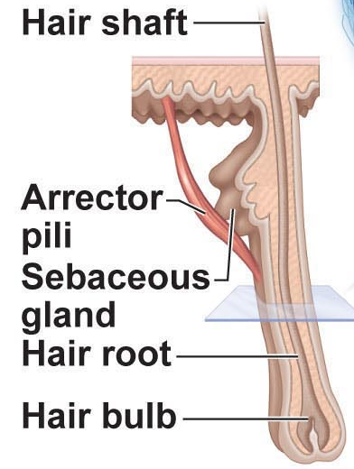
    - Hair Follicle: Bag that is embedded into the dermis and holds the hair bulb.
    - Hair bulb: The base of the hair. The hair shaft proceeds from it.
    - Hair Matrix: The mitotically active part of the Bulb.
    - Root hair plexus: A knot of sensory nerve endings that surround the hair bulb.
    - Hair Root: The part of the hair that proceeds from the bulb up until it reaches the epidermal surface.
    - Hair Shaft: The part of the hair that is outside of the skin.
    - Hair Papilli: Indents of dermal tissue into the follicle that contain capillaries that provide nutrients to the hair and signals it to grow.
    - Arrector Pili: A small muscle used to pull hair up and dimple skin. There is only one per follicle.
    - Sebaceous gland: Holocrine gland that secretes sebum. (oil used to lubricate and waterproof hair. As well as an antibacterial.
      - Whiteheads
        - When oil gets stuck in a hair follicle it appears white.
      - Blackhead
        - If the oil stays in there for too long it oxidizes and becomes black
      - Acne
        - Doesn’t have to do with oil. It’s a bacterial infection and you need antibacterial.
  - Diagram (know everything except the points under follicle wall)
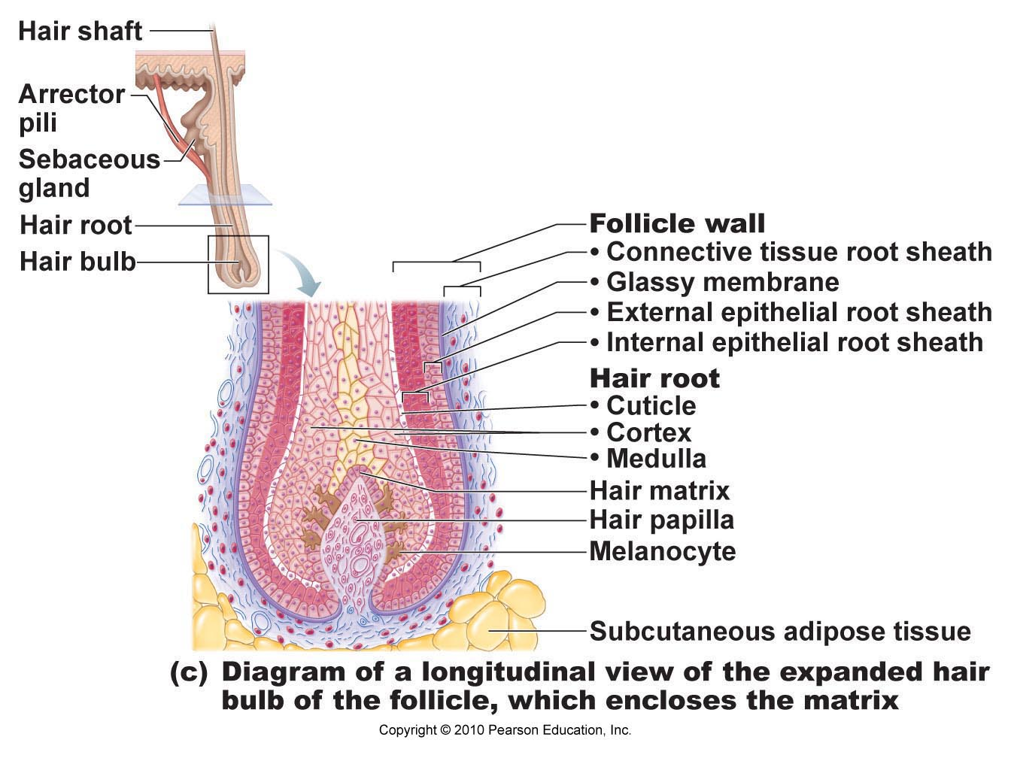
  - Hair Growth
    - Vellus Hair vs. Terminal Hair
      - Vellus hair: Fine hair that is on the skin of children and females
      - Terminal hair: The thicker hair that is on male’s arms, both genders heads. Pubic hair is terminal as well.
    - Hair Growth is determined mostly by hormones and nutrition
      - Testosterone being the main hormone
      - It is from the adrenal gland in females and from the testes in males
      - Hirsuitsm
        - When women have excessive hair growth. Such as the growing of facial hair.
        - Usually due to a malfunction in the adrenal gland
      - Avg. hair growth is 2.5 mm/week
    - Growth cycles
      - Active Phase
        - When the hair is actually growing and it is in this phase where it is very strong.
      - Resting Phase
        - Hair matrix dies
        - Hair bulb shrivles and this drags the papillae upwards.
        - It stays in this state for some time
        - Then the follicle regenerates and the matrix proliferates creating a new hair.
        - The old one is pushed out if it hasn’t already fallen out due to its weak hold.
      - Head hair has a longer active phase than the eyebrows. Because if the eyebrows had a longer phase then they would grow quite long.
      - Alopecia
        - Means loss of hair on the body or head
        - Male Pattern Baldness
          - A genetic disease where a gene switches on in adulthood that causes the follicle to responds to the testostorne more quickly.
          - This quick response shortens the active period and this causes hair to be shed fast.
          - It reaches a point where the hair is shed before it is even big enough to be seen with the human eye. This making the person bald.
- Nails
  - Scale-like modification of the epidermis that forms a clear protective covering over the dorsal part of the distal part of the finger.
  - Made of hard keratin
  - Used as a tool to scratch and pick up small objects
  - Structure
    - Nail Root: The most proximal part located under the skin.
    - Nail Body (Plate): The visible part of the nail
    - Free Edge: The part that is hanging in the air.
    - Nail Bed: The epidermal layer under the nail root and body.
    - Nail Matrix: The part at which the nail grows. Its located under the lunule.
    - Lunule: The proximal crescent moon shaped part that is white in colour. The whiteness is due to how thick the nail is at that part compared to other parts of the nail where the pink colour of the blood can be seen. The thickness is most likely due to the fact that it is protecting the matrix.
    - Nail Fold: The skin on the proximal and lateral sides of the nail that covers it slightly.
  - Diagnosis through observation of nails
    - Yellow-tinged: Fungal infection or a serious respiratory or thyroid gland disorder
    - Thickened: Fungal infection
    - Spoon Nail: This is when your nails are really concave. Possible iron deficiency.
    - Beau’s lines: This is when you have horizontal lines going down your nail. Possibly malnutrition. May be due to sporadic stoppage of growth from the matrix.
- Sweat Glands (Sudoriferous glands)
  - Are distributed over skin surface except nipples & parts of external genitalia
  - Up to 3 million glands/person
  - 2 Types
    - Merocrine (Eccrine)
      - More common
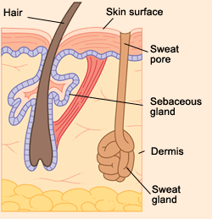
      - Found on palms, soles of feet and forehead
      - Simple, coiled tubular glands with pore at surface
      - Secrete sweat
        - A hypotonic filtrate of the blood
        - 99% water
        - Some salt (mostly NaCl)
        - Vitamin C
        - Antibodies
        - A little bit of waste (urea, ureic acid and ammonia)
        - Main purpose
          - Cool the body down due to heat. It starts at the forehead.
          - Emotional sweat starts at the palms or soles
    - Apocrine
      - Found in axillary and anogenital areas
      - They are not apocrine but merocrine glands
      - Larger than eccrine glands
      - Empty ducts into hair follicles
      - Apocrine sweat
        - Same composition as normal sweat but with protiens and lipids
        - More viscous
        - Sometimes white or yellow
        - Normally odourless but if bacteria are present in it then it has a bad smell. The basis of body odour
        - Main Purpose
          - Begin functioning after puberty due to androgens (sex hormones)
          - Unknown but perhaps human equivalent of other animals’ sexual scent glands
            - Increases with sexual activity
            - Enlarges and recedes with female menstrual cycle
      - Modified Apocrine glands
        - Ceruminous glands
          - Found in lining of external ear
          - Secretion is mixed with sebum of nearby sebaceous glands to make a sticky substance called cerumen or earwax.
          - Its assumed function is that it is used to deter insects and other foreign materials from entering the ear.
        - Mammary glands
          - Secrete milk
Major Functions of Skin
- PROTECTION: 3 types of barriers
  - Chemical: secretions, melanin
  - Physical: barrier to trauma & bacterial invasion; also waterproofing
  - Biological: Langerhans cells of epidermis & macrophages in dermis
  - * Not impermeable to: gases, fat-soluble vitamins & steroids, plant oleoresins, organic solvents, salts of heavy metals, penetration enhancers for drug administration
- BODY TEMPERATURE
  - Sweat to cool down. (0.5-12 L/day)
  - Vasoconstriction can be down to stay warm
- CUTANEOUS SENSATION
  - Receptors on skin that makes us aware of what’s going on
  - Tactile receptors, temperature receptors, etc.
- METABOLIC
  - The activation of Vitamin D when exposed to sunlight
- BLOOD RESERVOIR
  - Blood can be pulled away from the skin and sent to a part that needs it more. Like the example of blood being shunted to the skeletal muscle when working out
- EXCRETION
  - The small amount of wastes that we get rid of in our sweat
  - Urea, ureic acid and ammonia

Burns
- Can occur due to heat, electricity, radiation or chemicals
- 2 Main concerns
  - First concern: Fluid loss
    - Skin waterproofs us but with a lot of skin missing we will lose water.
  - Second Concern: Infection
    - Burned skin stays sterile for 24 hours but after that bacteria, fungi and other pathogens easily invade. They then multiply a lot due to the large amount of nutrients present in the dead burn cells.
- Degrees of burn
  - First degree
    - Only epidermis
  - Second degree
    - Epidermis and upper dermis
  - Third degree
    - Entire thickness of skin (everything)
- Treatment of burns
  - Skin grafting is usually done.
  - It being a method of replacing the burned skin with skin that is alive.
  - The patient’s body sometimes rejects the skin graft.
  - One can also do a surgery where the burned skin is replaced with fake skin. (silcon layer with dermal cells attached to it) The body consumes the dermal cells and replaces them with real ones. The silicon is then peeled off and a layer of epithelial cells that have been cultured from the patients own skin cells is applied on it. In the end you have new skin that the body doesn’t reject. However its been discovered that this skin is more likely to get infections than skin from skin grafting.
- Rule of Nines
  - To determine how much water a person has lost you use the Rule of Nines.
  - You basically divide the body into 11 parts each accounting for 9% of the total body area. With all the area surrounding the genitals being counted as 1%.
  - The percent lost (water) is the percent burned (skin).

