Chapter 2: How does the Nervous System Function
Overview of Brain Function and Structure
- The Brain’s primary functions
  - Creating a sensory reality
  - Integrating Information
  - Producing behaviour
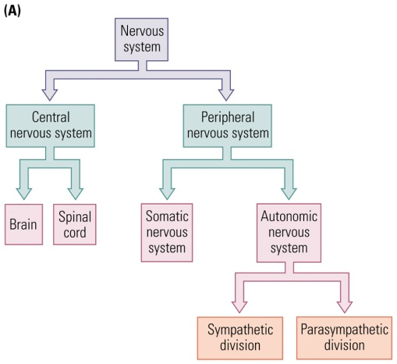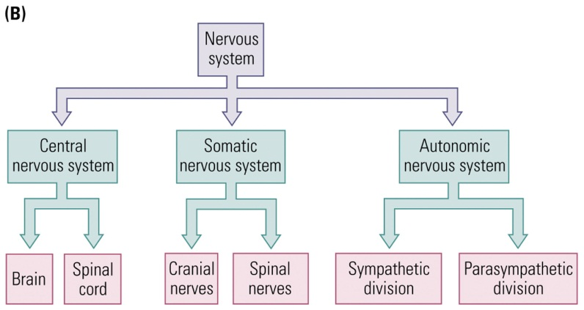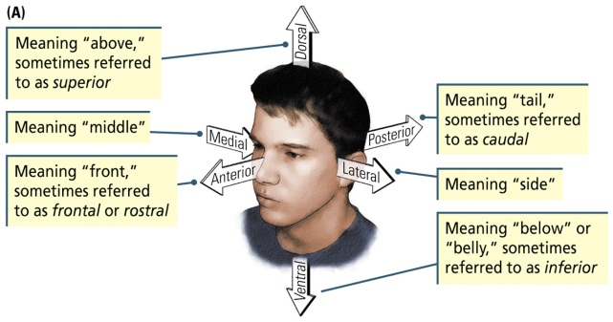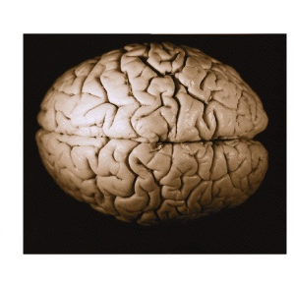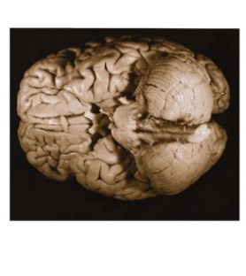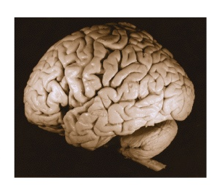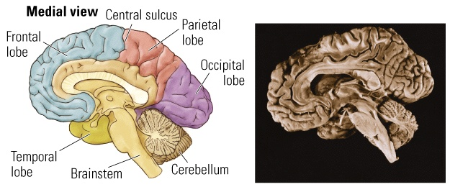
Medial
Lateral
Ventral
Dorsal
- 12 cranial nerves, and are involved in processing.
- Autonomic nervous system: Controlling functions of internal organs. Automatic processes.
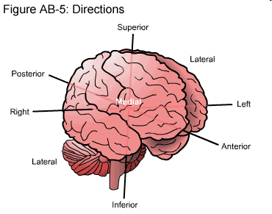
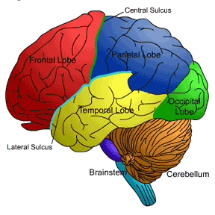
- The Frontal lobe is lateral to the Central Sulcus
- The Temporal lobe is ventral to the Parietal lobe
- The occipital lobe is posterior to the temporal lobe
- The brain stem is inferior/ventral to the cortex
Basic Terminology
- Planes
  - Horizontal (Slice through horizontally)
  - Coronal (Slice through up and down- vertically Crown)
  - Sagittal (Saddle Cut through from front to back)
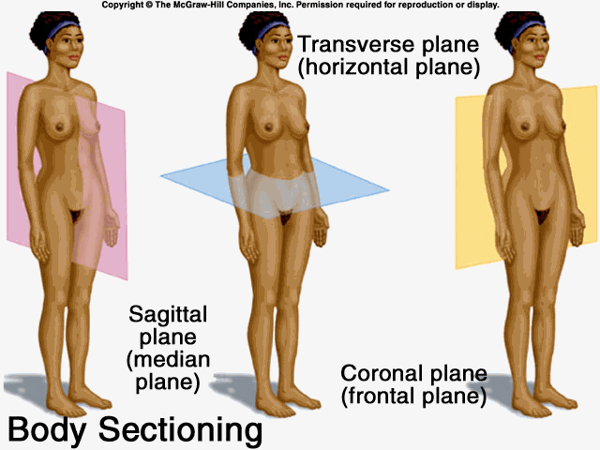
- Top: dorsal or superior
- Bottom: Ventral/inferior
- Front: Anterior/Rostral
- Back: Posterior/caudal
- Middle: Medial
- Side: Lateral
- Afferent: Information to the brain
- Efferent: Information from the brain
Surface Features
- Meninges: 3 layers of protective tissue of the brain (EXAM)
  - Dura Matter: “Hard matter”; tough outer layer of fibrous tissue
  - Arachnoid Layer: “Like a spider’s web”; Thin sheet of delicate connective tissue
  - Pia matter: “Soft mother”; moderately tough inner layer that clings to the brain’s surface
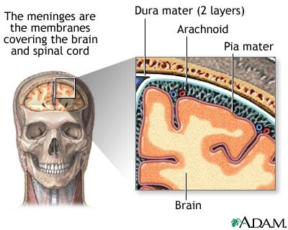
Meningitis
- Caused by: Infections in the meninges (particularly in the pia matter and the arachnoid layer, and the CSF in between them)
- Can result in: Swelling of the brain
- Symptoms include: Headaches, cervical rigidity, drowsiness, stupor, coma
- Note: There is a difference between meningitis and encephalitis (brain swelling). The latter referes to an infection to the brain itself
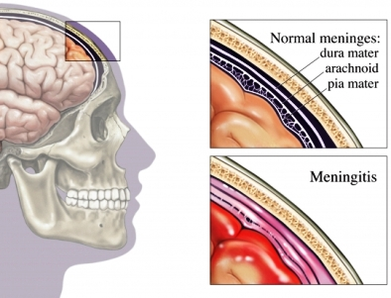
CSF
- Cerebrospinal fluid (CSF)
  - Sodium chloride and other salts
  - Fills the ventricles and circulates around the brain and spinal cord in the subarachnoid space (located between the arachnoid layer and the pia matter)
  - Cushions the brain
  - Meningitis:
    - Infection of the meninges and CSF
Surface Features
- Cerebrum
  - Major structure of the forebrain, consisting of 2 virtually identical hemispheres (left and right)
  - Most recently evolved brain structure in humans
- Cerebellum: “Little brain”
  - Located in the hindbrain; involved in the coordination of motor and possibly other mental processes
- Gyrus (pl. Gyri)
  - A groove in brain matter, usually found in the neocortex or cerebellum
- Sulcus (pl. Sulci)
  - A small cleft formed by the folding of the cerebral cortex
- Fissure
  - A very deep sulcus
Longitudinal Fissure
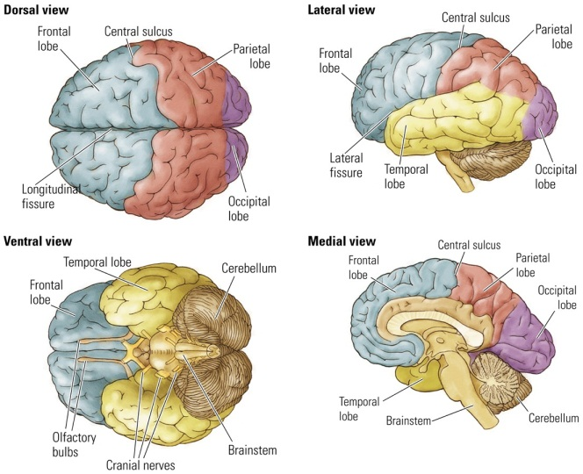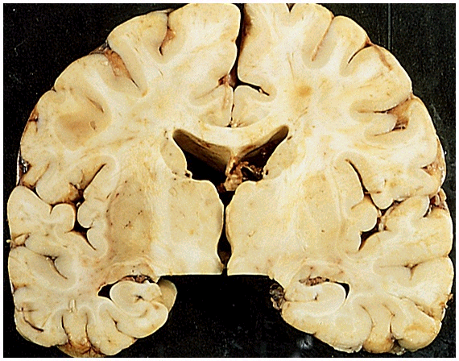
Sulcus
Gyrus
Cortex
- White matter: (EXAM)
  - Areas of the nervous system rich in fat-sheathesd neural axons
- Gray matter: (EXAM)
  - Areas of the nervous system predominately composed of cell bodies and blood vessels
- Ventricle
  - A cavity in the brain that contains CSF
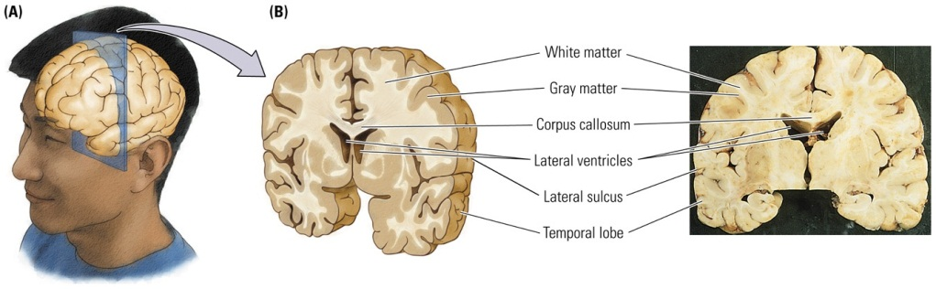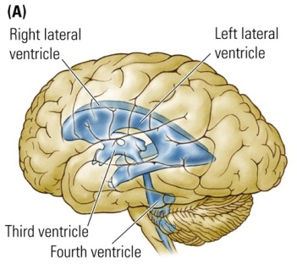
Internal Structures
- 4 ventricles
  - 2 lateral ventricles (L+R)
  - Third ventricle
  - Fourth ventricle
- Corpus Callosum
  - Fiber system connecting the 2 cerebral hemispheres
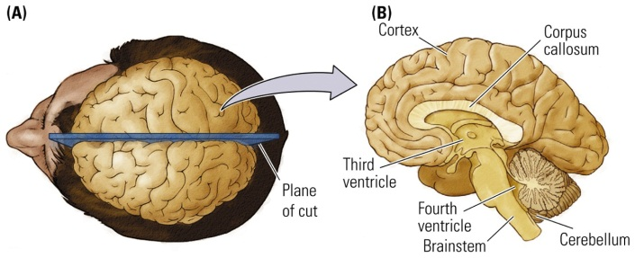
Cerebrovascular structure of the brain
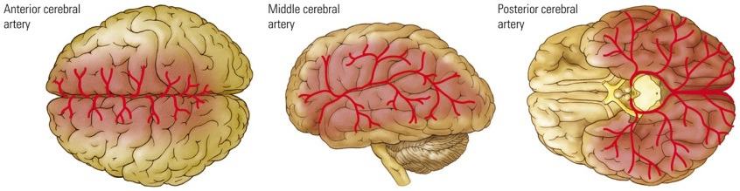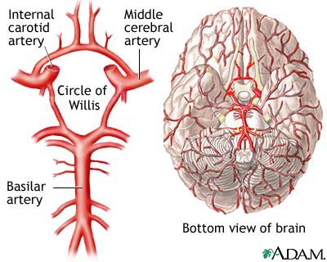
Stroke
- A sudden disruption of blood flow to the brain
- The nature of deficit depends on the site affected
- 2 major types of stroke:
  - Haemorrhagic (20% of strokes) Bleed
  - Ischemic (80% of strokes) Block
    - Embolic (embolus): A clot formed outside the brain
    - Thrombotic (Thrombus): A clot formed inside the brain
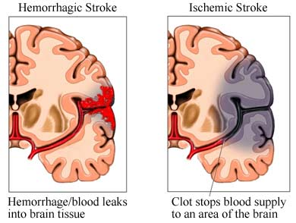
Aneurysm
- Weakness in blood vessel
Arteriovenous Malformation (AVM)
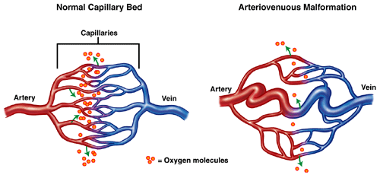
Microscopic Inspection
- 2 main types of cells
  - Neurons
    - Carry out the brain’s major functions
    - Approximately 80 billion
  - Glia
    - Aid and modulate neurons’ activities
    - Approximately 100 billion
The Central Nervous System
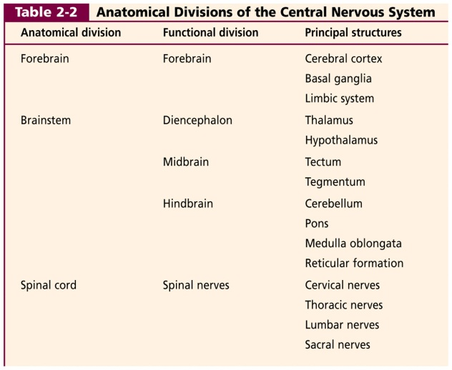 KNOW FOR EXAM. MAJOR FUNCTIONS FOR EACH PRINCIPLE STRUX. TABLE THAT IS POSTED ON VIRTUAL CAMPUS.
Anatomical Divisions: Spinal Cord
- Controls most body movements
- Can act independently of the brain
- Spinal reflex:
  - Automatic movement
  - Hard to prevent (brain cannot inhibit)
  - Example: Knee-jerk reflex (patellar tendon)
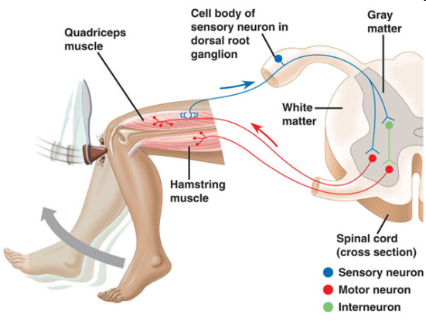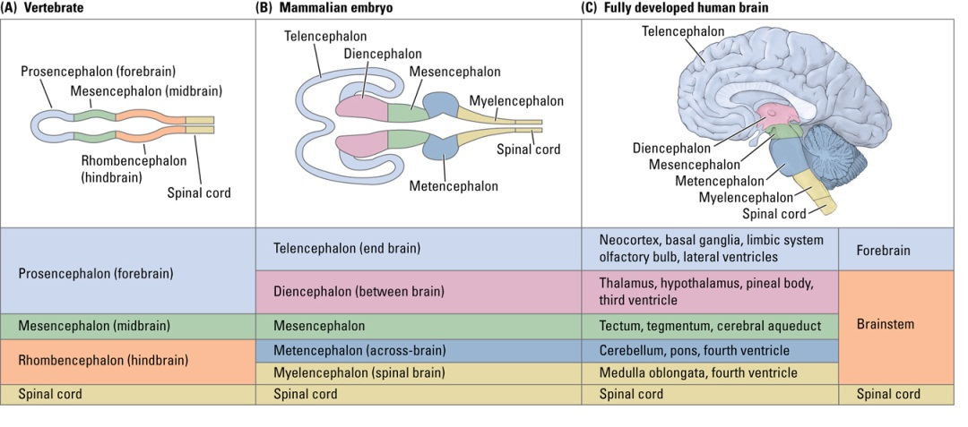
Anatomical Divisions: The Brainstem
- Begins where spinal cord enters the skull
- Produces movement and creates a sensory world
- Three regions
  - Hindbrain
  - Midbrain
  - Diencephalon 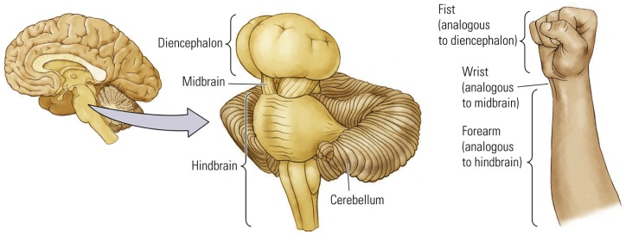
Brainstem: The Hindbrain
- Evolutionarily the oldest part of the brain
- Contains
  - Pons
  - Medulla
  - Cerebellum
  - Reticular formation
- Control of movement
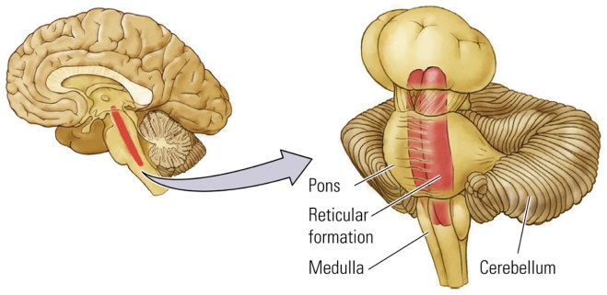
- Pons (“Bridge”)
  - Connects cerebellum to the rest of the brain
  - Controls important movements of the body
- Medulla
  - Rostral end of the brain
  - Vital functions: Control of breathing and heart rate.
- Cerebellum
  - Controls complex movements and has a role in a variety of cognitive functions
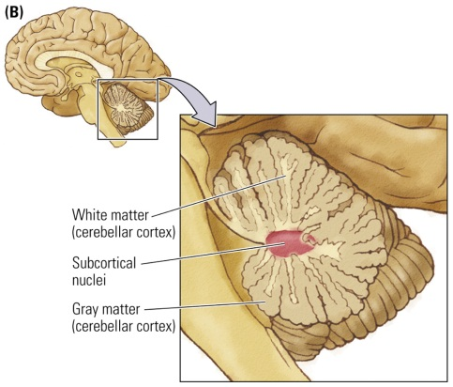 Cerebellum
- Reticular Formation
  - Netlike mixture of neurons (gray matter) and nerve fibres (white matter)
  - “reticular activating system”
  - Stimulates the forebrain: Regulation of sleep-wake behaviour and behavioural arousal.
The Brainstem: Midbrain
- Tectum (Roof of midbrain)
  - Sensory processing (visual and auditory)
  - Produces orienting movements
- Tegmentum (floor of midbrain)
  - Eye and limb movements
  - Species-specific behaviours
  - Perception of pain
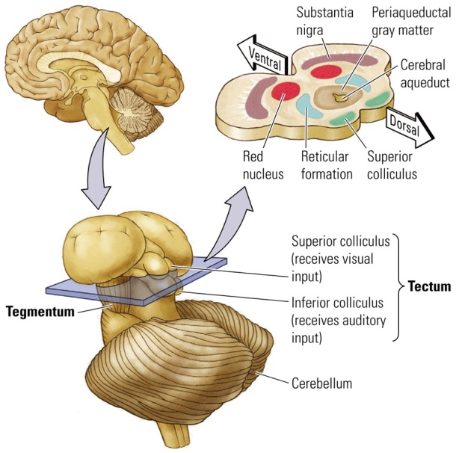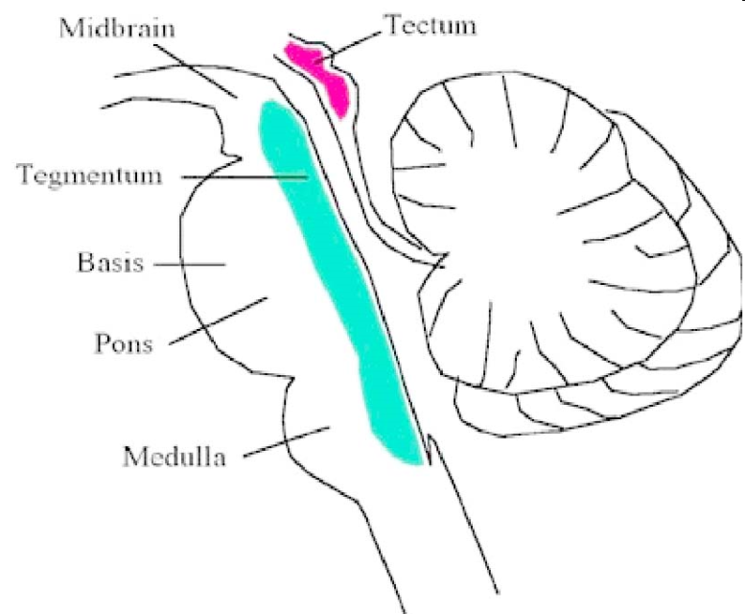

The Brainstem: Diencephalon
- Hypothalamus
  - Feeding
  - Sexual behaviour
  - Sleeping
  - Temperature regulation
  - Emotional behaviour
  - Hormone function: Through connections with the pituitary gland
- Thalamus
  - Sensory processing
  - Motor processing
  - Integrative functions
  - Motivation
  - Memory
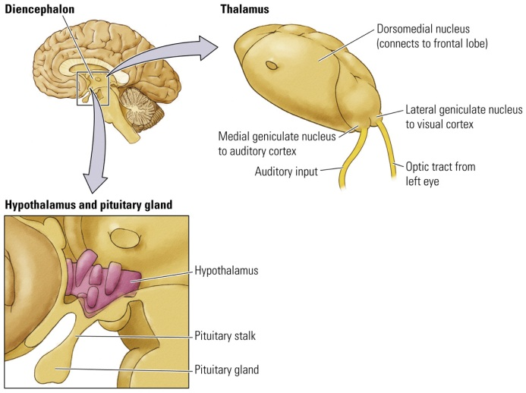
The Forebrain
- Neocortex (or cortex)
  - Regulates various mental activities
- Basal Ganglia
  - Control of movement
- Limbic System
  - Regulates emotions and behaviours that create and require memory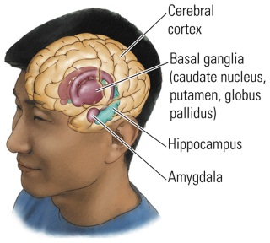

The Forebrain: Cortex
- Neocortex (“New Bark”)
  - 6 layers of gray matter
  - Creates and responds to a perceptual world
- Limbic Cortex
  - 3 or 4 layers of gray matter
  - Controlling motivational states
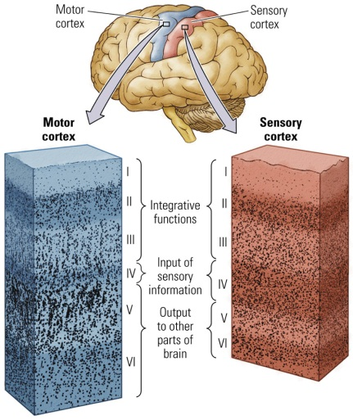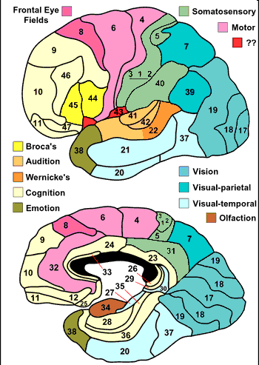
Organization of the Nervous System: The Central Nervous System
- The cortex: Layers
  - Different layers have different cell types
  - Density of cells in each layer varies
  - Differences in appearance relate to function
- Cytoarchitectonic Map
  - Map of neocortex based on the organization, structure, and distribution of the cells
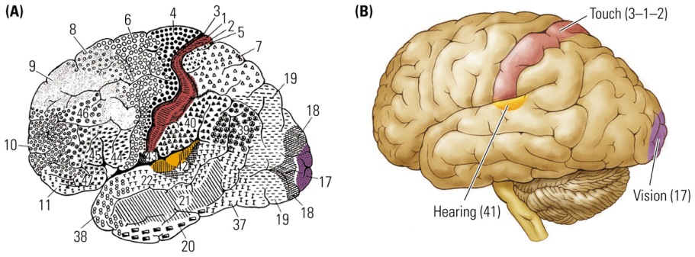
The Forebrain: Cortex
- Frontal: Movement, planning, and organization
- Parietal: Somatosensation and spatial processing
- Temporal: Semantic knowledge, auditory processing, gustatory
- Occipital: Vision
The Homunculus (Little Man)
- Depending on which neurons in that part of the motor strip are activated, it will move a different part of the body. (Hands will have a lot of the sensory strip, so will our lips)
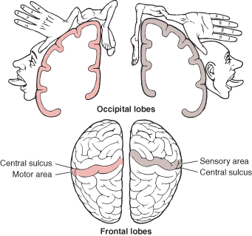
The Forebrain: Basal Ganglia
- Collection of nuclei just below the white matter of the cortex
  - Consists of 3 structures
    - Caudate
    - Putamen
    - Globus Pallidus
- Controls voluntary movement
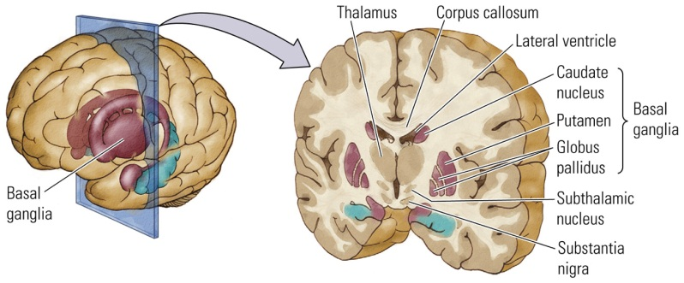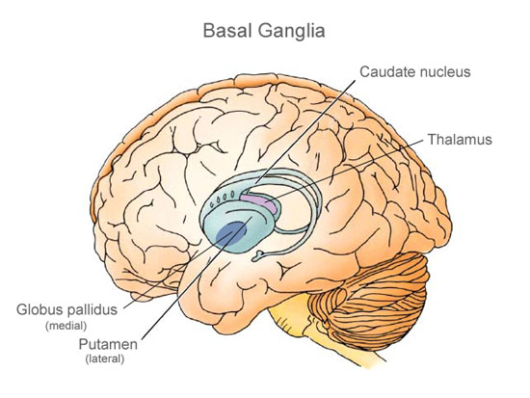
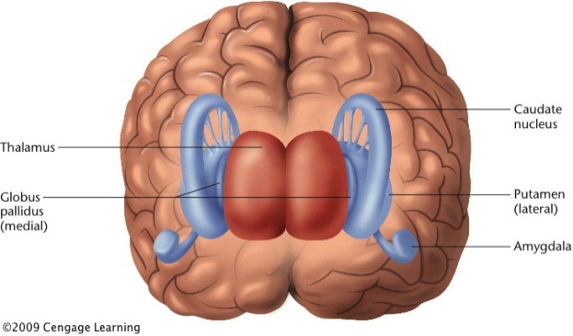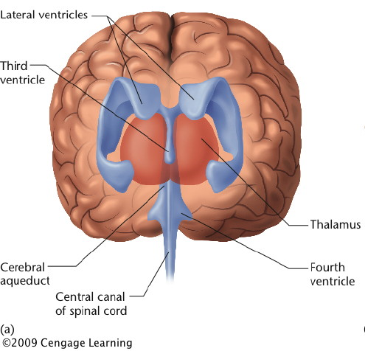
Diseases of the Basal Ganglia
- Parkinson’s Disease
  - Loss of dopamine producing cells
  - Substantia Nigra degeneration
  - Symptoms: Tremor, bradykinesia, rigidity, posture and balance
- Tourette’s Syndrome
  - Causes unknown (both genetic and environmental factors)
  - Motor and vocal tics
The Forebrain: Limbic System
- Group of structures between the neocortex and brain stem
  - Key: Cingulate cortex, hippocampus (Spatial mapping), and amygdala
- Regulation of
  - Emotional and sexual behaviours
  - Memory
  - Spatial navigation
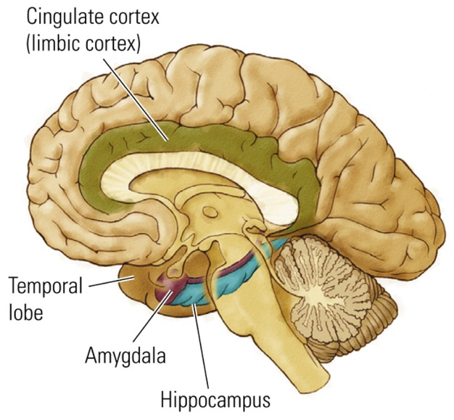
The Olfactory System
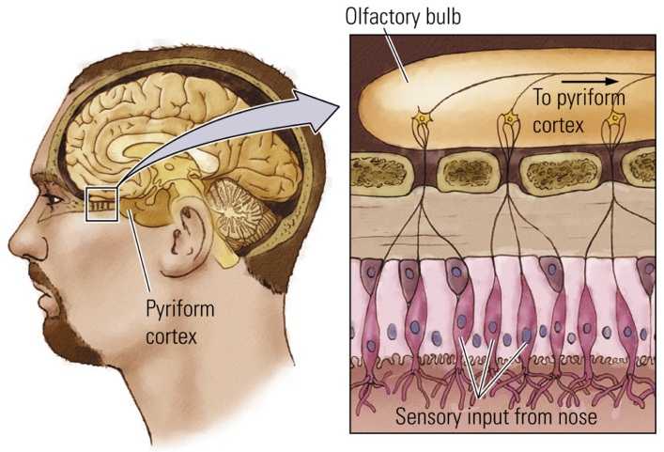
- Olfactory bulbs Pyriform cortex Thalamus Neocortex
The Somatic Nervous system: Cranial Nerves
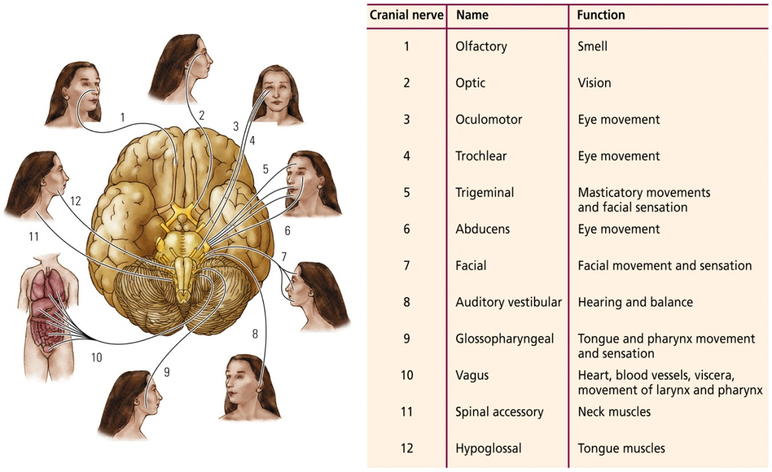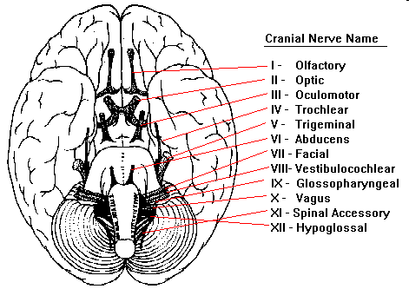
- “Oh, Oh, Oh, To Touch And Feel Very Good Velvet! Such Heaven!”
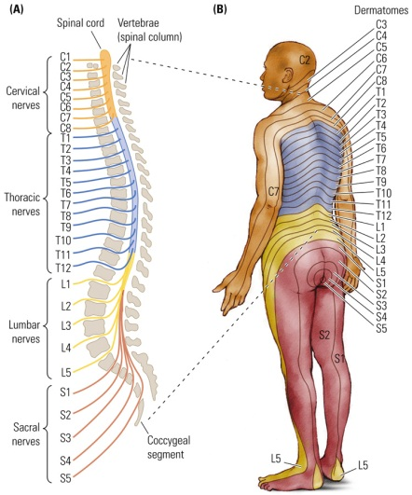
The Somatic Nervous System
- Dermatome: Area of the skin supplied with afferent nerve fibres by a single spinal-cord dorsal root
- Law of Bell and Megendie: The general principle that sensory fibres are located dorsally and motor fibres are located ventrally.
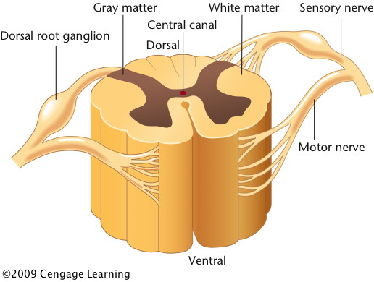
- White matter on the outside, and grey matter towards the center Opposite of the brain. More axons in white matter.
The Autonomic Nervous System
- Sympathetic System
  - Arouses the body for action (ex: To increase heart rate and blood pressure)
  - Mediates the “fight or flight” response
- Parasympathetic system
  - Opposite of sympathetic: Prepares the body to “rest and digest”
  - Reverses the “fight or flight” responses
The 10 Principles of Brain Function EXAM.
- The nervous system function is to produce movement within a perceptual world created by the brain
- Neuroplasticity: The details of nervous-system functioning are constantly changing (Experience, learning and memory)
- Many of the brain’s circuits are crossed 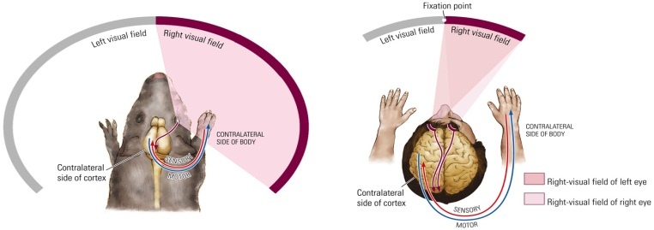
- The Central Nervous system functions on multiple levels
  - The same functions (motor, sensory) may exist on multiple levels
  - During evolution, new brain areas were placed on top of older ones
  - Newer brain levels added increased control and processing
  - Levels work together to produce behaviour
- The brain is both symmetrical and asymmetrical
  - Asymmetry is essential for certain tasks:
    - Language is usually on the left side
    - Spatial functions are usually on the right side
- Brain Systems are organized both serial (Hierarchically) and in parallel
  - Binding problem: Because a single sensory event is analyzed by multiple parallel channels that do not converge onto a single brain region, there is said to be a problem in binding together the segregated analyses into a single sensory experience. 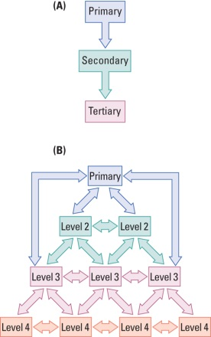
- Sensory and Motor divisions exist throughout the nervous system
  - Periphery: Cranial and spinal nerves
  - Brain: All the way up the cortex 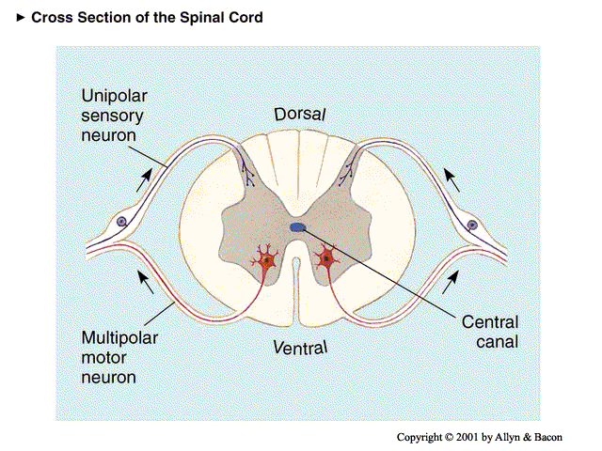
- Sensory input to the brain is divided for object recognition and motor control. 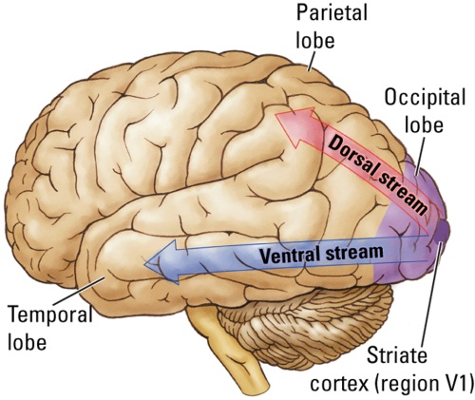
- Functions in the brain are both localized and distributed
  - Because functions (ex: Language) have many aspects, it’s not surprising that these aspects reside in widely separated areas of the brain
  - Small area of damage: focal symptoms
  - Large area of damage: Remove entire function
- The nervous system works through excitation and inhibition
  - Excitation: Process by which the activity of a neuron is increased
  - Inhibition: Process by which the activity of a neuron is decreased or stopped.
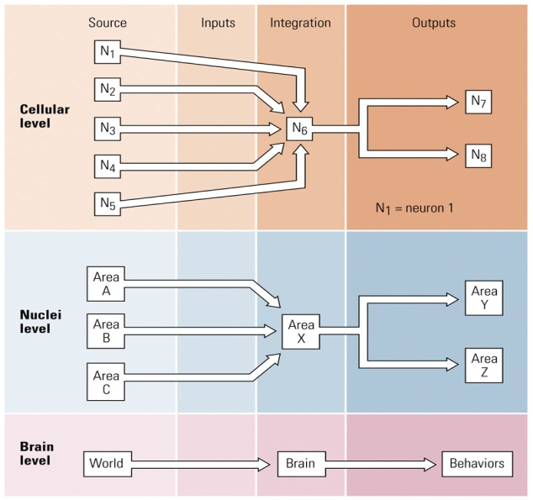
  - Applies to individual neurons and to nuclei.
+
-
-
+ +
+
+
-
-

