Biological Foundations of Behaviour
Chapter 1: The Origins of Brain and Behaviour
Biological Psychology
- Definition: The study of the physiological, evolutionary and developmental mechanisms of behaviour and experience
- Synonymous terms: Biopsychology, psychobiology, Physiological psychology, behavioural neuroscience.
Careers related to Biological Psychology
- Research
  - Neuroscientist
  - Cognitive neuroscientist
  - Behavioural neuroscientist
  - Neuropsychologist
  - Neurochemist
- Therapy
  - Clinical psychology
    - Clinical psychologist
    - Counselling psychologist
  - Medical school
    - Psychiatrist
    - Neurologist
    - Neurosurgeon
  - Allied medical field
    - Physical therapy
    - Occupational therapy
    - Social worker
The Nervous System
- Central Nervous System (CNS)
  - The brain and spinal cord
  - Spinal cord: Part of the CNS encased within the vertebrae or spinal column
- Peripheral Nervous System (PNS)
  - All the neurons in the body that are located outside the brain and spinal cord.
What is the brain?
- Hemispheres: Brain contains two almost symmetrical halves- right and left
  - Left: Dominant for language
  - Right: Musical, auditory information.
  - Therefore, the halves aren’t completely identical.
- Cerebral Cortex: Heavily folded outer layer of brain tissue composed of neurons (cortex= bark)
  - Gyri: Bumps on the folded surface
  - Sulci: Grooves of the cortex
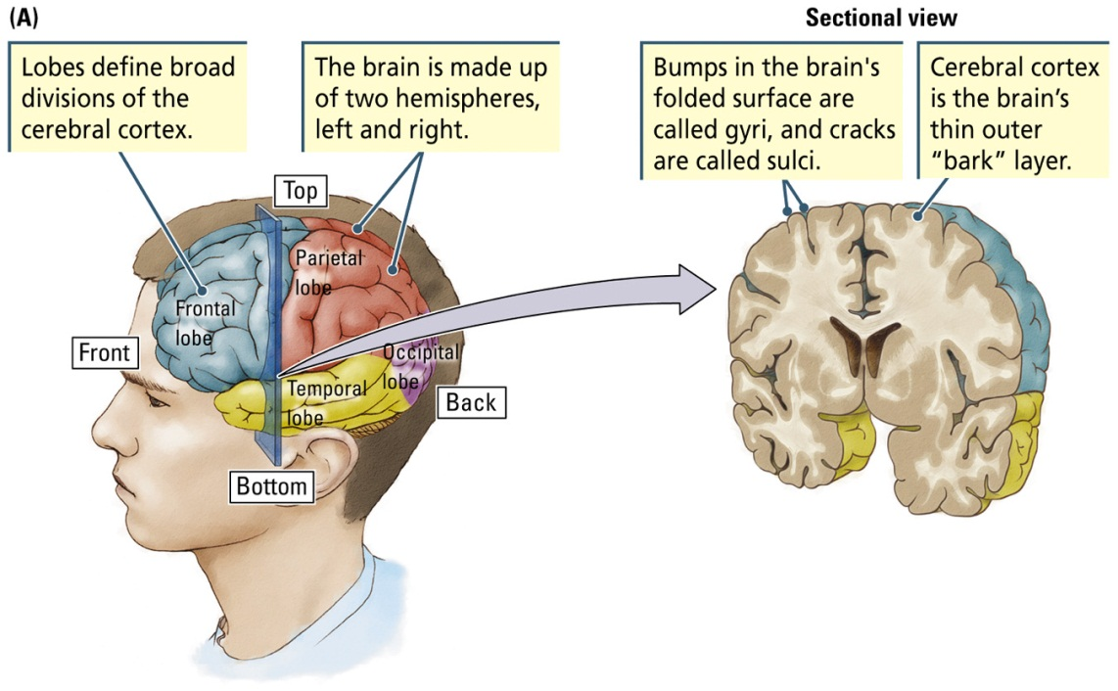
Gyrus (Gyri)
Sulcus (sulci)

Two Hemispheres of the Brain
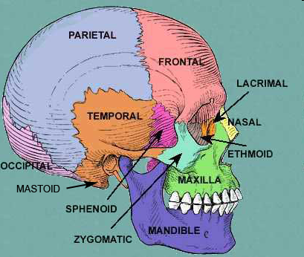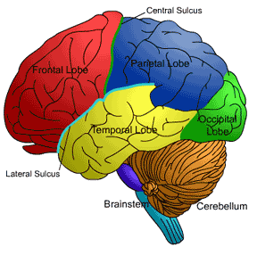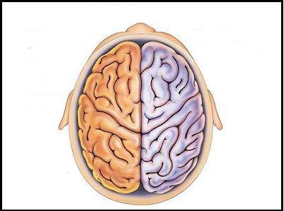
- Fissure: Very deep sulcus
What is the Brain?
- Four lobes (In each hemisphere)
  - Temporal lobe: Cortex lying below the lateral fissure, beneath the temporal bone at the side of the skull
  - Frontal lobe: Cortex anterior to (in front of) the central sulcus and beneath the frontal bone of the skull
  - Parietal Lobe: Cortex posterior to (behind) the central sulcus beneath the parietal bone at the top of the skull
  - Occipital Lobe: Cortex at the back of the brain and beneath the occipital bone of the skull
Gross Structure of the Nervous System
- Neuron: A brain cell engaged in information processing
- Sensory Neuron: Neuron that carries incoming information from sensory receptors into the spinal cord and brain
- Motor Neuron: Neuron that carries information from the spinal cord and brain to make muscles contract
The Neuron
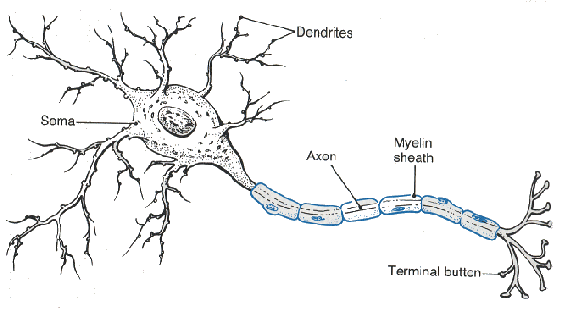
What is Behaviour?
- Behaviour:
  - Definition:
    - The manner of conducting oneself
    - Anything that an organism does involving action and response to stimulation
    - The response of an individual, group, or species to its environment
  - The way in which someone behaves
  - The way in which something functions or operates
- Innate behaviours: Relatively fixed, invariant ways of responding
- Learned behaviours: Flexible ways of responding
- Complexity of behaviour varies considerable in different species
  - Simple nervous system
  - Complex nervous system
  - Narrow range of behaviour
  - Wider range of behaviour
Historical and Evolutionary Perspectives to the Study of Brain and Behaviour
Are the mind and body one, or separate?
- Monism: The universe consists of only one kind of substance
- Dualism: Mind and body are different substances
Psychology’s roots: Greece
- Mind and body are distinct Socrates
  - The first dualists
  - Mind endures after death
  - Knowledge is born with us (innate)
- Plato: What is physical is really an illusion of what’s out there. Only through reasoning can we actually reach the truth.
Aristotle
- Mentalism
  - Psyche: Synonym for mind; an entity once proposed to be the source of human behaviour
  - Having a mind is essential to being human
  - The mind is non-material
  - Brain cooled the blood; no role in producing behaviour
  - The heart controls the mind
Descartes
- Dualism
  - Both a non-material mind and the material body contribute to behaviour
  - Mind-body problem: Quandary of explaining a non-material mind in command of a material body
  - Mind: Directs rational behaviour
  - Located in the pineal gland of the brain
  - Body and brain: Direct all other behaviour via mechanical and physical principles (ex: sensation, movement, and digestion)
  - Mind regulates behaviour by directing the flow of ventricular fluid to appropriate muscles
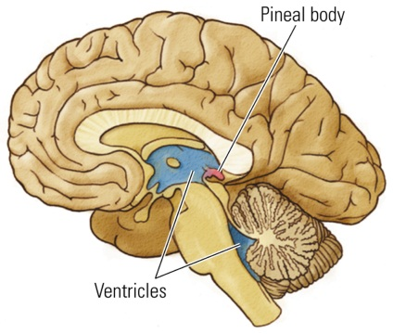
- Problems with Descartes’ Theory
  - Pineal gland is involved in biological rhytms, but NOT in intelligence or behavioural control
  - Fluid is NOT pumped from the ventricles to control movement
Tomas Hobbes & Pierre Gassendi
- Materialism
  - Behaviour can be explained as a function of the nervous system without explanatory recourse to the mind
Phrenology
- Franz Joseph Gall & Phrenology
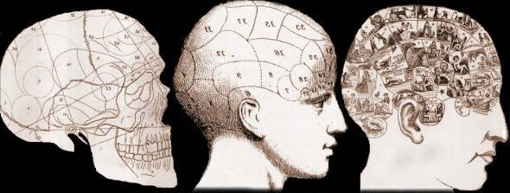
  - Shape and curvature of a person’s skull reveals mental faculties and character traits

- Extreme localization of function!
  - 27 different sections

Materialism
- Materialism supported evolutionary theories of Alfred Wallace and Charles Darwin
  - All living things are related
- Darwin’s concept of natural selection
  - New species evolve and existing species change over time
  - Differential success in the reproduction of different characteristics (phenotypes) results from the interaction of organisms with their environment
- How are traits selected naturally
  - Genetic mutation Adaptive trait increases chances of survival Trait passed on to offspring
Gregor Mendel (Materialism)
- Father of genetics
- First theory on how traits are passed on to offspring
- Heritable factors (genes) maintain their structural identity from one generation to another
- Genes are related to the physical traits displayed by the species.
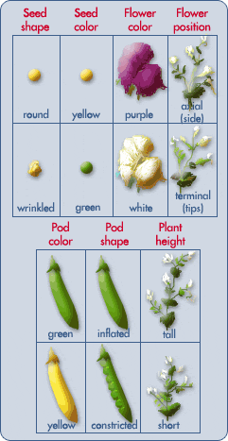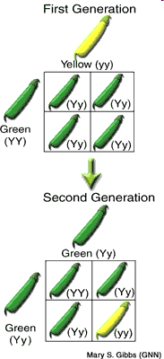
James D Watson and Francis Crick
- In 1953, proposed the double-helix model of DNA structure in the journal Nature
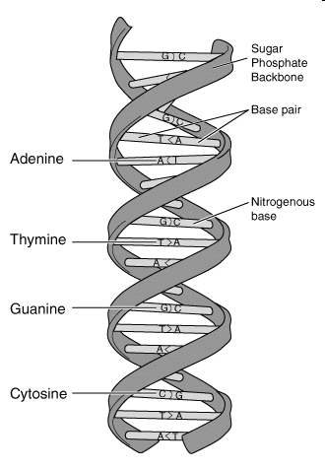
Implications of natural selection
- Because all animal species are related, their neurons and their brains must be related, too
- Because all species of animals are related, their behaviour must be related, too
Evolution of Brain and behaviour
- Common ancestor: A forebear from which 2 or more lineages or family groups arise (ex: Humans and apes)
- Can trace our lineage by comparing genes, brains, and behaviours of different animals
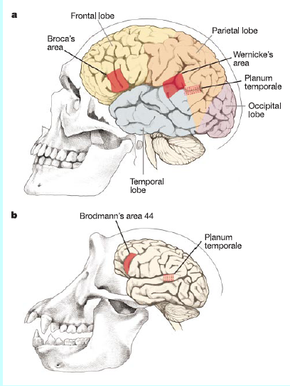
Classification of Life
- Taxonomy
  - Branch of biology concerned with naming and classifying species
    - Groups organisms with common characteristics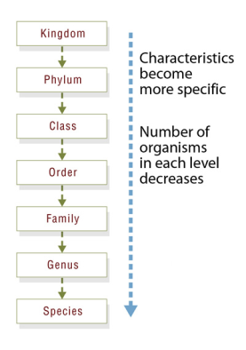
  - Kingdom Animalia.
  - Phylum Chordata
  - Class Mammalia
  - Order Primates
  - Family Hominidae
  - Genus Homo
  - Species Homo Sapiens
- Kingdoms: Monera (prokaryotes), protoctista (single celled organisms with organelles), fungi, animalia, plantae
Animal’s nervous systems
- Nerve net
- Segmented nerve trunk
- Ganglia
  - Collection of nerve cells that function somewhat like a brain
- Chordates
  - Animals that have a brain and spinal cord
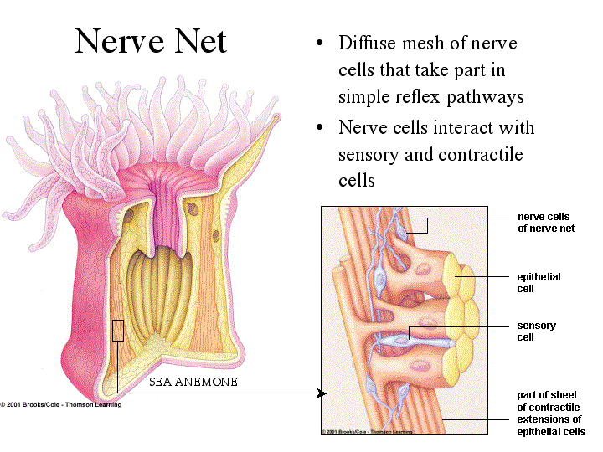
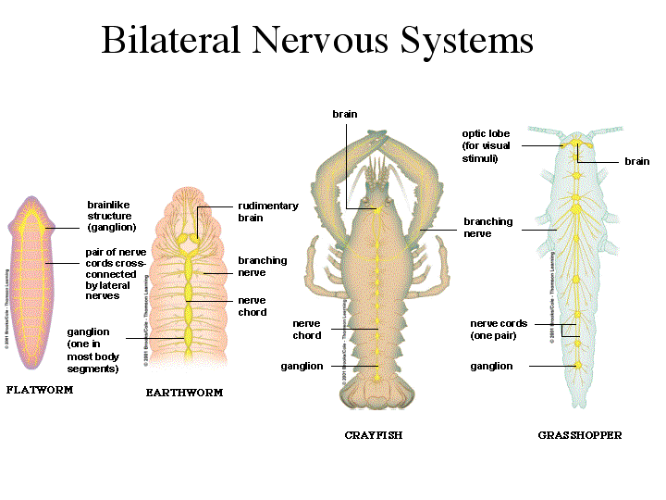
Chordates
- Have both a brain and a spinal cord.
- Humans, mammals, primates
- Features common to chordates
  - Bilaterally symmetrical and segmented
  - Brain and spinal cord encased in cartilage/bone
  - Crossed organization: Each hemisphere receives information from and controls the opposite side of the body
  - Spinal cord is dorsal (at the back) to the heart and gut
Primates
- Features common to primates
  - Excellent color vision
  - Eyes in front of face: enhance depth perception
  - Females: Usually only one infant per pregnancy; infants require more care
  - Larger brains
Human Evolution
- Hominid
  - Primates that walk upright; includes all forms of humans, living and extinct
- Hominid Ancestors
  - Australopithecus (Lucy)
    - 4 million years ago; Gave rise to the genus Homo, or human; Brains were 1é3 the side of ours.
  - Homo Habilis (Handy Human)
    - 2 million years ago; in Africa; Made simple stone tools
  - Homo Erectus (Upright man)
    - Migrated to Europe and Asia; 1.6 million years ago; Larger brain than homo habilis and more sophisticated tools.
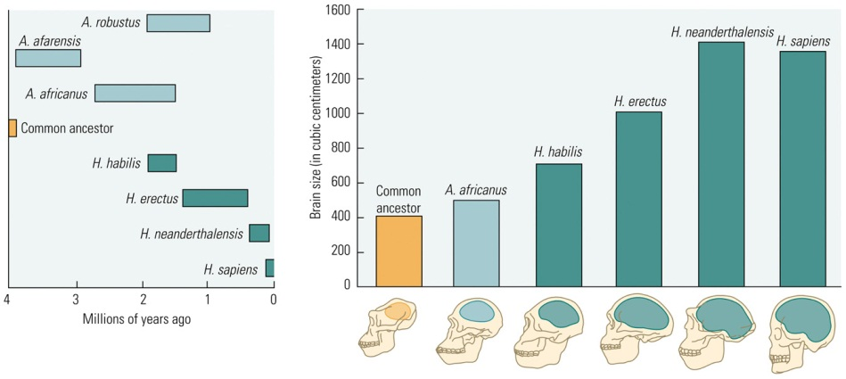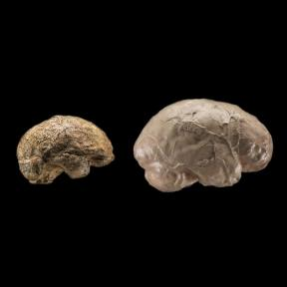
Homo
Sapiens
Homo
Erectus
E
The First Humans
- Homo Sapiens (Wise Human)
  - Africa and Asia: 200,000 years ago
  - Europe: 100,000 years ago
  - Larger brain than Homo Erectus
  - Coexisted with other hominids
    - Example: Neanderthals, who had comparable or even larger brains than homo sapiens
    - Exact reason why we replaced Neanderthals is unknown
Brain Size and Behaviour
- Harry Jerison (1973)
- Principle of proper mass:
  - Species exhibiting more complex behaviours will possess relatively larger brains
- Developed an index of brain size to allow comparisons among different species
  - Used body size to predict brain size
- Encephalization Quotient (EQ):
  - Measure of brain size obtained from the ratio of actual brain size to the expected brain size for an animal of a particular body size
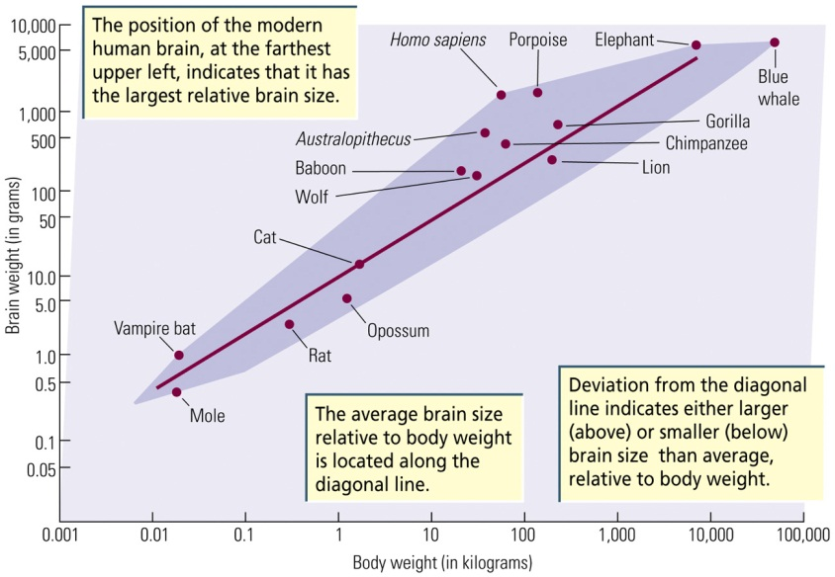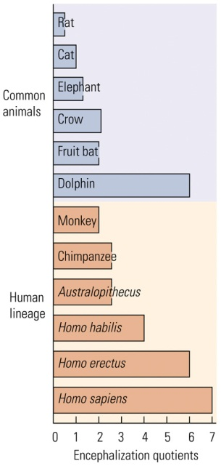
Why the Hominid Brain Enlarged
- Rapid climate changes have been thought to produce new environments that select for new traits (ex: Larger brains)
- Theories: (EXAM)
  - The primate Lifestyle
  - Changes in Hominid Physiology
  - Neoteny
Modern Humans
- Brain size and intelligence do not seem to be particularly related

