Question 1:
Bill Cooper’s statement to “use the entire crop for whole tomatoes” is incorrect because they are ignoring their other products (tomato juice and tomato paste) and their demand constraints. In addition, tomato juice gives a higher profit than whole tomatoes; therefore, it is not logical to produce only whole tomatoes. Even if the company wants to produce only whole tomato they will lose a lot of tomatoes quality B because the quality ratio for the whole tomatoes is 8 and the tomatoes of quality B is only 5.

Charles Myer’s reasoning, described in the last paragraph is incorrect as it is biased. He is only focusing on tomato paste because it offers a higher profit margin, as computed in table 13-19. Table 13-19, however, shows the profit margin of each of the three products, given that they are all produced. If they chose to only produce tomato paste, their profit margin would be different. you couldn't make a difference between the price of the different quality of tomatoes because you pay the whole 3 000 000 pounds at the same price. It's a fixed cost and not a variable cost. Similarly to part a, Myer is offering a solution, but not the optimal solution.

Question 2:
Step 1:
X11: pound of A quality tomato in whole tomatoes product.
X12: pound of B quality tomato in whole tomatoes product.
X21: pound of A quality tomato in Tomato juice product.
X22: pound of B quality tomato in Tomato juice product.
X31: pound of A quality tomato in Tomato paste product.
X32: pound of B quality tomato in Tomato paste product.

Step 2:
The tomato’s price is not a variable cost, it’s a fixed cost. Each pound of tomato cost you 6 cent.
So you have to pay: 3 000 000 * .06 = 180 000$ for the tomato.

Revenue from whole tomatoes per case: 4 -1.18-0.24-0.4-0.7=1.48
Revenue from tomato juice per case: 4.5-1.32-0.36-0.85-0.65=1.32
Revenue from Tomato paste per case: 3.8-0.54-0.26-0.39-0.77=1.85

Revenue from whole tomatoes per pound: 1.48/18= 0.082222222
Revenue from tomato juice per pound: 1.32/20=0.066
Revenue from Tomato paste per pound1.85/25=0.074

Max Z= 0.82222222(X11+X12)+0.066(X21+X22)+0.074(X31+X32)-180 000

Step 3:

-Whole tomato demand constraint: X11+X12=< 14 400 000 (800 000*18)
-Tomato juice demande constraint: X21+X22=< 1 000 000 (50 000*20)
-Tomato paste demand constraint: X31+X32=<2 000 000 (80 000*25)
-Quantity of quality A tomato constraint: X11+X21+X31=<600 000
-Quantity of quality B tomato constraint: X12+X22+X32=<2 400 000
-Ration whole tomato constraint: 9X11+5X12=>8(X11+X12)
9X11-8X11+5X12-8X12=>0
X11-3X12=>0
-Ration tomato juice constraint: 9X21+5X22=>6(X21+X22)
9X21-6X21+5X22-6X22=>0
3X21-X22=>0
Step 4:

Positivity constraint: X11,X12,X21,X22,X31,X32 =>0

Question 3:
Resolution on excel :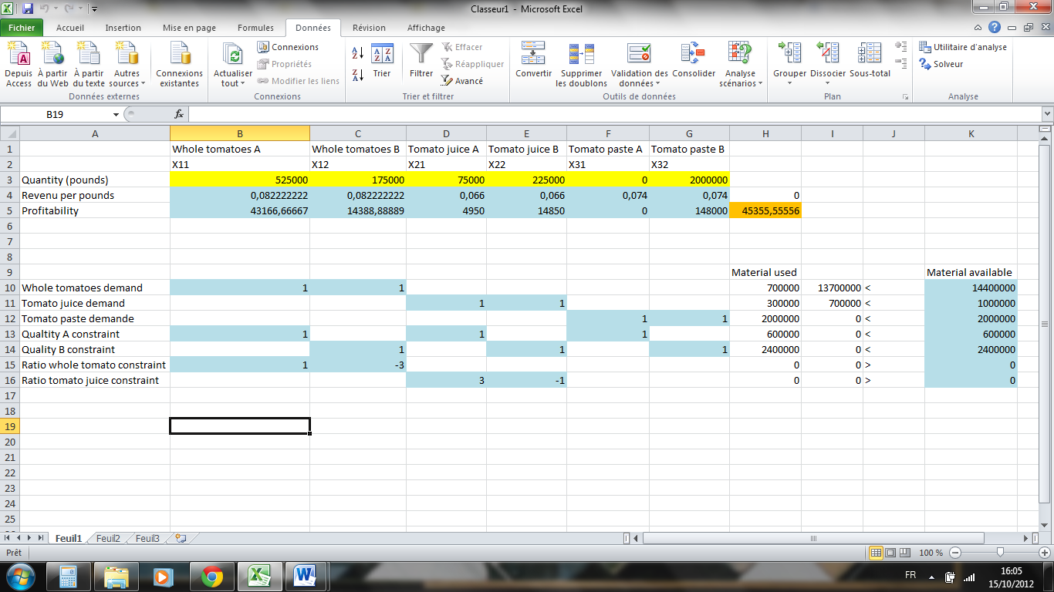

So the optimal values are:
X11= 525 000
X12= 175 000
X21= 75 000
X22= 225 000
X31=0
X32= 2 000 000
And Z= 45355.56

If the company wants to optimize its revenue they should use 525 000 pounds of A quality tomatoes and 175 000 pounds of B quality tomatoes to produce whole tomatoes. 75 000 pounds of A quality tomatoes and 225 000 pounds of B quality tomatoes to produce tomato juice and 2 000 000 pounds of B quality tomatoes to produce tomato paste. And with this production the profit of the company is 45355.56 dollars.

Question 4:
I would recommend to purchase the additional tomatoes because as you can see in the sensibility report
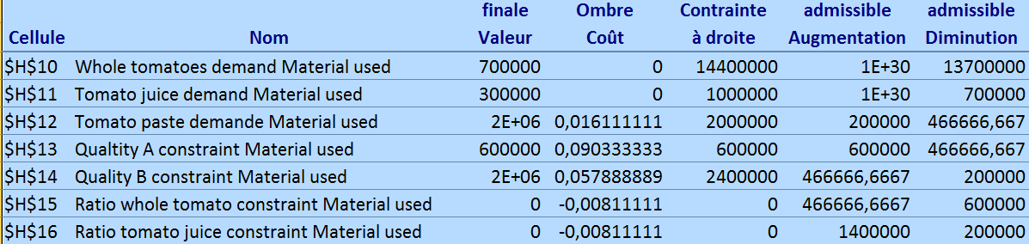
The shadow price of the quality A tomatoes is 9.03 cent(>8.5cent) and the allowable increase is 600 000 pounds you should purchase the additional 80 000 pounds of quality A tomatoes for 8.5 cent because the shadow price correspond to the limit price you could pay if you want to increase your profit. Since the price you are going to pay your tomatoes is less than the shadow price you should buy it.

Question 5:
Step 1:
X11: pound of A quality tomato in whole tomatoes product.
X12: pound of B quality tomato in whole tomatoes product.
X21: pound of A quality tomato in Tomato juice product.
X22: pound of B quality tomato in Tomato juice product.
X31: pound of A quality tomato in Tomato paste product.
X32: pound of B quality tomato in Tomato paste product.

Step 2:

You should add the cost of the additional tomatoes in the fixed cost:
180 000+80 000*0.085=186 800

Max Z= 0.82222222(X11+X12)+0.066(X21+X22)+0.074(X31+X32)-186 800

Step 3:

-Whole tomato demand constraint: X11+X12=< 14 400 000 (800 000*18)
-Tomato juice demande constraint: X21+X22=< 1 000 000 (50 000*20)
-Tomato paste demand constraint: X31+X32=<2 000 000 (80 000*25)
-Quantity of quality A tomato constraint: X11+X21+X31=<680 000
-Quantity of quality B tomato constraint: X12+X22+X32=<2 400 000
-Ration whole tomato constraint: 9X11+5X12=>8(X11+X12)
9X11-8X11+5X12-8X12=>0
X11-3X12=>0
-Ration tomato juice constraint: 9X21+5X22=>6(X21+X22)
9X21-6X21+5X22-6X22=>0
3X21-X22=>0
Step 4:

Positivity constraint: X11,X12,X21,X22,X31,X32 =>0
Using Excel we find:
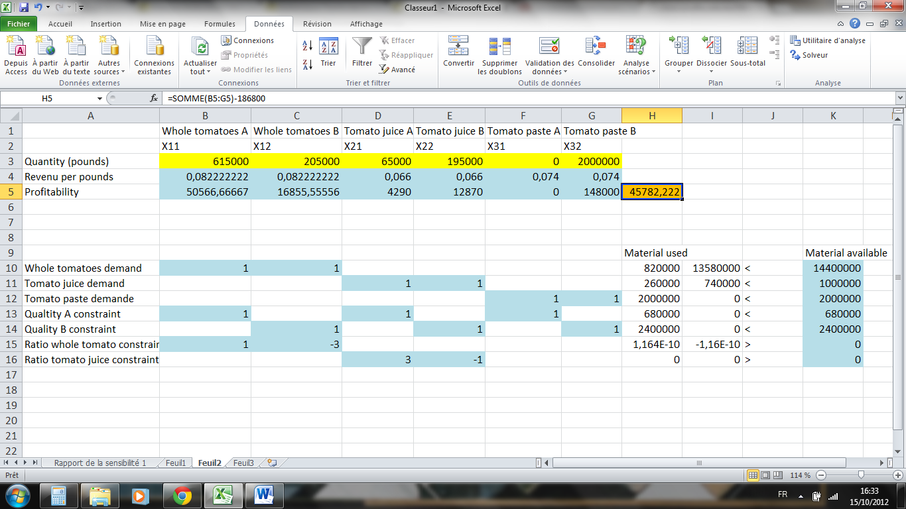
So the optimal values are:
X11= 615 000(+90 000 compared to the first solution)
X12= 205 000
X21= 65 000(-10 000 compared to the first solution)
X22= 195 000
X31=0
X32= 2 000 000
And Z= 45782.22

If the company wants to optimize its revenue you should use 615 000 pounds of A quality tomatoes and 205 000 pounds of B quality tomatoes to produce whole tomatoes. 65 000 pounds of A quality tomatoes and 195 000 pounds of B quality tomatoes to produce tomato juice and 2 000 000 pounds of B quality tomatoes to produce tomato paste. And with this production the profit of the company is 45782.22 dollars.

Question 6:
As you can see in the “ombre cout” shadow price column, the shadow price of tomato juice is 0 and the allowable increase is 1E+30 so the infinity. It means that the current demand is not entirely satisfied so there is no reason to pay for an increase in the demand in tomato juice because this expense will not increase your profit.

Question 7:

As you can see in the “ombre cout” shadow price column, the shadow price of Quality B tomatoes is 0.5789 and the allowable increase is 466 666.67. So you should buy the 75 000 additional quality B tomatoes because the increase is less than 466 666.67 pounds and you should pay them less than 5.789 cent because the shadow price is 5.789 cent and the shadow price correspond to the limit price you could pay if you want to increase your profit.

Question 8

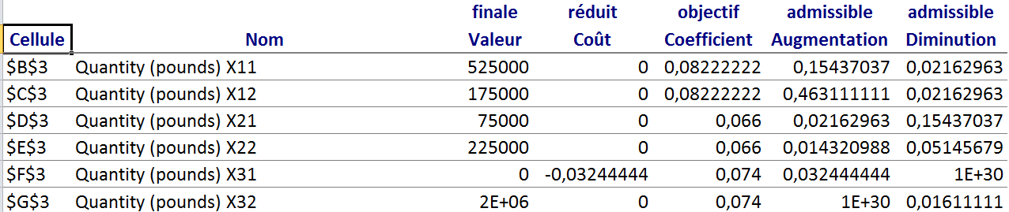
The tomato juice information corresponds to the quantity (pounds) X21 and quantity (pounds) X22 rows. As you can see the maximal decrease for X21 is 0.1543$ and for X22 is 0.0514$ for one pound. The decrease of the price is 10cent per case so that means it’s a decrease of:
0.1/20 = 0.05 cent per pound. As we can see the decrease of the tomato juice price is lower than the maximal allowable decrease of each row. So the optimal quantity will not change.

