Chapter Five

Human Resource Planning - The process of forecasting future human resources requirements to ensure that the required number of employees with the necessary skills to meet its strategic objectives.

Strategic Steps to HR Planning
- Develop the HR objectives
- Forecast and analyze Demand & Supply (internal/External Candidates)
- Develop and implement the HR plan to Balance
- Appraise and control the HR plan
(Books)
- Forecasting future human resources needs (demand)
- Forecasting the availability of internal and external candidates (supply)
- Planning and implementing HR programs to balance supply and demand
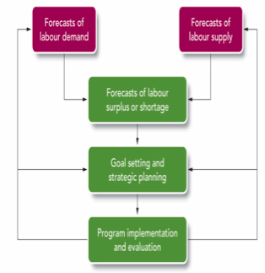

Results of Inadequate HR Planning
- Vacant positions create costly inefficiencies
- Mass layoffs requiring severance pay
- Simultaneous layoffs and hiring reduces morale and productivity, creates turnover
- Inability to meet operational and strategic plans

Goal Setting and Strategic Planning(3)
- Reducing a Surplus – when internal supply of employees exceeds the organization’s demand
Determining Labour Supply(2)
-Examines internal changes expected, Examines trends in the external labour market

-Markov Analysis
-Skills and Management Inventories
-Replacement Charts and Summaries or Transitional Matrix
-Succession Planning
Forecasting Demand for Labour (1)
- Answer question: Will the need for people increase or decrease?
- Statistical Models: (Quantitative)
Trend Analysis: The study of a firm’s past employment levels over a period of years to predict future needs.
Leading indicators
- Qualitative Techniques
Nominal group technique: A decision-making technique that involves a group of experts meeting face to face.
Delphi Technique: A judgmental forecasting method used to arrive at a group decision, typically involving outside expert as well as organizational employees.
- Managerial judgment
- Downsizing: Planned elimination of large numbers of employees to enhance the organization’s competitiveness
- Early-retirement Programs: Programs that encourage older workers to leave voluntarily
- Avoiding a Shortage – when internal supply of human resources cannot meet the organization’s needs
- Employing Temporary Workers: Provides flexibility & lower costs, however disadvantages include tension between temporary and permanent employees
- Outsourcing
- Overtime and expanded hours

Effective HR Strategy Formulation and Implementation

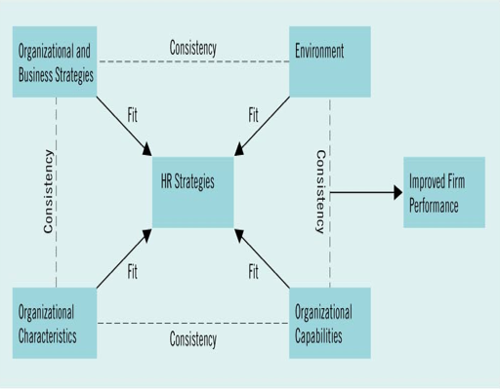
Forecasting the Supply of External (outside) Candidates
- General economic conditions
- National labour market conditions
- Local labour market conditions
- Occupational market condition

Human Resources Planning Model
Step 1: Forecast Demand for Labour
Considerations
- Organizational strategic plans
- Organizational tactical plans
- Economic conditions
- Market and competitive trends
- Government and legislative trends
- Social Concerns
- Technological changes
- Demographic trends
Techniques Utilized
- Trend Analysis
- Raio Analysis
- Scatter Plot
- Regression Analysis
- Nominal Group Technique
- Delphi
- Technique
- Managerial judgment
- Staffing Tables
Step 2: Analyze Supply
Internal Analysis
External Analysis
- General economic conditions
- Labour market conditions (national and local)
- Occupational market condition
- Markov Analysis
- Skills Inventories
- Management Inventories
- Replacement Charts and
development tracking
- Replacement Summaries
- Succession Planning

Step 3: Implement HR Programs to Balances Supply and Demand
Labour Shortage
Labour Surplus
- Hiring freeze
- Attrition
- Buyouts and early retirement programs
- Job sharing
- Part-time work
- Reduced workweek
- Alternative jobs within the organization
- Layoffs (reverse seniority or juniority)
- Supplemental unemployment benefited (SUBs)
- Termination severance pay
- Outplacement assistance
- Overtime
- Hire temporary employees
- Subcontract work
- Recruitment
- Transfer
- Promotion

When labour demand exceeds labour supply
- Scheduling overtime hours
- Hiring temporary workers
- Subcontracting
- External recruitment
- Internal promotions and transfers
- Performance management, training and retraining, and career development paly a critical role

When labour supply exceeds labour demand
- Hiring freeze: reassigning current workers to job openings
- Attrition: standard employees resignation, retirement, or death
- Incentives to leave the organization: buyouts or early retirement programs
- Job sharing
- Reducing position or part-time
- Working share and reduced workweek
- Finding employees alternative job within the organization
- Employee layoffs
- Termination of employment
- Evaluating the effectiveness of layoffs and downsizing is critical, as is managing “survivor sickness”

When labour demand equals labour supply
- Vacancies are filled internally through transfers or promotions, or externally by hiring new employees
- Performance management, training and career development are critical in achieving balance

